Worksheet


Making a Transportation Action Plan
Objective: Use the chart's series of questions to identify your "Top 3 Commute Options".
Instructions for Using the Chart:
- Start at the Top: Begin with the very first question on the chart: "Is the job close enough to walk or bike safely?".
- Follow the Arrows:
  - If your answer is "Yes", follow the arrow pointing to the right. Write down this transportation method (walking or biking)—it is now one of your potential commute options.
  - If your answer is "No", follow the arrow pointing downward to the next question.
- Work Your Way Down: Continue this process for each question on the list. Whenever your answer is "No," move straight down to the next option. The chart guides you to evaluate:
  - Having a driver's license and access to a car.
  - Relying on family or friends to help drive you.
  - The availability of public transportation in your community.
  - Qualifying for and accessing paratransit.
  - Using OOD/DODD employment supports to pay for rideshares.
- Identify Your Top 3: Every time you answer "Yes", add that method to your list of options. The ultimate goal is to reach the bottom of the flowchart having identified your Top 3 Commute Options.
Once you have identified your top three choices, you can use them to create a solid daily commute plan, reserving the second and third options as reliable backup plans for emergencies.

How will I get to work?

Charting Your Transportation Action Plan
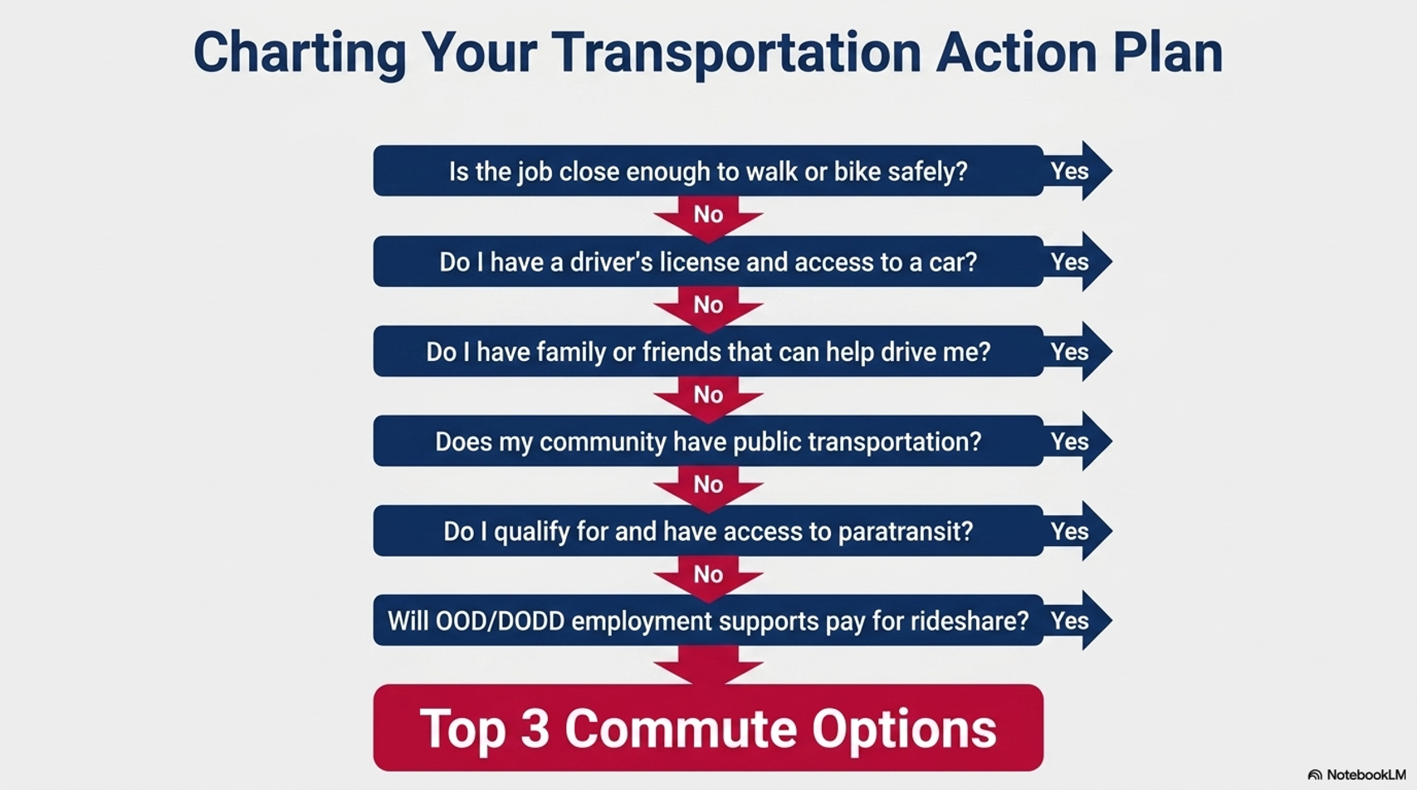

Based on the information above, list the options available for you to get to work:

