Ohio Job Seeker’s Guide

Facilitator’s Edition

Table of Contents
Module 1: CIE Employment Steps
Let’s Get to Work
Module 2: Discovery
Vocational Discovery: Welcome to Your Employment Journey
Module 3: Benefits Planning
Benefits Planning
Module 4: Networking, Job Applications, and Interviews
Job Seeker’s Journey: From Networking to Getting Hired
Module 5: Technology
Navigating the Modern Job Search
Module 6: Transportation
Mastering Your Commute
Module 7: Youth Transition
Everyone Can Work!

Let’s Get to Work
What is Community Employment?
Community Employment means having a job out in the community, just like everyone else. It means working for a business that hires all kinds of people, including people with and without disabilities. It also means you are not working in a program that is only for people with disabilities.

Understanding Your Potential:
What is Community Employment?
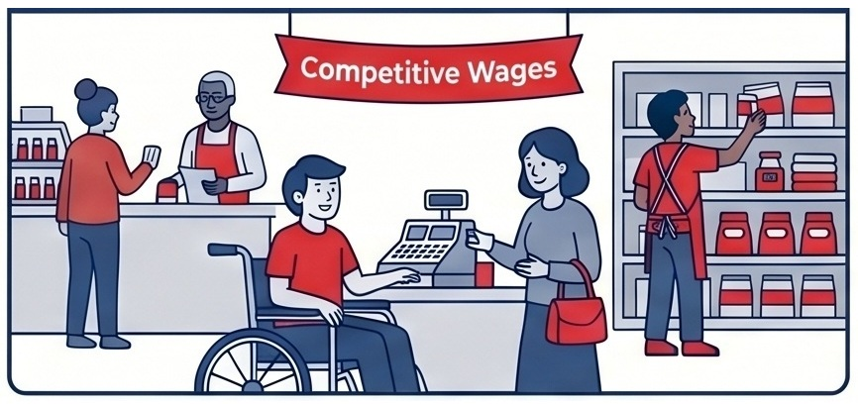
Working for a local business alongside people of all abilities for competitive wages.
When you have a community job, you will earn money for the work you do. You get paid the same as the other workers doing the same job. You will make at least minimum wage - and sometimes more. Some jobs also offer other kinds of benefits like paid days off and health insurance.

The concept of a “community job” can be confusing for some job seekers. Facilitators can clarify the points made in this section by comparing the individual’s current work situation to “community employment” and explaining how they are different (i.e. integrated settings, based on your skills, interests, wages, hours).
What is Community Employment

Real Jobs for Everyone

Working for businesses that hire all people, not just those with disabilities.
Equal Pay for Equal Work

You earn at least a minimum wage and the same pay as your coworkers.
Endless Possibilities

Roles range from offices and stores to restaurants or even starting your own business.
There are many kinds of jobs and places to work. Such as:
Where can people work in the community?
- Working in a store
- Helping in an office
- Cooking or helping customers in a restaurant
- Using computers, tools or machines
- Helping kids
- Cleaning or helping guests in a hotel
- Sorting and packing things in a factory
- You can even choose to be your own boss and start a business - this is called being “self-employed”

Work Environment | Common Tasks
Retail & Service | Working in stores, hotels, or restaurants.
Business & Tech | Helping in offices or using computers and machines.
Production & Logistics | Sorting, packing, or working in a factory setting.

Jobs can be:
When can people work?
- In the daytime or at night
- On weekdays or on weekends
- Full-time (all day)
- Part time (half days)
- Customized (maybe just a few hours or a few days a week)
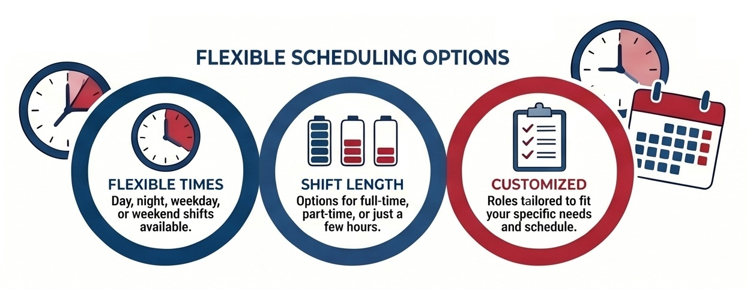
Flexible Times: Day, night, weekday, or weekend shifts available
Shift Length: Options for full-time, part-time, or just a few hours.
Customized: Roles tailored to fit your specific needs and schedule.
The best part?
There are many options, and you can decide what is best for you.
Facilitators may want to create a “Look Book” on an iPad that shows the kinds of jobs available in your community. Showing the jobseeker local businesses and familiar places may help them understand what “community” means- and what kinds of jobs are available in your community.

Meet Simon Ho
An administrative assistant at a downtown San Francisco law firm. Simon, who has autism, handles the firm’s mail, filing, and responds to requests from lawyers. These tasks play to many of his strengths. In the video below, we highlight how Simon found his ideal job through WorkLink, a program that enables people with intellectual and developmental disabilities (I/DD) to work.
The video, created with ODEP’s National Expansion of Employment Opportunities Network (NEON) initiative, explains how WorkLink used customized employment strategies to match Simon’s specific skills with the law firm’s needs. His coworkers say Simon’s contributions greatly improve office efficiency and productivity. “For PSA, they now have one of their most reliable employees,” says WorkLink program director Jeric Lake. “Simon doesn’t miss work. He doesn't come in late, and he loves his job.”
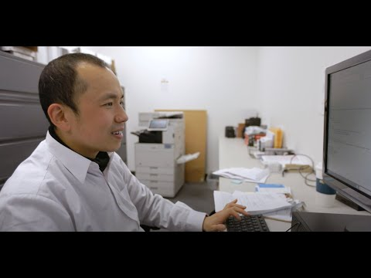
YouTube Link: https://www.youtube.com/watch?v=VD6XA3FYpNs

Let’s look closer!
Talk to your family and friends about the following questions:

What kind of job would you like to get?
What kind of jobs do your family members have? What about your friends?
How do you feel about working in the community?

Facilitator Activities
Review a Look Book that shows a variety of local jobs; Discuss CIE & differences from work centers or contracted jobs.
Micah Hetrick at BJ Brewhouse/Homage:
https://www.youtube.com/watch?v=eHYNqIUYchk
Talk with job seeker(s) about what kinds of job they might want to get. Encourage them to talk with their family, friends about their jobs. Discuss what they like about the idea of working in the community and things that might make them nervous.

Why Work?
Having a job is a good thing!
Working in the community is a great thing because it offers a wide variety of personal, social, and practical benefits. Here are the key reasons why having a job is beneficial:
Personal Growth and Independence: When you work, you get to decide what kind of job is right for you, learn new things, and become more independent. It is a great way to discover talents and skills you didn't even know you had.
Social Connections: A job gives you the opportunity to meet new people, make friends, and become an important part of your community.
Financial Benefits: Working allows you to earn money and get a paycheck.
Sense of Purpose and Pride: Having a job gives you something to do each day, lets you do something you like or care about, and makes you feel productive and useful. Fulfilling responsibilities makes you feel proud and good about yourself. It also provides you with opportunities to help others.
When you work in the community:
- You decide what kind of job is right for you
- You learn new skills
- You meet people and make new friends
- You earn money
- You become more independent
- You help others
- You are an important part of your community

Why Community Work Matters

Greater Independence

Earning your own money and making decisions about your own career path.

Building Connections

Meet new people, make friends, and become an active part of your community.

Personal Pride

Discovering hidden talents and feeling proud of the responsibilities you take on.

Working makes you feel proud.
Having a job is a big responsibility. Your boss is relying on you to be on time, to work hard - and do your best. When you do a good job and help others, it makes you feel good about yourself. You may also discover talents and skills you didn’t know you had!

Understanding Your Potential:
Why Work Matters

Employment builds independence, teaches new skills, and connects you to your community.
Watch this video for an example of why people go to work
Hear what people say about their jobs and why they like working in the community:

YouTube Link: https://youtu.be/3jAAZ2rjwjM
Facilitator Activities

People work for different reasons. Finding out what reasons are most important for your jobseeker will help you to identify jobs that will be more than “just a paycheck”. As the saying goes: "Find a job you love, and you'll never work a day in your life“.
Ask the job seeker to tell you about something that made them feel proud or good about themselves. Use the videos: talk about how proud Chris was for “getting a tip” for doing a great job. Why Megan’s job makes her happy.
Discuss the list of reasons people work. Talk about how jobs can be different, how different jobs can offer different things and why people might like working in one job- and maybe not another. Then, use the Why Work? Worksheet to identify what the job seeker thinks are their most “important reasons” for working.
From Boxes to Robots: Megan Learns Confidence at Work
https://www.youtube.com/watch?v=l3W9SUz-3xo
Chris Gets a Tip
https://www.youtube.com/watch?v=F6g5vgG5Iw8

Worksheet

Why Work?

Why is work important to me?
Instructions: Use the scale below to rate how you feel about the reasons people might work:
😐 = Not Important
🙂 = A Little Important
😊 = Somewhat Important
😄 = Important
😁 = Very Important

Why Work?
What matters to me… | 😐 | 🙂 | 😊 | 😄 | 😁
Earning money / getting a paycheck | ☐ | ☐ | ☐ | ☐ | ☐
Learning new things | ☐ | ☐ | ☐ | ☐ | ☐
Meeting new people | ☐ | ☐ | ☐ | ☐ | ☐
Making friends | ☐ | ☐ | ☐ | ☐ | ☐
Helping people or my community | ☐ | ☐ | ☐ | ☐ | ☐
Being more independent | ☐ | ☐ | ☐ | ☐ | ☐
Having something to do each day | ☐ | ☐ | ☐ | ☐ | ☐
Doing something I like or care about | ☐ | ☐ | ☐ | ☐ | ☐
Feeling productive and useful | ☐ | ☐ | ☐ | ☐ | ☐

My Top Choices
Look at the items you marked or 😁.
The most important things to me about working are:

Let’s Talk About Work…
One thing I am excited 🤩 about

One thing I am unsure or nervous 😟 about:

One thing I want help 🙋 with:

After the rating exercise, guide students to focus specifically on the items they marked with a 😄 or 😁. This helps them filter their answers to pinpoint the most important reasons they want to work.
Facilitate an open discussion: The "Let's Talk About Work..." section is a crucial check-in to gauge how the student is feeling emotionally about the process. Look out for their answers;
Paying special attention to the things they are nervous about and the areas where they request help will be essential for guiding how you support them as they continue through the material.

Your Pathway
Where am I on My Path to Employment?
Everyone is different, and everyone’s path to getting a job will be different, too. Maybe you are in high school and wondering what comes next. Maybe you want to work but are not sure what kind of job is a good fit for you. Maybe you have a job but want something new. Or maybe you have never worked and feel a little nervous about getting a job —and that’s okay.
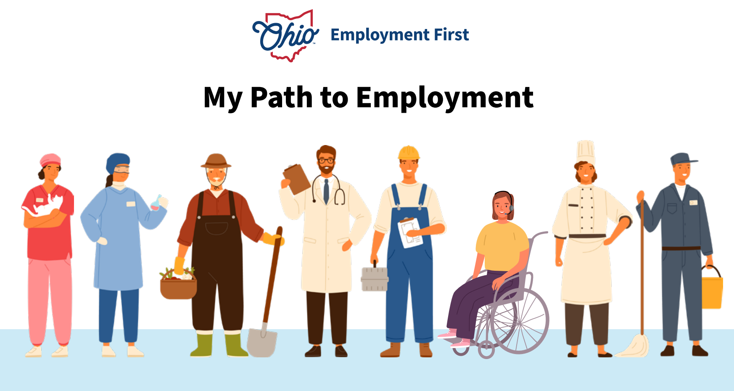
This Job Seeker’s Guide has modules that can help you no matter where you are on the pathway. These modules can help you:
- Learn more about yourself and your skills
- Explore what different kinds of work look like
- Set an employment goal
- Take steps toward finding a job that is right for you.
We are all on the Path to Employment, and everyone’s journey is different. The Path to Employment helps you think about where you are now and what you need to move in the direction you choose. It also helps others understand how to best support you.

Click here to access the My Path to Employment Companion Guide. On the worksheet, circle where you think you are on your pathway to employment. Share this with your family and your job search team.
https://ohioemploymentfirst.org/Employment-First-Companion-Guide

This section helps job seekers understand that everyone’s journey to employment is unique. Facilitators should guide the person to identify where they are on their pathway, what they already know about themselves, and what support or next steps may be helpful. The OH DODD’s pathway guide is a great resource.
Take a Look at Micah’s Employment Journey
Micah Hetrick works at both Homage and BJ's Brewhouse. He is a valuable member of both teams and is happy with the work he's doing. Micah is surrounded by a great support system including great employers, The Altitude Initiative, job coaches and family. This is a glimpse into his employment journey:

YouTube Link: https://www.youtube.com/watch?v=eHYNqIUYchk

Facilitator Activities
Facilitators should reinforce that there is no “right” starting point. Job seekers may be exploring work for the first time, changing jobs, or figuring out what kind of work fits them. And that feeling unsure or nervous is normal.
This guide is meant to be a “toolbox” for supporting jobseekers at any stage of their employment journey. The modules are flexible - you can move forward step by step; jump past modules; return to a module later or revisit steps you already did – based on the needs of the jobseeker.
OH DODD Path to Community Employment, a facilitator’s guide to Employment Planning
https://dodd.ohio.gov/wps/wcm/connect/gov/2c46aa60-937b-4a28-9feb-33c9587e1a6f/Path+to+Community+Employment.pdf?MOD=AJPERES&CONVERT_TO=url&CACHEID=ROOTWORKSPACE.Z18_79GCH8013HMOA06A2E16IV2082-2c46aa60-937b-4a28-9feb-33c9587e1a6f-pvRi2W7
Faith’s Pathway So Far (Project SEARCH to Nutcracker)
https://www.youtube.com/watch?v=i9ggfP9Dsoo

How do I get started?
Where am I on My Path to Employment?
The first step to finding a good job is to think about what you enjoy and what you do well. Talk to people about where these kinds of things happen and what businesses might need people like you.
Remember, everyone’s pathway to employment is different. If you are not sure what you like or what job might be a good fit- that’s okay. You can start by exploring different jobs, visiting workplaces or talking to people who do those jobs. Some people take classes to learn new skills. Others try jobs out through volunteering or internships. When you know what kind of job you want, you can start talking to employers and applying for jobs.
You don’t have to do this alone.
Talk to people about your ideas and what might be good next steps. There are lots of people who can help you.

Taking Action on Your Path:
Create Your Personal Profile

Identify your unique strengths, skills, and the types of work environments you enjoy.

Facilitator Activities
Using the worksheet, help the job seeker identify their passions and strengths, interests and places they like (Bullets 1 & 2).
Help the job seeker to think about what kinds of job tasks/work they might be asked to do at places they listed. Talk about other places that they may want to consider for their list. Talk about what jobs they may not have thought about that might match their skills and interests. Then ask the job seeker if these might be good jobs to explore.
Based upon your conversations with your job seeker - are you seeing any “significant themes”? Discuss your thoughts and ideas with the job seeker – did anything you mention resonate with the job seeker? If so, discuss potential ideas and options for next steps.
Review the other modules in the Job Seeker Guide and explain that there are lots of ideas and resources that will help them with their job search – and that some of these might be “good next steps” for the job seeker to think about.

Worksheet

What might be the right job for me?
Instructions: Use this worksheet to help you identify your passions and strengths, your interests and the places you like.

- Complete a Personal Profile. Write down your strengths, skills, things you enjoy and what is important to you at work.

Strengths:
Skills:
Things you enjoy:
What is important to you at work:

- Think about places you like to go or businesses where your skills could be useful.

- Make a list of businesses you think of. You can also ask family, friends, teachers or your team for more ideas.
1.
2.
3.
4.
5.

- For each business you listed: Ask yourself: would this be a good place for me to work? Why? or Why not?
1.
2.
3.
4.
5.

- Share your thoughts with your family, friends and team. They can help you explore your ideas and think of next steps.

Who Can Help?
Getting a job takes work.
But the good news is - there are lots of people who can help you:
- Personal connections like your family-members and friends
- Professionals: like social workers like your DODD service coordinator; your teachers; Employment service providers-like Rehabilitation counselors at OOD; or local placement programs.
Build your “Job Search” team.
Build a team of people who can support you in your job search. It is good to have people on your team who know you well AND people who know a lot about jobs and how to get one.

Taking Action on Your Path:
Build Your Job Search Team
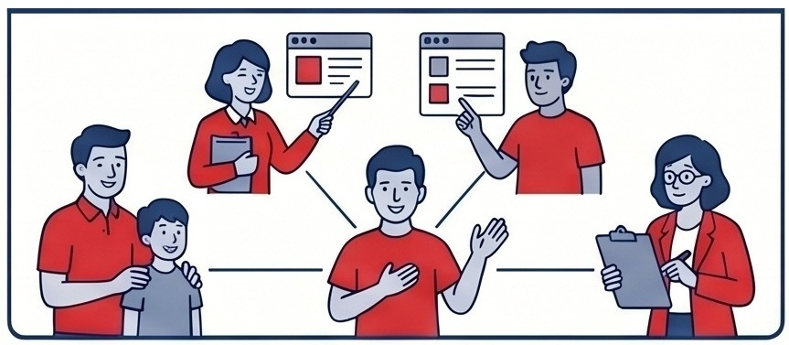
Connect with family, friends, teachers, and professional counselors to support your search.


Activity
Tell your family and people you know that you want a job. Ask them if they can help - or if they know someone who can. Set up a meeting, in-person - or on zoom, to get their ideas about how to get your job search started.
- Make a list of 5 people who can help you find a job.
- Start the Conversation: meet with them as a group, in-person, or on zoom.
- Share your worksheets and your ideas with them.
Distinguish between personal and professional helpers: Help the job seeker identify the different types of people they can reach out to. Make sure they consider both personal connections, like friends and family, and professionals, such as teachers, DODD service coordinators, employment service providers, or rehabilitation counselors at OOD. You can talk about how your role as a facilitator can be considered a professional helper.

Taking Action on Your Path:
Start the Conversation

Set a meeting with your team to share your goals and explore next steps.

Why Do We Work: Beyond a Paycheck
This instructional video explores the many reasons people work beyond simply earning a paycheck. Through real-world examples and guided discussion, viewers will learn how employment can provide purpose, independence, personal growth, social connection, and opportunities to contribute to their communities.
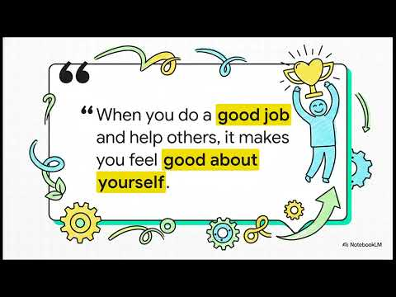
YouTube Link: https://youtu.be/ZJEBR2n3u1Y
Let’s get to work!

Facilitator Activities
Assist the job seeker to use their phone contacts, social media or emails to identify possible people for their team.
Support the job seeker to identify the “professionals” in their life - and ask for their assistance or advice.
Visit some local Job Centers or talk with some employment service providers.
Show them online resources that might be useful.
Prepare them for outreach and sharing: Help the student plan how they will connect with their team to get their job search started. You can help them set up 1:1 meetings or group gatherings, either in-person or over Zoom. Remind them that these meetings are the perfect opportunity to share their previously completed worksheets and ideas with their team.

Module 1 Resources

Worksheets
Why Work? Worksheet – Module 1.1
What might be the right job for me? Worksheet – Module 1.3

Videos
Meet Simon Ho
https://www.youtube.com/watch?v=VD6XA3FYpNs
An administrative assistant at a downtown San Francisco law firm. Simon, who has autism, handles the firm’s mail, filing, and responds to requests from lawyers. These tasks play to many of his strengths. In the video below, we highlight how Simon found his ideal job through WorkLink, a program that enables people with intellectual and developmental disabilities (I/DD) to work.
Watch this video for an example of why people go to work
https://youtu.be/3jAAZ2rjwjM
Take a Look at Micah’s Employment Journey
https://www.youtube.com/watch?v=eHYNqIUYchk
Micah Hetrick works at both Homage and BJ's Brewhouse. He is a valuable member of both teams and is happy with the work he's doing. Micah is surrounded by a great support system including great employers, The Altitude Initiative, job coaches and family. This is a glimpse into his employment journey.

Why Do We Work: Beyond a Paycheck
https://youtu.be/ZJEBR2n3u1Y
This instructional video explores the many reasons people work beyond simply earning a paycheck. Through real-world examples and guided discussion, viewers will learn how employment can provide purpose, independence, personal growth, social connection, and opportunities to contribute to their communities.
Faith’s Pathway So Far (Project SEARCH to Nutcracker)
https://www.youtube.com/watch?v=i9ggfP9Dsoo

Additional Resources
My Path to Employment Companion Guide
https://ohioemploymentfirst.org/Employment-First-Companion-Guide
We are all on the Path to Employment, and everyone’s journey is different. The Path to Employment helps you think about where you are now and what you need to move in the direction you choose. It also helps others understand how to best support you
OH DODD Path to Community Employment, a facilitator’s guide to Employment Planning
https://dodd.ohio.gov/wps/wcm/connect/gov/2c46aa60-937b-4a28-9feb-33c9587e1a6f/Path+to+Community+Employment.pdf?MOD=AJPERES&CONVERT_TO=url&CACHEID=ROOTWORKSPACE.Z18_79GCH8013HMOA06A2E16IV2082-2c46aa60-937b-4a28-9feb-33c9587e1a6f-pvRi2W7

Vocational Discovery: Welcome to Your Employment Journey
Finding a job is more than just filling out applications, it's about discovering your strengths, exploring your interests, and creating a plan for your future. This guide is designed to help you take the next steps toward employment by giving you the tools and activities needed to build a successful career path.
As you work through these modules and activities, you will learn more about yourself, the types of jobs that match your interests, and the skills employers are looking for. You will explore different careers, research workplaces, connect with professionals, and identify the training or education you may need to reach your goals. The goal is to take a personalized approach to employment by matching unique personality traits with locally-owned professional opportunities. This set of resources aims to bridge the gap between self-reflection and the discovery of meaningful community-based work.
The action plan in this worksheet will help you organize what you learn and turn your goals into achievable steps. Use it to track your progress, record new ideas, and celebrate your accomplishments.
Remember, career planning is a journey, and it's okay if your goals change as you gain new experiences. The most important thing is to keep exploring, learning, and moving forward toward a job and career that is right for you.
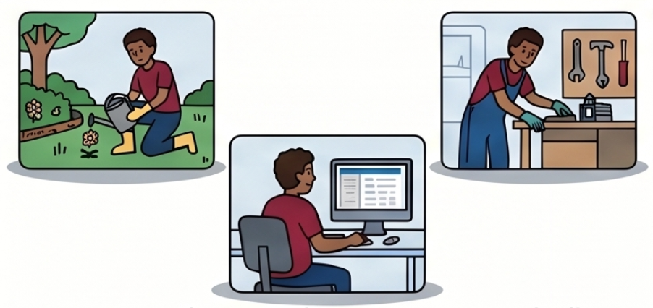
Introduction to Self-Discovery
What is Discovery?
Discovery is a person-centered process designed to help individuals with disabilities find meaningful, well-matched employment. By definition, discovery is the act of uncovering or learning things about yourself that you may not have previously been aware of.
Instead of relying on traditional tests or formal assessments, Discovery focuses on your real life. The goal is to take time to figure out:
- What you enjoy doing and what is important to you.
- Your natural strengths and what you are good at.
- The specific environments and conditions where you do your best work.
- What kinds of support you need to succeed.
There is no “right” job for everyone.
The goal is to find the right job for YOU.
Activity
Answer the following questions:
- What does my best day look like?
- Where am I?
- Who am I with?
- Describe places where you feel your best, this could be at home, your bedroom, your favorite place - describe the space.
- Think about your social media feed, what comes up? That can help give insight into your interests.
Tip: You can sketch what this looks like, write it out, or describe how it sounds!

Facilitator Activities
This module introduces Discovery as a person-centered, strengths-based process aligned with Customized Employment and Employment First principles.
Focus on:
- Replacing deficit-based thinking with strengths-based exploration
- Supporting informed choice and self-determination
- Avoiding premature job matching
- Encouraging real-world observation and relationship building
- Real world observations, experiences - not simulated
This process avoids deficit-based language.
Discovery is a process that honors who you are, no matter how we communicate, no matter what our interests are, you can’t fail Discovery - because it’s learning about you.

What Happens During Discovery?
Discovery is a way to learn about yourself? - what’s important to you? - what do enjoy doing? - What do you need to be at your best? All of these are important questions when considering the type of work you want.
How it Works: Because Discovery is a highly active process, it doesn't involve just sitting in a program or filling out a long list of forms. Instead, you learn about yourself by engaging with your community. During this process, you will:
- Try new activities, and practice real, non-simulated tasks.
- Visit different places, including spaces where you already feel comfortable and new locations that interest you.
- Talk to people, such as family, friends, and businesses, to gather their observations about what you are good at and what environments might fit you best.
What Discovery is NOT:
- It is not a test that you can pass or fail.
- It is not someone else deciding for you what job you should have.

Discovery is Real Life


Not a Traditional Test

Discovery happens in real world settings rather than formal assessments or paperwork.

Ultimately, Discovery replaces traditional evaluations by collecting positive, real-world information to tell a story about who you are, which is then used to direct your search for a job that truly fits you.
For example, your discovery might include seeing you in spaces where you feel comfortable and it can be seeing you in new places that might interest you that you haven’t explored yet.
What happens during Discovery?

The Active Discovery Loop:
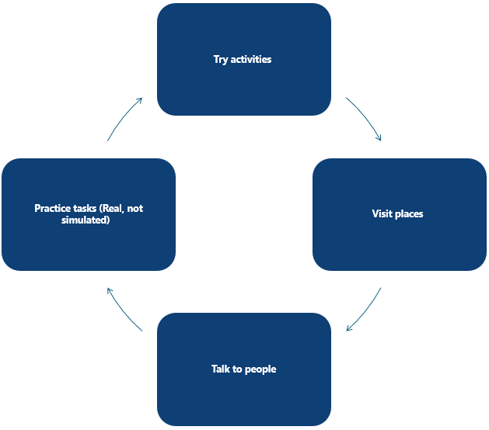

Activity
Try Discovery Yourself!
During Discovery, you will… Try activities, visit places, try new things at those places, talk to people you know and don’t know and practice real tasks. Not pretending or simulated.
If this is not possible to do in the current setting, instead try to think about places and activities that interest you. These should be tied to the interest areas and things learned in the earlier stage.
For example:
Alice likes to organize. She has her room organized using clear plastic containers, there is a method to her organization. She also has books about organizing on her shelf like The Home Edit. An activity for Alice to consider or reach out to might be a professional home organizing service or interior design firm.

Try It Out
And then ask yourself:
What did you like? ________________________________________________________________________
What was hard? ___________________________________________________________________________
What helped you? ________________________________________________________________________
What do you want to know more about? ________________________________________________
Were you smiling when you were there? _________________________________________________
Did time go by quickly? __________________________________________________________________

Facilitator Activities
What is Discovery? Purpose of this Section: Help participants understand what Discovery is, why it matters, and how it supports finding the right job fit.
Key Message for Participants: Discovery is about learning who you are, what you enjoy, and what you need to succeed at work.
Facilitator Talking Points- Introduce Discovery (Plain Language): Discovery is a way to learn about yourself. It helps answer questions like
- What is important to you?
- What do you enjoy doing?
- What do you need to be at your best?
Facilitator Tip: Pause and ask participants to reflect on one of these questions before moving on.
Define Discovery: Discovery means learning or uncovering things about yourself that you may not have known before. It is an active process, not something that just happens on paper.
Say to participants:
“Discovery is about finding new things about yourself—not just writing down what you already know.”
Clarify What Discovery Is NOT: Discovery is not a formal test or assessment. It is not just paperwork or forms. It is not a report filled with deficits or limitations. Instead: It tells your story. It focuses on strengths, interests, and possibilities. It should feel positive and personal.
Facilitator Tip: You may want to say:
“If it feels like a checklist or a test, we’re not doing Discovery the right way.”
Emphasize Storytelling: Discovery should result in a story about the person: Who they are, what they enjoy, and what they need in a workplace.
Facilitator Prompt:
“What are some things you would want someone to know about you before hiring you?”
What Does Discovery Look Like? (Make it Concrete) Give visual pictures/video
Facilitator Tip:
Use real-life examples when possible (home, community, hobbies, volunteering).
What Happens During Discovery?
Tell Participants: “During Discovery, you will…Try activities, visit places, try new things at those places, talk to people you know and don’t know and practice real tasks and not pretend or simulated.

Building a Support System:

Who is on Your Team?
Remember, you do not have to navigate your employment journey alone. Building a career is easier when you have people who can support and guide you along the way. You may already be working with a teacher, employment specialist, counselor, or another professional who can help you explore careers, develop skills, and connect with employers.
If you have not yet connected with these resources, there are many free programs and services available to help you prepare for, find, and maintain employment.
The most appropriate service will depend on your individual needs and circumstances:
General Job Seekers:
Visit an OhioMeansJobs Center. Every county in Ohio has one, offering resume assistance, skills training, and direct job placement. You can find your nearest location at OhioMeansJobs.com.
https://ohiomeansjobs.ohio.gov/job-seekers/find-a-job/local-help
Individuals with Disabilities:
Opportunities for Ohioans with Disabilities (OOD) provides vocational rehabilitation and job coaching. You can browse OOD-approved providers, filter by location, and view provider success rates using the OOD Provider Search.
https://ood.ohio.gov/information-for-individuals/resources/search-for-a-provider
Developmental Disabilities:
The Ohio Department of Developmental Disabilities (DODD) funds individualized employment support through county boards. Your service and support administrator (SSA) can authorize a certified employment provider to help you with job development. Learn more through Ohio Employment First.
https://ohioemploymentfirst.org/job-seekers
Mental Health Support:
The Ohio Department of Mental Health and Addiction Services (OhioMHAS) utilizes evidence-based supported employment (IPS) to help individuals with serious mental health conditions find and keep jobs. You can consult your local regional consultant by using the Ohio Department of Behavior Health’s IPS Providers Contact List.
https://dbh.ohio.gov/community-partners/employment/documents/employ-ohio-ips-providers-contact-list
When it comes to learning about yourself, sometimes the best insights come from the people who know you best. As part of the Discovery process, you are not expected to figure everything out on your own. Building a support team — made up of people who care about you and know you well — is one of the most important steps in finding the right job.
In this section, we will look at how to interview the people in your life so that their observations and perspectives can help paint a fuller, more accurate picture of who you are, what you are good at, and where you might thrive at work.
When it comes to building your team, you can choose people to support you, like:
- These people help you—but you are the leader.
Some people in your life may be paid to help you, like staff or service providers. They can be an important part of your team. It is also important to have people in your life who are not paid to be there, like friends, family, neighbors, or other people you trust. Having both kinds of support is an important part of life.
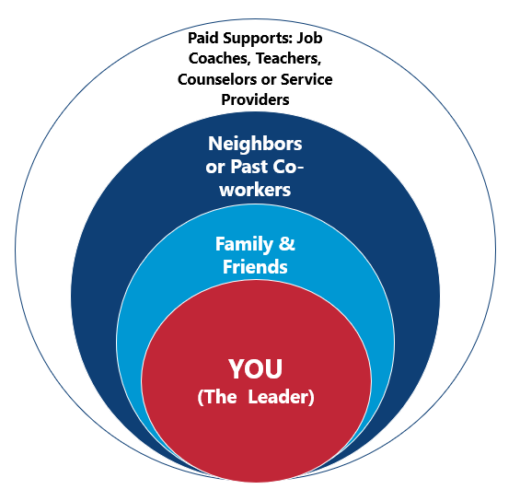
Your team can include many different people. It may also include other people with disabilities. What matters most is that the people on your team believe in you and want to support you.
Your team is not there to decide whether you should work. The goal is to help figure out what kind of job or work setting fits you best. Together, your team can help think about what environment feels right for you and how to support you in reaching your employment goal.
Activity
Connecting With Others Who Know You Well
Who are the people who love you most? Who else knows about your likes and dislikes? Has anyone ever said you would be good at something? We can often learn from those who care about us through their observations of us.
After collecting that information, are there themes or consistencies in the information you learned from your loved ones? For example, did they share that you are always connecting with other people? That you naturally greet others every Sunday at church, or that you love hosting parties? This might reflect that you are at your best when interacting with others and helping them feel welcome.

Facilitator Activities
Encourage:
- Balanced team composition
- Avoiding over-dominance by paid professionals
- Including people who know the individual in different settings
It is important to notice when a person’s team is made up primarily of paid staff. That can be a signal that we need to be intentional about helping the person build relationships with people who are not paid to be in their life, because that is an important part of a full and meaningful life. Team members may also include other people with disabilities.
The only requirement for being part of the team is a shared commitment to supporting the individual. The purpose of the team is not to debate whether the person wants to work. Instead, the focus should be on identifying the setting, environment, and conditions that will help this person be successful, and how the team can work together to support them in reaching that goal.

Worksheet


My Team Map
Instructions:
- Pick Your Team Think about the people in your life who know you best. This can be family members, friends, or professionals who support you. Write their names down on the worksheet. During the Discovery process, it is important to talk to people who know you well to learn more about your strengths and what you are good at.
- Add Their Contact Info Next to each person's name, write down how you can reach them. This could be their phone number or email address.
- Write Down How They Can Help Think about what each person on your team can do to support your job search. Write this next to their contact info. For example, a team member could help you:
- Try out new activities or practice real tasks.
- Visit new places that interest you.
- Answer questions about when they are most proud of you or where you are at your best.
- Lead Your Team! Remember, you are the most important person in this process. Your voice, your choices, and your goals matter most. Your team is just there to support the choices you make!

My Team Map
Name | Contact Information | What do they help you with? | Do you want them involved?

Connecting With Others:

They Don’t Know You, Yet!
Talking to Businesses
After gathering insights from the people who know you best, the next step is to start looking for patterns in what you have learned. What keeps coming up? What themes stand out about your strengths, interests, and the way you work best? Once you have a sense of those themes, you can begin thinking about the kinds of businesses and jobs in your community where those same qualities show up every day. This is where your story starts to connect with the world of work.
In Discovery, we also connect by talking to people who work in businesses. This is called an informational interview. It is not a job interview—it is a chance to learn. You can ask people about what they do, what tasks are important in their job, and what they enjoy about their work. This helps you understand different kinds of work and what might be a good fit for you.

A Theme is Not a Job Description
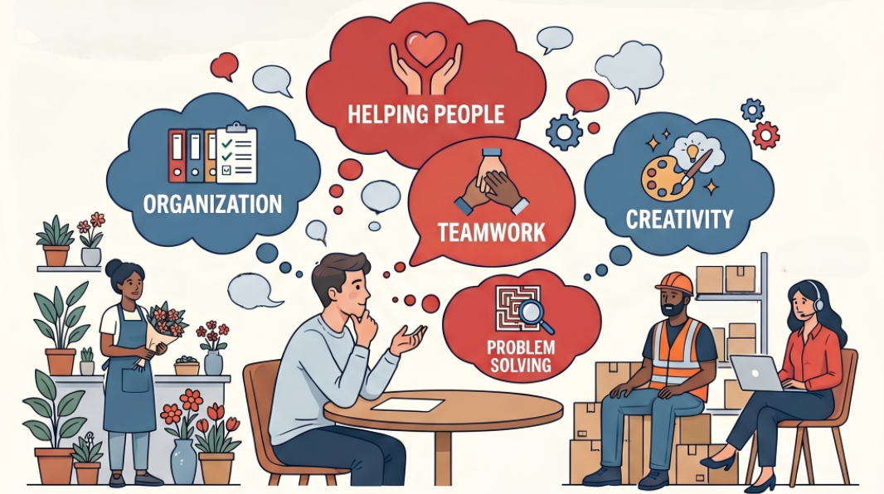
One of the most common questions a person can answer is: What do you do? When we talk to people about jobs they do and ask them what they enjoy about it, they often will not give you tasks that are on their job description but aspects of work that are most rewarding and often special to them.
As you talk with different businesses, pay attention to what stands out to you. What tasks sound interesting? What work environments feel right? After a few conversations, look for patterns.
For example, you might notice you are most interested in jobs where you help customers, organize materials, or work as part of a team. Try not to focus on specific job titles yet—focus on the themes or common ideas you are learning about the kind of work that fits you best.
Vocational themes are big ideas about the kind of work you like.
When we rely on job descriptions too early, it limits our thinking. Instead of trying to match to a standard job requirement, your individual theme helps translate natural strengths into powerful contributions. For example, shifting from a basic statement like "I like working with people" to a more meaningful theme like "I love creating spaces where people feel welcomed and heard".
Themes can also open up possibilities. If a person's theme is "Organization," you don't just look for a filing job description. Instead, you brainstorm real places in the community where people share that same passion for organizing, such as an interior design office, a professional organizing business, or a party planner's office.
By focusing on these overarching themes and the rewarding aspects of work, you will discover environments where will naturally thrive, rather than trying to fit into the narrow box of a traditional job description.
Connecting the information: As mentioned before, it’s important not to make the jump to thinking in job descriptions. Job descriptions are outlines of jobs that encompass many different skills and often when we compare ourselves to a job description we immediately think, “I’m not sure if I can do that” or “I’m not sure I meet those requirements.” The truth is companies are always hiring, you just have to be the right fit, help them make money and be successful.

Facilitator Activities
In this section, support the individual in understanding that Discovery happens through multiple ways of learning—not just self-reflection, but also through the perspectives of others. Guide them to identify people who know them well and have seen them at their best (e.g., family, friends, teachers, coworkers). Facilitate conversations or interviews with these individuals to gather observations about strengths, preferences, and natural abilities. Emphasize that these insights are valuable data points in the Discovery process.
As information is gathered, help the individual look for patterns or consistencies across what others share. Encourage discussion around repeated themes (e.g., connecting with others, organizing, helping, creating) without translating them into specific job titles too quickly. Your role is to help surface broad vocational themes that reflect how the person naturally contributes and engages, which will later guide customized employment strategies.
After gathering input from people who know the individual well, support them in identifying emerging themes and beginning to connect those themes to real work in the community. Guide the individual to think about businesses or settings where those themes may be present. Introduce informational interviews as a key Discovery activity—these are not job interviews, but opportunities to learn about tasks, environments, and workplace expectations directly from employers and employees. Provide support in identifying potential businesses, preparing simple questions, and facilitating or accompanying the conversation as needed.
As informational interviews occur, help the individual reflect on what stood out. Prompt them to consider which tasks were interesting, what environments felt like a good fit, and what conditions seemed to support success. Assist them in identifying patterns across multiple conversations, reinforcing broad vocational themes rather than narrowing prematurely to specific job titles. Document these insights clearly, as they will inform vocational themes, conditions for employment, and next steps in customized job development.
Have participants talk to those loved ones again, this time sharing the consistencies that came up such creating a welcoming environment. Have them ask their contact, who can they think of in their community who has a similar interest that we could talk to? If this is in a group setting, look for consistencies in the group members. Consider bringing in speakers or ideally going to them (in small groups) to have individual conversations.

Worksheet
Finding Places That Match Your Themes
Instructions:
- Pick Your Top 3 Themes Think about the things you are good at and enjoy the most. Pick 2 or 3 "big ideas" (themes) to focus on.
- Think About Where Those Themes Happen Where do people who share your interests work? Remember, do not worry about a specific job title or job description right now. Just think about the kinds of places where your theme is happening every day.

Example:
My Theme: Organization (I love sorting and arranging things).
Places where people organize things:
  - An interior design office
  - A professional organizer's business
  - A party planner's office
Tip: Try to name specific local places, like "Main Street Event Planning" or "The City Library" instead of just general ideas!)

Working with Animals | Organization | Helping Others
Independent pet grooming studios — small, owner-operated shops focused on personalized care for pets and their owners. | Professional home organizers — small, independent businesses that help people declutter and create functional, beautiful living spaces. | Independent tutoring and learning centers — small, locally run spaces where educators help students build confidence and skills one person at a time.
Boutique veterinary or holistic animal wellness clinics — smaller practices where staff build real relationships with animals and their families. | Boutique moving and settling-in services — locally owned companies that not only move belongings but help clients get fully organized in their new home. | Boutique wellness and massage studios — small, independently owned spaces focused on personalized care and helping clients feel their best.
Local dog training studios — hands-on work helping animals learn and supporting owners through the process. | Independent bookshops — small stores where organizing inventory, displays, and special orders is a labor of love. | Local yoga and fitness studios— community-centered spaces where instructors guide and support people toward their health goals.
Independent pet supply and nutrition shops — locally owned stores where staff guide customers in choosing the best products for their animals. | Local flower and floral design studios — artisan shops where organizing supplies, arrangements, and orders keeps everything running smoothly. | Artisan coffee shops and cafes— neighborhood gathering spots where regulars are known by name and the atmosphere is built around connection and hospitality.

Finding Places That Match Your Themes
Theme 1: | Theme 2: | Theme 3:

Create a Positive Personal Profile
No one can fail Discovery. The process of finding a job can take time. By identifying your themes and getting hands on experience with working you will start to visualize yourself in certain roles in your community.
All the information you gather during Discovery is captured in a Positive Personal Profile. This profile acts as a summary of who you are, documenting:
- Dreams and Interests: What you are passionate about and what your dream life looks like in 3 to 5 years.
- Talents and Preferences: Your natural gifts, learning styles, values, and environmental preferences (e.g., working alone vs. with people, indoors vs. outdoors).
- Dislikes and Challenges: "Dealbreakers" or jobs you would hate, along with any specific challenges you face, and the solutions or accommodations needed to overcome them.
- Support System: The people you go to for help and advice (your "Team Map").

Facilitator Activities
This section helps the student begin to conceptualize and inventory their own strengths and support needs. This step is essential in implementing a student-centered, strengths-based approach to career planning. You can use a tool like TransCen’s Positive Personal Profile (see information below) to document the skills inventory and use it to drive creation of post-school and annual goals on the IEP.
TransCen’s Positive Personal Profile
Transition professionals can’t facilitate employment for a student based on what they can’t do but rather based on what they can do – the skills, strengths and aptitudes a person brings to the process. The TransCen Positive Personal Profile (PPP) allows you to take a strengths-based approach to career planning. The PPP is a one-page inventory of all the positive things about a person relating to life goals and employment.
The PPP can jumpstart the discovery process in employment and pinpoint key areas for additional exploration and skills building. The Profile is a collaborative tool which is most useful when multiple people who know the student best contribute to it. Information on the PPP can be shared across all interagency partners and be used to help students develop eye-catching resumes and prepare for interviews.
For more of TransCen’s free transition and employment facilitation tools visit:
https://www.transcen.org/training-ta/resources/
TransCen’s Positive Personal Profile
https://www.youtube.com/watch?v=QplMbA5SRLo

Worksheet
Positive Personal Profile
Instructions: To fill out the Positive Personal Profile, you will use it as a worksheet to summarize all the rich information you gathered during the active Discovery process.
Think of this document as a snapshot of who you are.
Once your Positive Personal Profile is filled out, you will have a focused guide that helps you move into the next phase: looking for jobs that actually fit you, meeting with real employers, and trying out different job tasks. Finding a job is more than just filling out applications, it's about discovering your strengths, exploring your interests, and creating a plan for your future. This guide is designed to help you take the next steps toward employment by giving you the tools and activities needed to build a successful career path.
As you continue to work through these modules and activities, you will learn more about the types of jobs that match your interests, and the skills employers are looking for. You will explore different careers, research workplaces, connect with professionals, and identify the training or education you may need to reach your goals. The goal is to take a personalized approach to employment by matching unique personality traits with locally owned professional opportunities.
Remember, discovery is a journey, and it's okay if your goals change as you gain new experiences. The most important thing is to keep exploring, learning, and moving forward toward a job and career that is right for you.

Positive Personal Profile
Name: ___________________________________ Date: _______________________________________
Dreams and Goals: What do you really want to learn or do? What is your dream job? What do you hope your life looks like in 3 to 5 years? | Interests: What activities are you enthusiastic about? Do you have hobbies? What are your passions?
Talents, Skills and Knowledge: What are you good at? What are your natural gifts? | Learning Styles: How do you learn best? Tell me about a thing you have learned successfully
Values: What is important to you? What are your passions? What guides your life? | Positive Personality Traits: What do people compliment you on? What makes you a good friend?
Environmental Preferences: Do you prefer to work alone? With people? Outdoors or indoors? In a silent place or noisy? | Dislikes: What types of jobs would you hate? What kinds of things do you not like doing? Any “deal-breakers” or things that make you mad?
Work Experiences: Talk about your previous places you worked. What did you learn there? | Support System: Who do you go to for help? Who do you look to for advice?
Specific Challenges: Are certain things troublesome or hard for you? What might impact your success in the community or at work? | Solutions and Accommodations: How do you deal with or overcome these difficulties?
Career Ideas, Community Connections and Possibilities to Explore:

Setting Your Employment Goal
The most critical first step is defining a personal employment goal to act as a guide for your search. By investigating local businesses and identifying the specific skills required for various roles, you can align your interests with the needs of your community. Ultimately, we aim to reduce stress and increase success by providing a structured framework for exploring options and getting organized.
Start with YOUR Employment Goal.
Deciding on a job goal is an active "adventure" that provides you with a clear map for your job search, making it easier to know what to do next. Building on the self-discovery process and using some tools to sort through this preparation makes the actual job search much less stressful and set you up for success when it comes to start applying.
Some steps that you can take today to help you decide:
- Reflect on your strengths and interests: refer to your Positive Personal Profile - take your themes from Discovery, and ask yourself what you’re good at, what you enjoy doing and what makes you feel happy? For example: What environments you like to be in, and what interactions with others do you want to have?
- Future Planning: Future planning involves looking ahead 5 to 10 years and asking yourself what you dream of doing and what you want your life to look like. Part of future planning is understanding that you do not need to have all the skills for your dream job right now, because skills can be learned. To make the process less overwhelming, it is helpful to establish both short-term and long-term goals, keeping in mind the important reminder that your "first job" does not have to be your "forever job"
- Talk with your Support Team: Share your ideas with the people who know you well. They can help you brainstorm new career ideas and figure out the next actionable steps.
- Look Around Your Community: Find businesses that match your goal and interests. These might be good places for you to work. Create your List of 10.
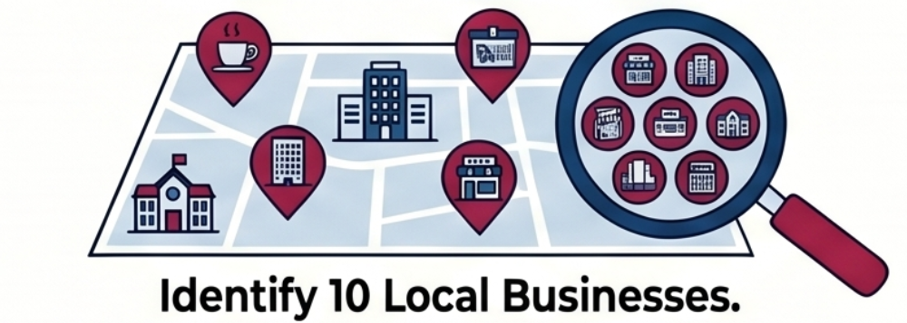

Use the Tools provided: Take advantage of career-matching tools like the Career One Stop: Work Values Matcher on the GetMyFuture website or the O*Net Interest Profilers. These resources will help you identify your work Values and Explore careers that align with your profile.
GetMyFuture website: https://www.careeronestop.org/GetMyFuture/default.aspx
O*Net Interest Profiler: https://onetinterestprofiler.org/

Activity
Create Your List of 10
Community Business Exploration
The best way to learn about jobs is to look around your community and see what businesses are there. This activity will help you learn about different workplaces and find places where you might like to work someday.
Instructions: Use the transportation you have available to you. You can walk, ride a bike, take a bus, get a ride, or drive. Look around your community and make a list of 10 businesses or organizations that you would like to learn more about that match your specific theme - Finding Places That Match Your Themes.
After completing this activity, it is natural to think about applying for these jobs and diving into the Job Search. Before you do this, we would encourage you to learn more about benefits services and supports that can also help you understand your specific situation with your money and what you may be able to qualify for.
Note: Everyone’s situation is different. One person's benefits may seem similar to another, but it's important to understand your own. The following module will discuss in more detail about what options you have.

Create Your List of 10
For each business, answer the questions below.
Business Information
1. Business Name
What is the name of the business?

2. Location
Where is the business located?

3. What Interests Me?
What caught your attention about this business?

What do you like about it?

4. Why Is It on My List?
Why do you want to learn more about this business?

5. Jobs at This Business
What jobs do you think people do here?

6. How Do People Apply for Jobs?
Can you apply online?

Can you apply in person?

Where can you find information about jobs?

7. Who Do I Know Here?
Do you know anyone who works here?

Does a friend, family member, teacher, or neighbor know someone who works here?

When You Are Finished
Look back at your list of 10 businesses and think about these questions:
Which businesses interest you the most?
What do they have in common?
What kinds of work do you seem to like?
Which 3 businesses would you like to learn more about?
Remember: You are not looking for the perfect job right now. You are learning about your community and discovering places where your interests and strengths might be a good fit.
Facilitator Activities
Clarify misconceptions:
- Not compliance-driven
- Not assessment-heavy
- Not time-limited artificially
- Not job placement
“Before we go any further, it’s really important that we talk about what Discovery is not.
A lot of people come into this process with past experiences — things like tests, evaluations, or programs where someone else was making decisions about them.
Discovery is different. And naming that clearly helps set the right expectations for everyone in the room.”
Core Content (Walk Through Each Point)
“Discovery is not a test you pass or fail.
There is no score. There is no grade. There is no outcome where someone says, ‘you did well’ or ‘you didn’t.’
In fact, no one can fail Discovery.”
“Discovery is not a long list of forms.
Yes, there may be some documentation along the way, but the purpose is not paperwork — it’s understanding the person.
If it starts to feel like paperwork is the focus, we’ve likely moved away from true Discovery.”

“Discovery is not someone deciding for you.
This is not a process where professionals observe and then make decisions about the person.
Instead, it’s about learning with the person — understanding their strengths, preferences, and what helps them be successful.”
“Discovery is not a program you sit in.
It’s not something that happens in a classroom or only in an office.
Discovery is active. It happens in real life — in homes, in communities, in places where the person is comfortable and where their strengths naturally show up.”
Reframe: What Discovery Actually Is
“Discovery is active.
It involves doing, trying, exploring, and noticing.”
“Discovery is about your real life — not a simulated environment, not a test setting, not a checklist.
We want to see people at their best, in spaces that are real and meaningful to them.”
Contrast with Traditional Assessment
“Many of us are familiar with traditional assessments.
Assessments often involve:
- A set of questions
- A structured format
- And then results that help someone else make a decision
Sometimes those assessments don’t fully capture a person — especially when they don’t reflect someone at their best.”
“Discovery is different.
Instead of asking, ‘How did you score?’
We’re asking, ‘Who are you when you’re at your best?’”
Key Message (Anchor Statement)
“Discovery is a qualitative process.
That means:
- We are gathering stories
- Observations
- Patterns
- Real experiences
Not numbers or scores.”
“And because of that —
No one can fail Discovery.”
Closing the Section
“When an assessment doesn’t capture someone accurately — when it misses their strengths or doesn’t reflect who they really are —
Discovery can take the place of that traditional assessment.
It allows us to build a much fuller, more accurate picture of the person.”

Module 2 Resources

Videos
TransCen’s Positive Personal Profile
https://www.youtube.com/watch?v=QplMbA5SRLo

Worksheets
Try Discovery Yourself – Activity – Module 2.1
My Team Map – Worksheet – Module 2.2
Finding Places that Match Your Theme – Worksheet – Module 2.3
Positive Personal Profile – Worksheet – Module 2.4
Create Your List of 10 – Activity – Module 2.5

Additional Resources
OhioMeansJobs Find a Job Center Tool
https://ohiomeansjobs.ohio.gov/job-seekers/find-a-job/local-help
Opportunities for Ohioans with Disabilities (OOD) Provider Search Tool
https://ood.ohio.gov/information-for-individuals/resources/search-for-a-provider

Ohio Employment First for Job Seekers
https://ohioemploymentfirst.org/job-seekers
Ohio Department of Behavior Health’s IPS Providers Contact List
https://dbh.ohio.gov/community-partners/employment/documents/employ-ohio-ips-providers-contact-list
Career One Stop: Work Values Matcher
https://www.careeronestop.org/GetMyFuture/default.aspx
O*Net Interest Profilers
https://onetinterestprofiler.org/
TransCen’s free transition and employment facilitation tools
https://www.transcen.org/training-ta/resources/

Benefits Planning
The following module will provide you with an introduction to disability benefits and how working and benefits can go together. It doesn’t have to be one or the other. Many people worry that if they go to work, they will immediately lose their benefits, healthcare, or supports. The good news is that there are rules and programs called work incentives that are designed to help people work safely and gradually.
This module will help you learn:
- The difference between SSI and SSDI
- How work may affect your benefits
- What supports and work incentives are available
- Why benefits planning is important
- Who can help you make informed decisions about work
Benefits planning can feel confusing at first because there are a lot of new words, acronyms, and rules. That is normal. You are not expected to figure this out alone. This module is meant to introduce the basics in plain language and help you understand that work and benefits can work together.

Consult a Certified Professional

Work with a Certified Benefits Planner to create a personalized employment roadmap.
Everyone’s situation is different. Some people may work part-time. Some may work full-time. Some may try and work slowly over time. The important thing to remember is that earning more money through work can often help you have more choices, more independence, and more total income overall.
As you move through this module, remember:
- Asking questions is okay
- It is okay to take your time learning
- Benefits planning is personal to you
- Working does not automatically mean losing everything
There are trained professionals, including Certified Benefits Planners, who can help you understand your specific benefits and make a plan that works for you.

Facilitator Activities
In this section, we are going to talk about why benefits planning matters when someone is thinking about getting a job or increasing their work hours.
Getting a job can be a really positive and exciting step. Work can help a person earn money, build new skills, meet people, and have more independence. For many people, work is also connected to pride, purpose, and being more involved in their community.
At the same time, many adults with disabilities receive public benefits that are very important to their daily lives. These may include Social Security disability benefits, such as SSI or SSDI, Medicaid, food assistance, housing assistance, or other supports.
Because these benefits are so important, it is very common for people and their families to feel nervous about work. They may ask questions like:
- “What will happen to my benefits if I get a job?”
- “Will I lose my Medicaid?”
- “What if I make too much money?”
- “What if I try working and it does not work out?”
- “Who can help me understand all of this?”
These are very real concerns. As staff, it is important that we do not dismiss those fears or give quick answers that may not be accurate. Benefits rules can be complicated, and every person’s situation is different.
The most important message in this section is this: You can work and have access to your benefits - let's continue to learn more.

The Benefits Planning Process
The benefits planning process is a personalized, and often free, service designed to help you understand how employment will impact your public benefits, such as Supplemental Security Income (SSI), Social Security Disability Insurance (SSDI), Medicaid, and food assistance.
You may or may not already receive benefits like:
- Federal Disability Benefits (such as SSDI or SSI) - a monthly check that helps you cover your basic expenses such as shelter
- Medicaid or Medicare - this is health insurance that gives you access to medical professionals - like going to the doctor
- Food Assistance - this is support to purchase food
All of these benefits listed are benefits or entitlements to help people with disabilities and those who have little income or resources.
Because the rules and acronyms can feel overwhelming, the primary goal is to relieve fears about losing benefits and to help you as a job seeker try working safely and gradually using "work incentives". We strongly advise against guessing; instead, let’s begin the planning process before starting a job, increasing hours, or accepting a raise.

Activity
Understanding Common Fears About Work and Benefits
Starting a job can bring excitement, but it can also bring questions and concerns.
This activity will help you think about any worries you or your family may have about employment and identify information or support that could help. “What are some fears you or your family may have when you start working?”
If you need ideas to get started, consider whether you have concerns about:
- Losing SSI or SSDI
- Losing Medicaid
- Losing food assistance
- Losing housing support
- Not knowing what to report
- Getting an overpayment
- Not being able to get benefits back if the job ends
- Family members being afraid to take a risk
- Not knowing who to ask for help
- I can only work part time
Fear and uncertainty can sometimes prevent you from exploring employment opportunities. Learning about benefits, work incentives, and available supports can help make informed choices with greater confidence.
Changes happen gradually
Benefits usually change slowly, not all at once.
Working does not mean your benefits automatically stop right away; instead, there are programs called "work incentives" designed to help you try working safely and gradually while maintaining healthcare and support.
Confronting the Fear of the Workplace
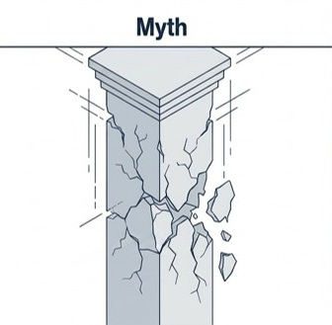
Myth: working means an immediate loss of all benefits and healthcare.

Reality: Social Security provides structured safety nets that allow you to work, earn more, and maintain essential support.

Benefits Planning Query and Analysis (BPQY)
There is a report that you can request from Social Security that will confirm what benefits you receive. It’s called ‘Benefits Planning Query and Analysis'. You can request your BPQY using the following steps.
You must request the BPQY for yourself or provide a signed consent form asking for the release of the BPQY to a third party, like a representative payee, family member, or friend. The Benefits Planning Query Handbook has sample consent forms and text. If you plan to have the BPQY released to a third party, you should use the sample text when filling out the forms.
https://www.ssa.gov/disabilityresearch/documents/BPQY_Handbook.pdf

Did You Know?
You can:
- Work part-time or full-time
- Keep Medicaid (health care) in many cases
- Use special programs to protect your benefits

Securing Professional Help.
If you are looking for assistance with public benefits (like Medicaid, SSI, or SSDI) and employment, credentialed professionals known as Work Incentive Coordinators (CWIC) or WIP-C™ certified planners to help you navigate how working impacts your benefits. Or if you think you qualify and would like to learn more.
Several regional organizations and state-affiliated programs in Ohio offer expert guidance to ensure you keep your essential benefits while transitioning into employment:
- Disability Rights Ohio: Administers statewide WIPA (Work Incentives Planning and Assistance) services. Call their intake department at 1-800-282-9181.
- Legal Aid Society of Greater Cincinnati: Provides statewide technical assistance and direct WIPA services for many Ohio counties. Reach them at 1-800-582-2682.
- Ticket to Work Help Line: A national Social Security resource where trained benefits planners can assist with your job plan. Call 1-866-968-7842.
- Ohio Department of Behavioral Health: Partners with Cornell University to train planners holding the WIP-C™ credential. Visit the Ohio DBH Work Incentives and Benefit Planning
https://dbh.ohio.gov/community-partners/employment/work-incentives-and-benefit-planning

Facilitator Activities
In this section, reassure participants that working does not usually mean benefits stop right away. Many public benefit programs include rules that allow people with disabilities to try work, earn income, and often keep important health care coverage like Medicaid.
Emphasize that benefits usually change gradually, not all at once. This can help reduce fear for job seekers and families. Let participants know that each person’s situation is different, so it is important to ask for a benefits analysis before starting a job, increasing hours, or making major work changes or reach out to a certified benefits planner which we will discuss later in the content.
A helpful message to repeat is:
Work can change benefits, but work does not automatically end benefits. With the right information and planning, people can often work, earn more money, and keep needed supports.

Information Gathering
Gathering accurate information about your specific benefits is a critical early step. Because the Social Security Administration (SSA) manages different programs, you should determine exactly what you receive before you can plan effectively.
Understanding the "House of Social Security Disability Benefits”
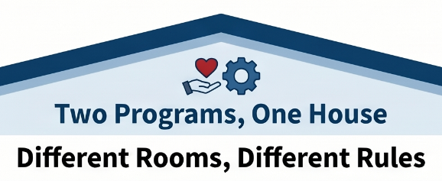
A key part of information gathering is learning that the SSA manages both Supplemental Security Income (SSI) and Title II programs like Social Security Disability Insurance (SSDI). Think of it as a house with two different rooms and two different sets of rules.
Gathering the correct information about which "room" you belong to is essential, because the work rules will differ depending on the benefit you receive. For individuals needing more basic information to start this process, there are videos specifically designed to help answer "What is SSI?" and "What is SSDI?"
YouTube Link: What is SSI? https://www.youtube.com/watch?v=ercXb8lfSbI
YouTube Link: What is SSDI? https://www.youtube.com/watch?v=7oq-Ecu9UZA

SSI: Supplemental Security Income
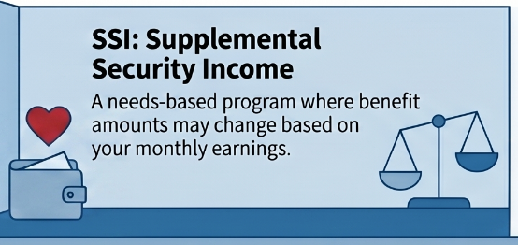
A needs-based program where benefit amounts may change based on your monthly earnings.

SSDI: Social Security Disability Insurance
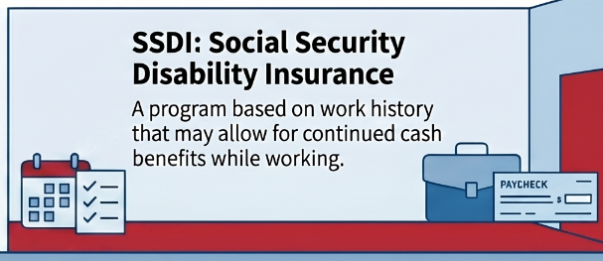
A program based on work history that may allow for continued cash benefits while working.
If you receive SSI or SSDI:
- Your benefits may change based on how much you earn
- You may still receive some cash benefits (SSI or SSDI) while working

When you learn about how work affects these benefits, you will find out these simple facts:
- You will usually have more money: If you work and earn money, your benefit checks might change. For example, your SSI check might go down, but you can still receive some cash benefits while working. Because of your paychecks, you will almost always have more total money overall.
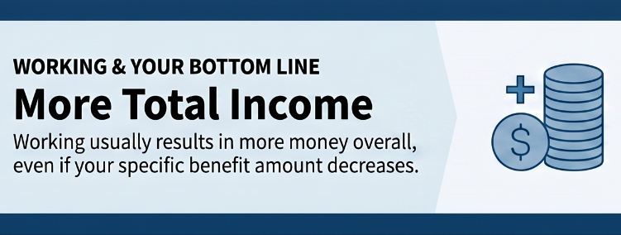
- You can keep your health care: Many people worry about losing health insurance, like Medicaid, if they get a job. The good news is that you can usually keep your Medicaid while working. There are special programs, like the Medicaid Buy-In, that make sure you stay covered so you can still pay for your doctor and your support staff.
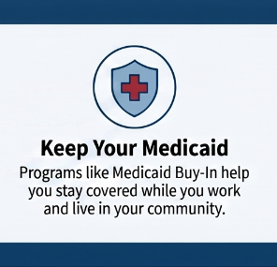
- You can still get help with food: Your food assistance (SNAP) might change when you start earning money, but you might still qualify to get help buying food.
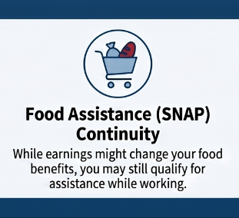
The most important takeaway is simple: working usually means you have MORE money overall, even if some of your individual benefits change.

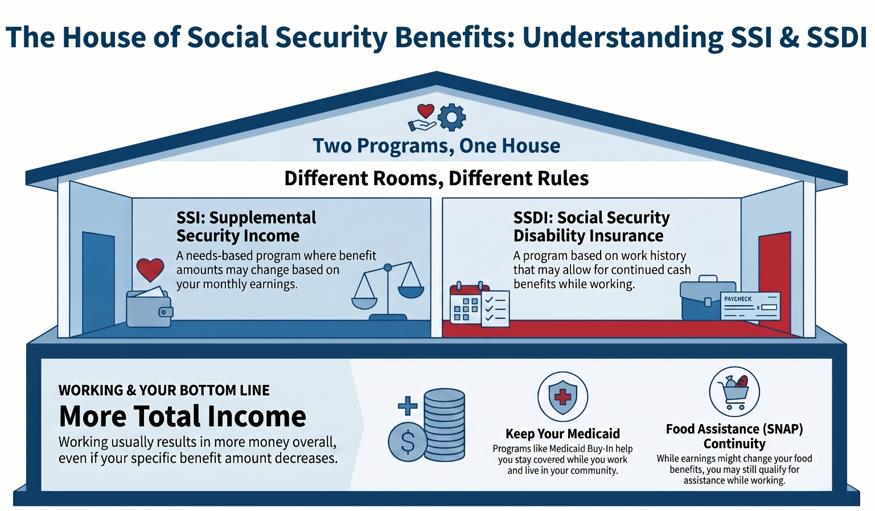

Facilitator Activities
In this section, we are talking about SSDI work incentives. SSDI is different from SSI. SSDI is based on a person’s work history, or sometimes a parent’s work history, not financial need in the same way SSI is. Because of that, the work rules are different.
A key message for job seekers and families is: Working does not automatically mean SSDI stops right away.
Social Security has work incentives that allow people to test work. The Trial Work Period allows SSDI beneficiaries to try working for a period of time while continuing to receive their SSDI payment, as long as they report their work and continue to meet disability requirements.
After that, the Extended Period of Eligibility provides another layer of protection. During this period, Social Security looks at the person’s earnings to decide whether an SSDI payment is due for that month.
NOTE: **As facilitators, we should not try to calculate SSDI work incentives unless we are trained benefits planners. Our role is to explain that work incentives exist, reduce fear, and help the person request benefits planning.**
A good way to say this is: “SSDI has work incentives that may let you try working without your benefits ending right away. The rules can be confusing, so before you start working or change your hours, we should help you connect with a benefits planner who can look at your specific situation.”
Facilitator reminder: Encourage the person to report wages, keep copies of pay stubs and Social Security notices, and ask for benefits planning early. The Social Security Red Book is a key reference for SSDI and SSI work incentives (will cover reporting later).

In this section, we are talking about SSI work incentives. SSI is different from SSDI. SSI is based on financial need, so wages from work can affect the person’s monthly SSI payment.
A key message for job seekers and families is:
Working may lower the SSI check, but it does not automatically mean the person will have less money overall.
Social Security does not count all earned income the same way it counts unearned income. Some wages are excluded before Social Security calculates the person’s SSI payment. Because of this, many people who receive SSI can work and have more total monthly income.
SSI work incentives may include supports such as:
Earned Income Exclusion: Social Security does not count all of a person’s wages when figuring SSI. Essentially, for every $2 you make SSA will reduce your check by $1
PASS Plan: A Plan to Achieve Self-Support may allow a person to set aside income or resources for a work goal.
1619(b): Some people can keep Medicaid even when their earnings are high enough that their SSI cash payment stops. This means you get to keep your Medicaid and work.
As facilitators, we should not try to calculate someone’s SSI unless we are trained benefits planners. Our role is to explain that work incentives exist, reduce fear, and help the person request benefits planning. Please use DB101 website SSI calculator.
A good way to say this is:
“SSI has rules that can help people work and still keep important supports. Your SSI check may change when you earn wages, but that does not automatically mean you will be worse off. Before you start working or change your hours, we should connect you with a benefits planner who can look at your specific situation.”
Facilitator reminder: Encourage the person to report wages, keep copies of pay stubs and Social Security notices, and ask for benefits planning early.

State Benefits in Ohio
Rather than describe benefits using confusing acronyms It helps to focus on benefits that are specific to what each program can do for everyday life. In addition to the two federal benefits SSDI and SSI, you may also receive Medicaid (health insurance), Food Assistance (SNAP), or Ohio Works First (OWF).
The Core Support Programs:
SSI and SSDI: As discussed in Module 3.2 - Information Gathering, these are federal benefits and act as foundational support programs that provide you with necessary cash benefits while still ensuring that choosing to work will put more money in your pocket.
Supplemental Nutrition Assistance Program (SNAP): This is food assistance. It helps people with low incomes buy healthy food. If you start working and earning money, your food benefits might change, but you can often still qualify for some help
https://benefits.ohio.gov/home/resources/assistance-programs/01-snap
Ohio Works First (OWF): is the financial assistance portion of the state's Temporary Assistance to Needy Families (TANF) program. It provides cash benefits to eligible families for up to 36 months.
https://benefits.ohio.gov/home/resources/assistance-programs/02-cash
Ohio Medicaid: and related programs improve wellness and health outcomes by providing health care coverage for eligible individuals.
https://benefits.ohio.gov/home/resources/assistance-programs/03-medicaid
These programs can help support you while you work toward your goals. In Ohio, you can learn about and manage your benefits online through:
benefits.ohio.gov
This is an online hub where you can:
- Use a self-assessment tool to quickly check what kind of help you might be eligible for.
- Apply for food, cash, medical, or childcare assistance.
- Upload your verification documents directly from your smartphone.
- Sign up for text reminders so you can easily report changes to your food assistance right from your phone.

Need Help Understanding Your Benefits?
You do not have to figure this out alone. If you want help understanding your state benefits or how work may affect them, you can contact your local County Department of Job and Family Services (CDJFS).
https://jfs.ohio.gov/job-services-and-unemployment/job-services

How Do I Know What Benefits I Receive?
You’ve now taken in a lot of information thus far!
It is helpful to know what benefit you receive - let’s take a look at a resource available in Ohio that is here to help you navigate this very question.
The website is: Disability Benefits 101, or DB101.
DB101 can help you learn more about benefits, work, and health care. Let’s start with checking out the web page titled: “What Benefits Do I Get?”
https://oh.db101.org/oh/programs/income_support/which_benefits/
This page can help you start figuring out what benefits you may receive from Social Security or from the state of Ohio. DB101 explains that Social Security has two main disability benefits: SSDI, which is based on work history, and SSI, which is needs based - meaning in little to no income or resources. Both can provide monthly payments to people with disabilities.

Facilitator Activities
As we talk about work and benefits, it’s important for participants to understand that there are state benefits available that can help support them while they pursue employment and independence.
In Ohio, some common state benefits include:
- Medicaid, which helps with healthcare coverage
- Food Assistance, also called SNAP
- Ohio Works First, or OWF
A helpful tool for managing these benefits is the Ohio Benefits website at benefits.ohio.gov. Participants can use this site to:
- Apply for benefits
- Renew benefits
- Report changes
- Upload paperwork
- Check the status of their case
It’s also important to remind participants that they do not have to figure this out alone. Many people feel nervous or overwhelmed when trying to understand how work may affect their benefits. That is normal.
If someone needs direct help understanding their benefits situation, encourage them to contact their local County Department of Job and Family Services, also called CDJFS.

The Importance of Getting Assistance
The major theme you may have noticed is that you are not expected to figure this out on your own. The rules of Social Security are complicated! However, professional assistance is built into this system to give you personalized guidance so you can transition to work safely and confidently.

Who Can Help?
The most highly trained experts in this field are Certified Benefits Planners or Community Work Incentives Coordinators (CWICs). You can typically connect with them through:
State Vocational Rehabilitation (VR) agencies: such as Opportunities for Ohioans with Disabilities (OOD).
WIPA Programs: The Social Security Administration funds Work Incentives Planning and Assistance (WIPA) projects, such as Disability Rights Ohio and Disability Rights Iowa, which employ these experts. Click here to access Disability Rights Ohio guide to benefits planning that’s available where you live.
https://www.disabilityrightsohio.org/benefits-counseling
Local County Agencies: For specific state benefits, like food assistance or Medicaid, you can also get help from a county caseworker at the Department of Job and Family Services.
It’s important to connect with an expert – ask for a Certified Benefits Planner and use the DB101 Site to connect with local experts to help you navigate your benefits.
https://oh.db101.org/planners.htm
What Do Professionals Do?
These experts provide counseling that is typically free and customized to your specific situation. They work with you to help you request and interpret your Benefits Planning Query and Analysis (BPQY), which is an official report from Social Security confirming what benefits you get. Explain exactly how working will impact your SSI, SSDI, Medicaid, or food assistance. Help you apply special "work incentives that allow you to safely test out working while keeping your safety net.

Calculating the Impact of Work
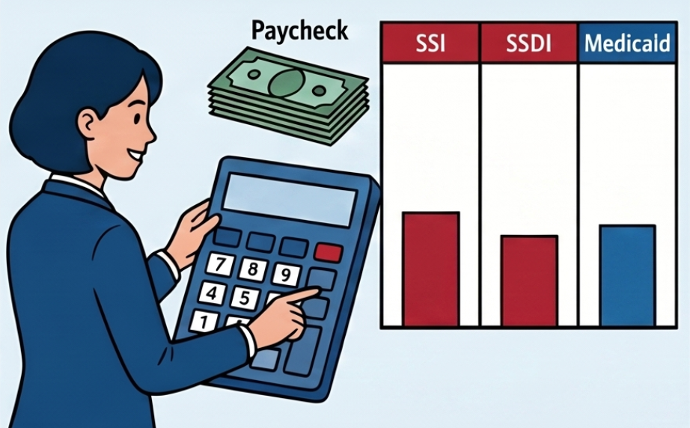
These certified benefits planners and CWICs will explain exactly how earning a paycheck changes your SSI, SSDI, and Madicaid.
The Importance of Certification
The rules surrounding disability benefits are complex, and bad information can cause people to unnecessarily fear losing their healthcare or income. To prevent this, professional assistance is highly regulated. Planners must pass rigorous training and certification programs through Virginia Commonwealth University (VCU) or Cornell University. This specialized training ensures they are giving you accurate advice and not reinforcing dangerous myths.
The Red Book is a general reference tool designed to provide a working knowledge of the employment support provisions for individuals with disabilities under the SSDI and SSI programs. The Red Book is primarily for educators, advocates, rehabilitation professionals, and counselors who serve persons with disabilities. It is also expected that applicants and beneficiaries will use it as a self-help guide.
Its purpose is to provide a working knowledge of our work incentives so that users can advise individuals with disabilities appropriately and recognize when to seek case-specific guidance from SSA. The Red Book is available online at: www.socialsecurity.gov/redbook/

The Golden Rule
"Do Not Guess" Above all, when it comes to your benefits, you should never guess. You should always reach out to a professional before you start a new job, increase your hours, or accept a raise so you know exactly what to expect.


Let’s look closer!
Who is one person you could ask for help if you had a question about your benefits? Possible answers may include:

- Benefits planner
- OOD counselor
- Case manager
- Employment specialist
- Family member or trusted supporter
- Social Security office
- DB101 website

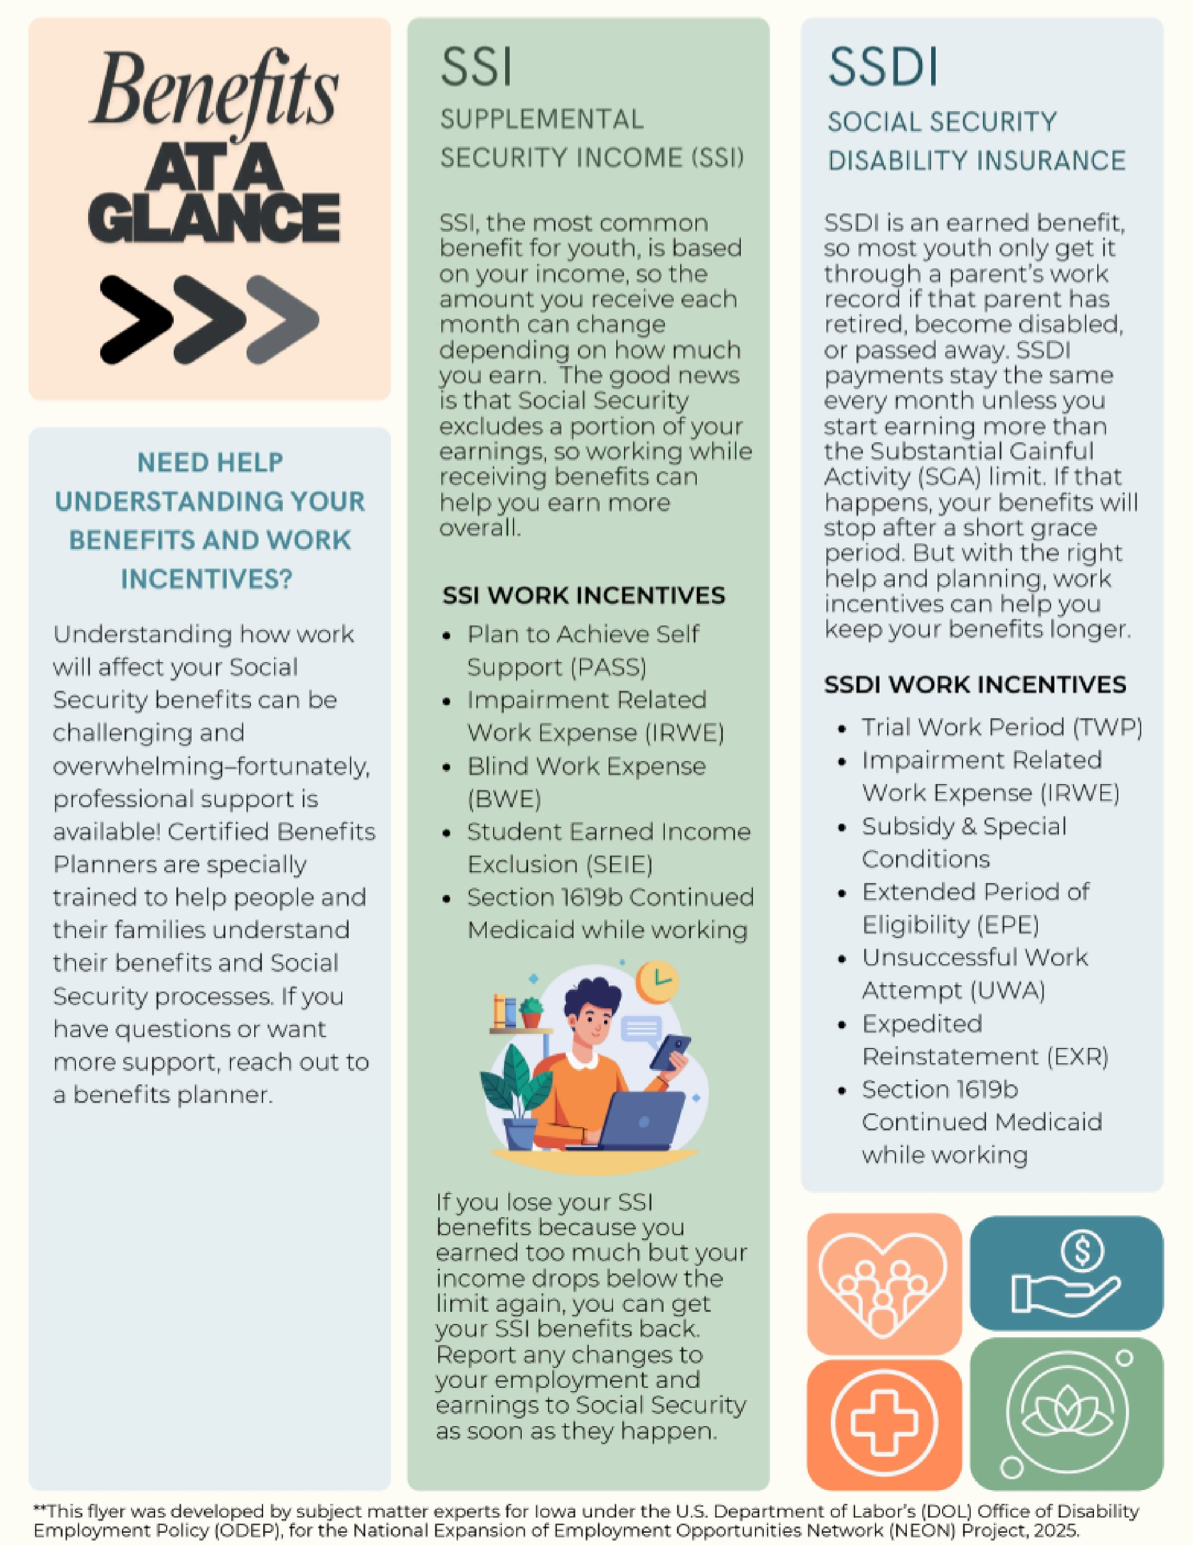
Facilitator Activities
When discussing SSDI, emphasize that SSDI is an earned benefit connected to work history and that there are work incentives designed to support people in trying employment safely. Explain that Social Security reviews earnings over time and that there are steps and protections built into the process.
This is also a good opportunity to remind participants that every situation is different. Encourage individuals and families to connect with a Certified Benefits Planner so they can understand how work may impact their own benefits and healthcare coverage.
We often hear people say, “If I go to work, I can only work part-time or I’ll lose my benefits.” This is a very common fear, especially for individuals receiving SSDI.
Part of this misunderstanding comes from the fact that SSDI is considered more of an “all or nothing” benefit. Unlike SSI, which changes gradually as income changes because it is needs-based, SSDI benefits generally do not reduce little by little. Instead, Social Security looks at whether a person is working above a level called Substantial Gainful Activity (SGA).
If a person consistently earns above the SGA level, Social Security may view this as the individual becoming more financially independent through work. At that point, the person may begin using SSDI work incentives and protections that are built into the program to support employment transitions.
This process can feel overwhelming, and facilitators do not need to become benefits experts. The most important takeaway is helping individuals and families understand that many of the things they hear about benefits and work are incomplete, outdated, or simply not true.
Encourage participants to ask questions, report wages, and connect with a Certified Benefits Planner who can explain how work may impact their specific situation.

Active Steps to Begin Implementing Your Benefits Plan
After you have prepared, gathered information, and consulted with professionals, it’s time to put your plan into action. Applying for, managing, and updating your benefits change along with you. As you grow in your job, start living on your own, or get married.
All of life’s milestones may trigger an action that you will need to take on your own behalf. There are tools to help:
- Use the Ohio Benefits Self-Service Portal www.benefits.ohio.gov to officially apply for or renew your state benefits. By logging in securely with an OHID, you can access programs like Medicaid (health insurance), SNAP (food assistance), Ohio Works First (cash assistance), and Early Care and Education Services. The state has modernized this implementation step by introducing E-Signature, which makes applying over the phone with a caseworker much easier and faster.
- Provide Necessary Documentation: As part of implementing your benefits plan, you will be required to verify your information. The Ohio portal allows you to easily upload verification documents directly from your smartphone, even while you are on the phone with an agent.
- Reporting Changes in Income: A critical ongoing step in the benefits planning process is reporting your earnings once you start a job or your hours change. You can report these changes directly within your Ohio Benefits account. To make this step even easier, Ohio recently introduced SNAP text reminders, which allow you to report changes to your food assistance case directly from your phone.
- Getting Hands-On County Help: We can’t stress this enough, implementing these steps can still be confusing, but you do not have to figure it out alone. To successfully execute your benefits plan, you are encouraged to find and contact your local County Department of Job and Family Services (CDJFS). These county agencies can help you navigate the system, understand how your new job affects your state benefits, and assist you with your cash, food, medical, and childcare assistance cases.

ABLE Accounts in Ohio
An ABLE account is a special savings account that lets people with disabilities save and spend money without risking the benefits they depend on. The name stands for Achieving a Better Life Experience, and that's exactly what it's meant to do.
In Ohio, ABLE accounts are offered through a program called STABLE Account, one of the first programs of its kind in the country. You can use the money in your account for a wide range of everyday needs, including housing, transportation, education, health care, and more.
https://stableaccount.com/
Here's why it matters:
Normally, if you receive SSI or Medicaid, you can only have a small amount of money in savings; often as little as $2,000. With an ABLE account, you can save up to $100,000 or more without it counting against those limits.
You don't need a background in finance to understand this. We'll walk through everything step by step, so you can make the best decision for your own life.


STABLE Accounts How to Save Money and Keep Your Benefits
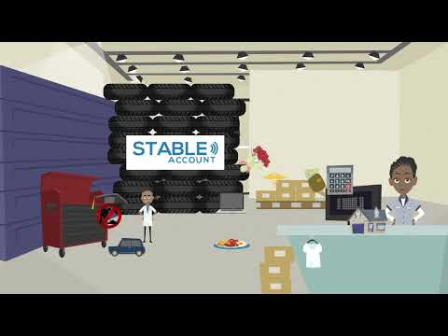
YouTube Link: https://youtu.be/gBHlDGZip5w?si=oDDfbifXVExztQ4A
The country's first ABLE program: Ohio's STABLE Account
On June 1st, 2016, STABLE, Ohio’s ABLE program, was the first ABLE account program in the country to open to the public. Ohioans and other people with disabilities nationwide can open STABLE accounts and get all of the benefits that ABLE accounts offer.
Click here for more information on STABLE Accounts.
https://oh.db101.org/oh/situations/workandbenefits/assets/program.able.htm

Facilitator Activities
You do not need to be a benefits expert to lead this session. That is not your role here.
Your role is to show up as someone who believes in the people in this room — and to help them understand that the system has more room in it than they've been told.
Many of the people joining today have heard the same thing over and over: "You can only have $2,000." Their families have heard it. Their case managers have repeated it. And it's not wrong — but it's not the whole picture.
What's often missing from that conversation is this: there are intentional tools built into the system to help people with disabilities save money, go to work, and still keep their benefits. Things like work incentives and Ohio STABLE accounts exist specifically because policymakers knew that $2,000 wasn't enough — and they built safety nets on purpose.
You don't need to know every rule. You don't need to have all the answers. What you need to do is open a door — and help people see that asking questions and exploring options is safe. Point them toward benefits counselors, the STABLE Account team, and other experts who can walk them through their specific situation.
Your job today is reassurance. The expertise will come from the right people at the right time.
Families and supporters often carry a great deal of responsibility and worry when it comes to benefits. For many families, benefits have represented stability, healthcare, and safety for years. Because of that, conversations about work can bring up fear, anxiety, or past negative experiences.
It is important to acknowledge those concerns without reinforcing myths. Many people have heard messages like, “If you work, you’ll lose everything,” when in reality benefits systems are often much more gradual and flexible than people realize.
As facilitators, we want to help families shift from a fear-based mindset to an informed decision-making mindset. Encourage families to ask questions, explore options slowly, and connect with benefits experts rather than relying on stories or assumptions.
Remind participants that they do not need to become benefits experts themselves. The purpose of this discussion is to help people understand that work and benefits can often exist together and that planning and support are available throughout the process.
Discussion Questions
- What are your biggest concerns about benefits and work?
- What have you heard about working while receiving benefits?
- What information would help you feel more confident?
- How can supporters encourage exploration while still helping someone feel safe and supported?

Module 3 Resources

Videos
What is SSI?
https://www.youtube.com/watch?v=ercXb8lfSbI
Gathering the correct information about which program fits your needs is essential, because the work rules will differ depending on the benefit you receive. For individuals needing more basic information to start this process, this video will help to answer some questions.
What is SSDI?
https://www.youtube.com/watch?v=7oq-Ecu9UZA
Gathering the correct information about which program fits your needs is essential, because the work rules will differ depending on the benefit you receive. For individuals needing more basic information to start this process, this video will help to answer some questions.

Additional Resources
The House of Social Security Disability Benefits – Module 3.2
Benefits Planning Query and Analysis (BPQY) Handbook
https://www.ssa.gov/disabilityresearch/documents/BPQY_Handbook.pdf
Disability Benefits 101 – “What Benefits Do I Get?”
https://oh.db101.org/oh/programs/income_support/which_benefits/

Disability Benefits 101 – Certified Benefits Planners
https://oh.db101.org/planners.htm
Benefits at a Glance – Module 3.4

Job Seeker’s Journey: From Networking to Getting Hired
What’s Next
The following module will serve as a comprehensive guide for navigating the employment landscape, ranging from initial preparation to post-interview follow-up. We will highlight the importance of utilizing local state agencies, like those in Ohio, to access career training and specialized support for families and job seekers. Detailed instructions are provided for creating a master job application and using digital tracking tools to organize deadlines, contacts, and interview stages.
Additionally, the activities and resources offer practical advice for managing the emotional aspects of a job search, such as staying positive after rejection and building confidence through mock interviews. Together, these resources equip you with strategies and technical skills necessary to secure a new position successfully.
Now it’s time to take the next steps: finding jobs and getting hired.
In this module, you will learn how to:
- Use your personal Network - people you know - to connect with employers
- Find and apply for jobs
- Talk about your skills and make a strong impression during an interview

Facilitator Activities
This module is about moving from planning to action. Jobseekers may feel excited, nervous or unsure. Your role is to build confidence, create opportunities to practice and help them manage their job search.
Start by acknowledging that talking to employers can feel uncomfortable– and let the job seeker know that lots of people feel this way– but with practice- it gets easier.
Break the job search process down into small steps. Focus on one step or activity at a time.
Find ways to make it real- not just talking about it at a table or worksheets: Role playing an interview; practice introductions and shaking hands; Practice doing an online job search on Indeed; Visit a business and talk with a manager; set up mock interviews.

How Do I Connect With Employers?
Connecting to employers may be one of the more exciting parts about a job search. While doing this, you’re learning about what is in your community, what types of jobs exist, and the potential new opportunities that could be behind the next job you apply for. Before you go to the local shop down the street to ask for an application; take a few steps back and start here.
It’s simply two phases:
Phase 1: Tell People You Are Looking for a Job
One of the best ways to start looking for a job is to start with PEOPLE YOU KNOW - your family and friends might know people who can help you connect with businesses.
Share your job goals with them. Connecting with people you already know can uncover potential opportunities you may not know exist. Who is better to ask what you should do for a job than those who know you best?
What jobs do people in your network do already?
Ask:
“Do you know anyone who works at Company ABC?”
“Can you introduce me?”

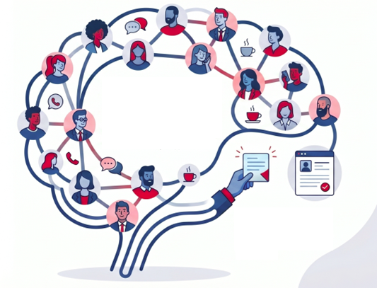
Using the information gained, you can now navigate potential job options more effectively.
Get connected to your community
Volunteering is a good way to connect. When you volunteer, you learn new skills - you can add these to your resume. You also meet new people who can give you reference letters for your portfolio or might be able to help you in your job search.
Try an internship
Internships are an excellent way to learn about a particular job and build your professional skills. You can typically arrange an internship through your school, a vocational counselor, or other educational and workforce programs.
For finding opportunities specifically in Ohio, the state provides OhioMeansJobs (OMJ) Centers in every county. These centers are dedicated to helping job seekers find employment, access job training, and utilize technology like computers and the internet for job hunting. You can visit your local OMJ center to get hands-on assistance or use the OhioMeansJobs website to set up an account, search for open roles in your area, and create job alerts for positions that match your skills.
Click here to access the OhioMeansJobs Career Center Directory.

https://jfs.ohio.gov/about/local-agencies-directory

Activate Your Personal Network

Friends & Family

Tell family, friends and neighbors you are looking for work – they are often the best link to hidden job opportunities!

Visit Businesses in Person

Go to places that interest you, ask to speak with a manager, and be ready to share your resume and explain why you want to work there.

Gain Experience Through Volunteering

Volunteering builds new skills for your resume and helps you meet people who can provide professional reference letters.

Phase 2: Showcase Your Skills
Time to show off. Go to the places that interest you and ask to talk to the manager. Say why you like the business; share your resume; ask if they need workers.

Articulate your specific talents clearly to demonstrate value to the employer.
Be ready to tell them some of your skills and strengths. You have talent and the reason you are in that business is to show them that you can be an asset to them. Let them know what you can do.
Ideally, we want to make a strong impression. You can use some of the skills and activities in this section to help practice and stand out.
Make a Strong Impression

Use interview conversation to build a professional connection and stand out.
Other Connections Opportunities
There are several effective strategies you can use to search for and connect to jobs, ranging from in-person tactics to online tools:
We have mentioned Networking and Direct Business Engagement, but there are more opportunities to connect, engage, and find a place you feel you belong. Job fairs are excellent events for meeting and talking with many different employers all in one place.
Searching for Jobs Online
- Use Job Boards: Set up accounts on hiring websites like Indeed, ZipRecruiter, and Google Jobs. You can search by your desired role, location, or salary, and set up job "alerts" so you are notified when matching jobs are posted.
- Social Media and Professional Sites: Create a profile on LinkedIn or other professional social media sites to find and connect with people working at your target businesses.
- Check Company Websites: Directly visit the websites of the specific companies you have on your target list to look for their open roles.
- Leverage AI and Automation: You can upload your resume to an AI tool and ask it to find job openings in your area that match your skills. Additionally, there are automation platforms, like LoopCV, that can search for listings and even automatically apply to jobs on your behalf.
- Set up an Email Account: You will need this to search for jobs, submit applications, and communicate with employers.
When utilizing these various methods, it is highly recommended to use a spreadsheet or a job application tracker to stay organized. Tracking the company name, role, salary, date applied, and interview stages will help you remember when to follow up and keep you from missing crucial deadline.
Facilitator Activities
Help the job seeker think about the people they know: Family, friends, neighbors, teachers, staff, coaches.
Practice how to ask for help or information. Use Role-playing and simple scripts for job seekers to practice talking about their skills; to people they know or managers:
- “I am good at…” or “I like to…”
- “Hi ____, I’m looking for a job in ____. Do you know anyone who works at ____?”
- “Hi, my name is ____. I’m looking for a job. I’m interested in working here because ____. I am good at ____.”
- Don’t forget to work on smiling and shaking hands and thanking people.
When the job seeker is feeling confident, take them to “test drive” their scripts. Walk into a business and ask to talk to a manager or set up a mock interview with an Employer.

Worksheet
Finding Job Opportunities
Instructions: Use this worksheet as your personal roadmap to organize and track your job search activities.
Step 1: Begin by identifying your job search goals, including the roles you are interested in, your available hours, skills, and transportation should all be considered.
Step 2: Next, brainstorm and list the people in your personal networks, (such as family, friends, or former coworkers) who might know about potential job leads. By using the Networking checklist to ensure you are reaching out to people effectively.
Step 3: As you go out into the community, use the table in this section to record the local businesses you visit in person. Note the date, who you spoke with, what you learned, and when you need to follow up.
Step 4: Assess weekly. This should be a living document that is updated consistently throughout the job searching process. Goals will sometimes change as you learn more about available jobs and meet more people that can help you find the next job for you.

Job Seeker Information
Name: __________________________________________________________
Date Started: ___________________________________________________
Career Interest/Field: __________________________________________
Employment Goal: ____________________________________________

Step 1: Set Your Job Search Goal
Use this section to identify the type of job you are looking for.

My Job Goal
Job Title(s) I am interested in:

Hours I would like to work:
☐ Full-Time
☐ Part-Time
☐ Seasonal
☐ Flexible
Preferred Work Location(s):

Skills and strengths I can offer employers:

Transportation Plan:
☐ Drive myself
☐ Public transportation
☐ Ride from family/friend
☐ Walking
☐ Other: __________________________________________________

Step 2: Identify People in My Network
People in your network can help you learn about job opportunities.
Name | Relationship | Contact Information | How They Can Help | Follow-Up Date
Networking Checklist:
☐ Tell family and friends I am looking for work
☐ Ask teachers, counselors, or job coaches for leads
☐ Connect with former employers or coworkers
☐ Attend job fairs or community events
☐ Practice introducing myself to employers

Step 3: Visit Businesses and Ask About Jobs
Visiting businesses can help you learn about openings and make connections.
Date | Business Name | Person Contacted | What I Learned | Follow-Up Needed
Interview Checklist:
☐ Dress appropriately
☐ Bring copies of resume
☐ Introduce myself confidently
☐ Ask if they are hiring
☐ Ask how to apply
☐ Thank the employer for their time

Action Plan: Goals for Next Week

Worksheet

Job Application Tracker
Instructions: Click the download link below to use this helpful Job Application Tracker tool. It can be opened with Excel or uploaded to Google Drive and opened with Google Sheets. Fill out as many fields as you can, there are dropdown boxes in some fields to help you out.
(Link to download the ‘Job Application Tracker’ tool is part of the online Job Seeker’s Guide)
Here is a sample of how the Job Application Tracker will function:
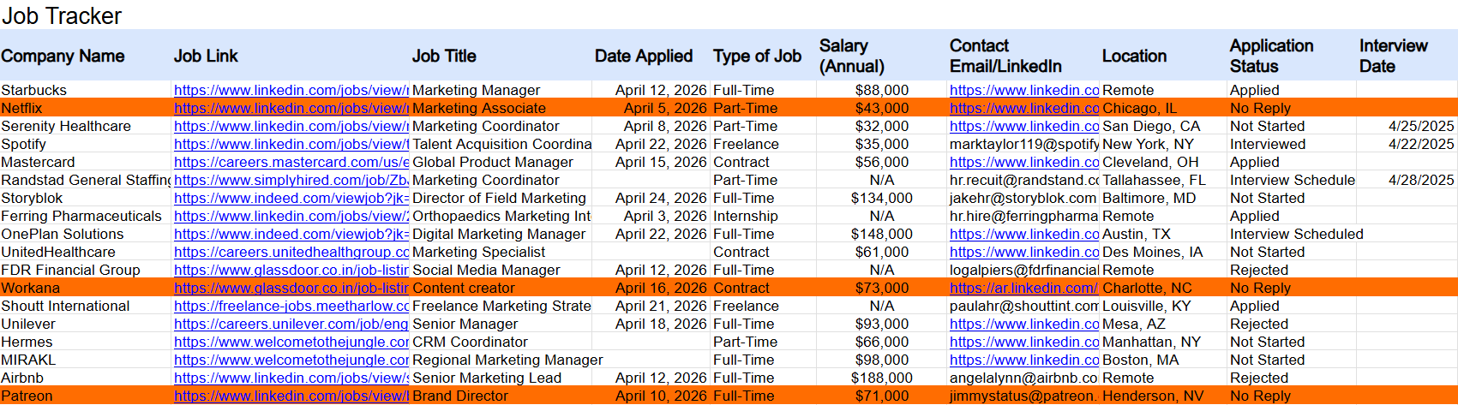

Applying For Jobs
The goal of job seeking is to ultimately become employed. Businesses use applications to track, identify, and review potential candidates for jobs. Applying for jobs can feel like a never-ending process but by using a Master application and having determination you will quicky find that the process will lead to results.
When you find a job that interests you, the next step is to officially apply, which lets the employer know you have the right skills and experience for the role. Job applications can be submitted online or on paper, and they generally require your contact information, educational background, and work history.
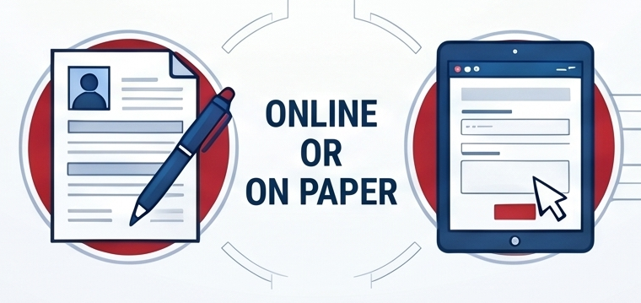
To make the application process much smoother and faster, it is highly recommended to create a Master Job Application. This acts as a central document where you store all your details, meaning you won't have to hunt down dates or rewrite your job duties every time you apply.


 | Essential Contact & Personal Info  Include professional email, reliable phone number, and proof of legal right to work.
 | Education & Training History  List high schools, colleges, and certifications with dates, locations, and specific areas of study.
 | Detailed Work History  Record company names, supervisor contacts, specific job duties, and reasons for leaving each role.

Here is what you should prepare for your applications:
- Personal Information: Use a professional-sounding email address and provide a phone number with a professional voicemail greeting. If an application asks if you have ever been fired, be honest but brief. Do not pass blame; instead, explain what happened, emphasize what you learned, and focus on what will be different moving forward.
- Education and Training: List your high school, any college or career technical courses, certificates, and even relevant workshops or conferences you have attended.
- Experience: Work experience is more than just paid jobs; it also includes volunteering, internships, household chores, and school club activities. When describing what you did, be detailed and use "action verbs" (for example, instead of saying "tutored students," say "tutored a rotating group of students... conveying concepts").
- Skills: Review job announcements to see what employers are looking for and list your matching skills. Be sure to include both job-specific skills (like computer programming or using carpentry tools) and transferrable skills (like time management or written communication).
- References: Prepare a list of professional references, such as former employers, teachers, or coworkers, who can speak positively about your employability. It is best to ask for their permission in writing before listing them on an application
Miscellaneous Checklist
☐ Legal/Eligibility
What to include:
Driver’s license number, work permit (if under 18), and US authorization.
☐ Availability
What to include:
Specific days, hours, and the total hours you can work per week.
Leveraging Ohio Resources for Your Applications
Because many employers require you to apply online and communicate via email, having reliable internet and a computer is essential. If you need technology access, remember that OhioMeansJobs (OMJ) Centers are located in every county across the state. You can visit your local OMJ center to use their computers, internet, and printers for free, and they even offer technology training to help you navigate online applications.

Tracking Your Progress
Before you hit "submit," always have someone proofread your application, as typos or incomplete fields can instantly disqualify you. Once submitted, remember to log the position in the job application tracker we discussed earlier. Be sure to record the exact "Application Date," as this will help you calculate the perfect time to send a follow-up email if you haven't heard back from the hiring manager.

Facilitator Activities
Applying for jobs might be stressful or confusing for your job seeker. They may not have a lot of paid work experience or might not have the exact skills requested. Facilitators should help the job seeker understand that the employer is just trying to get to know a little bit about them– and that you can help them find things to share on their applications.
Show the job seekers a few applications and discuss how they are similar and different. Talk about how to use the job postings to decide what the employer is looking to find. Help the job seeker think about things they may have done that will demonstrate these things.
Complete the Application Template before looking for jobs. Emphasize that this is about you – you have this information. We are just writing it down.

Worksheet

Application Template
This example worksheet is designed to help Ohio job seekers gather and organize information commonly requested on employment applications. Completing a Master Job Application can make applying for jobs faster and easier.

Personal Information
Full Name: ________________________________________________________________________________________________
Street Address, City, State, ZIP Code: _____________________________________________________________________
Phone Number: ___________________________________________________________________________________________
Alternate Phone Number: ________________________________________________________________________________
Professional Email Address: ______________________________________________________________________________
County of Residence: _____________________________________________________________________________________
Emergency Contact: ______________________________________________________________________________________
Languages Spoken: _______________________________________________________________________________________
Do you have a valid Ohio Driver License or State ID?: ____________________________________________________
Are you legally authorized to work in the United States?: ________________________________________________
Have you ever been convicted of a felony? (Explain if required): _________________________________________

Employment Goal
Desired Job Title(s): _______________________________________________________________________________________
Preferred Industry: ________________________________________________________________________________________
Full-Time / Part-Time / Seasonal: _________________________________________________________________________
Preferred Work Schedule: ________________________________________________________________________________
Date Available to Start: ___________________________________________________________________________________
Preferred Ohio Work Location(s): _________________________________________________________________________
Transportation Plan: ______________________________________________________________________________________

Education and Training
High School / GED Program: _____________________________________________________________________________
Ohio Career Technical Center or Vocational Program: ____________________________________________________
Community College or University: ________________________________________________________________________
Certificates or Licenses Earned: ___________________________________________________________________________
OhioMeansJobs Training Programs: ______________________________________________________________________
Apprenticeships or Workforce Credentials: _______________________________________________________________

Work Experience
Employer | Job Title | Dates Worked | Supervisor | Duties | Reason for Leaving

Volunteer and Community Experience
Include volunteer work, internships, church/community involvement, or school activities that demonstrate responsibility and job skills.
__________________________________________________________________________________________
__________________________________________________________________________________________
__________________________________________________________________________________________
__________________________________________________________________________________________
__________________________________________________________________________________________
__________________________________________________________________________________________

Skills
☐ Customer Service
☐ Computer Skills
☐ Communication
☐ Teamwork
☐ Time Management
☐ Problem Solving
☐ Equipment or Machinery Experience
☐ Other Job-Related Skills
__________________________________________________________________________________________
__________________________________________________________________________________________
__________________________________________________________________________________________

References
Name | Relationship | Phone | Email

Ohio Job Search Resources
- OhioMeansJobs Centers
- OhioMeansJobs.com
- Opportunities for Ohioans with Disabilities (OOD)
- Local Workforce Development Boards
- Community Colleges and Career Centers

Application Tips
- Use a professional email address and voicemail greeting.
- Keep copies of resumes, certifications, and references.
- Review applications carefully before submitting.
- Follow up with employers after applying.
- Dress professionally for interviews and business visits.

Mastering the Interview Process
A practical approach to the interview process requires preparation, planning, and self-reflection. Success often depends on the steps you take to align your personal skills, experiences, and strengths with the responsibilities of the position. It is also important to research the company’s mission, values, and culture while preparing yourself for the interview experience and the expectations of the role.
This resource will provide a structured toolkit including rehearsal techniques and organizational lists, designed to help you make a lasting, positive impression.

From Preparation to Placement: The Interview Success Guide
Landing an interview is an exciting next step after submitting your applications! It is completely natural to feel anxious beforehand; in fact, being nervous is okay and normal.
To help manage those nerves and make a strong impression, it is highly recommended to "script out" and practice your answers to the questions you are most likely to hear.
Pre-interview preparation
A question Employers often ask is:
“Why do you want to work here?”
Be ready to answer this question. Look at the company’s website or if possible, go into the business. Make a list of the things you like about the business. It could range from location, lighting, friendliness, the business mission or even the products they sell. Study them and explain why you want the position
Another very common question (if not the most often question asked to another person):
“Tell me about yourself?”
When scripting your response to this, be sure to include your career goals and how they relate to the business you are interviewing with.
Learn as much as you can about the job
Make a list of the job duties and the skills they want. Use your resume to think about your skills and experiences and how they relate. Make a list of the things you have done and what you know how to do.
When scripting your answers, always remember to tailor your responses to reflect the specific needs and skills the business is looking for.

Research the Business & Role

Study the company website and job duties to explain why you want the position.
The Mirror Tip (practice makes perfect!)
Once you know what you want to say, practice makes perfect. A great strategy to relax and build confidence is to practice answering your questions out loud in front of a mirror.
While you are practicing in the mirror, remember to smile! It is actually hard to stay nervous when you are smiling, and a genuine smile will help you introduce yourself professionally when you finally shake the interviewer's hand. Additionally, you are allowed to bring the lists you made about the company and your skills with you to the interview to help you stay calm and focused.
Script Your Success

Practice answers for “Tell me about yourself” and “What is your biggest weakness?”

Ace Your Job Interview
This instructional video provides a step-by-step guide for a successful job interview - including tips on body language. It lists common questions and explains how to handle nerves and stay positive throughout the entire search process.
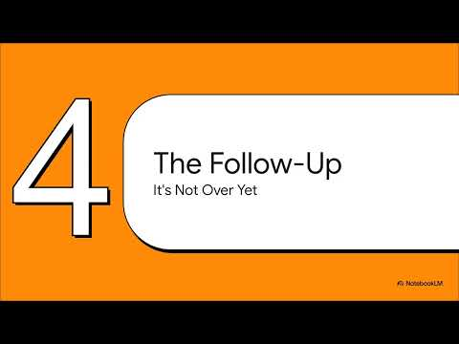
YouTube Link: https://youtu.be/JFV8bKrQI7A

Let’s Get Ready to Interview!
To successfully navigate a job interview, job seekers must prioritize professional etiquette and active engagement from the initial greeting to the final follow up. You know what you’re good at. Present your skills and your history while using thoughtful questions to demonstrate your interest in the role - be sure to remain confident.
Bring Your Portfolio

Share your resume and specific examples of your skills and household or work experience.
Beyond the interview itself this process requires persistence and patience. Specifically when you are sending thank you notes and while your managing you own expectations durring the employers decision making process.
Master the professional intro

Smile, introduce yourself clearly, and offer a professional handshake to build rapport.
Start with a confident body language, this include standing up straight, introducing your self by name, offering a strong handshake and remember to smile! To clearly communicate your value without getting flustered, prepare a short, customizable script.
A great template to use is:
“Hi, my name is ____. I’m looking for a job. I’m interested in working here because ____. I am good at ____.”.
When scripting your introduction, which is a great way to prepare for the "tell me about yourself" interview question, be sure to include your career goals and tailor your response to reflect the specific needs of the business you are speaking with.
Be sure to practice and “test drive” your introduction. The best way to master your deliver is to practice it repeatedly. Role play with your family and friends or go back to the mirror. This will help it feel more natural. When you built up that confidence you can take it out for a spin with a local business and ask to speak to a manager and introduce yourself in person.
Mock Interview Simulator
Try out this Mock Interview Simulator to test your skills! Make sure to pause when the video says to, so you can have a chance to answer the questions! Unpause when you’re done for a few quick tips.
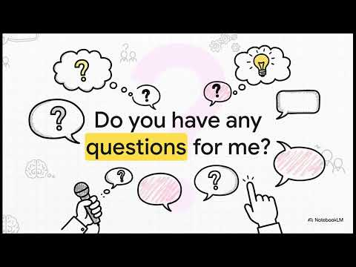
YouTube Link: https://youtu.be/z1FFtXXs2ig
Closing An Interview
Asking questions at the end of an interview is a crucial part of making a strong, professional impression. It is highly recommended that you prepare at least 3 questions to ask the interviewer before you go in.
Prepare Your Questions

Have 3 questions ready for the interviewer about the company or daily responsibilities.
Asking questions is important because it shows the employer that you are genuinely interested in the position and that you took the time to research their business.
When deciding what to ask, your questions can focus on the specific details of the job or on the company as a whole. As you research the company before your interview to learn about their mission, vision, and workplace culture, you can use those details to write down thoughtful questions to bring with you.
To help you prepare, here are three highly recommended questions you can ask during an interview:
"What do the day-to-day responsibilities of this role look like?" This question helps you understand exactly what you will be doing on a typical shift and shows you are eager to understand the practical expectations of the job.
"What are the most important qualities for someone to be successful in this position?" Asking this demonstrates that you are focused on doing a great job and want to know how the employer measures success. It also gives you a chance to briefly remind them of how your skills match those qualities.
"Can you tell me a little bit about the company culture or the team I would be working with?" This shows you care about being a good fit for their work environment and helps you figure out if it is a place where you would be happy working.
The absolute best questions are often the ones you write down yourself while researching the company's website before the interview!
Following Up: Please Say “Thank You”.
When it comes to the follow up process after an interview, the action you should take next is to send a Thank you email to the person you met. This will help reinforce your interest in the position.
The Power of Thank You

Send a follow-up thank you email to the interviewer immediately after the meeting.
Following the thank you, expect to wait. A waiting period is completely normal because the employer may have lots of other “applicants” to review and they need time to get through those meetings to decide who to hire. Be prepared, it may take a few weeks before you hear back from them.
Waiting can be hard, but by keeping your job application tracker up to date with the dates of your interview and a follow up email can help you stay organized and manage your stress while you wait for a decision. Keep checking in and keep interviewing. Sometimes it takes a few no’s to find that right fit for you.

Facilitator Activities
Start preparing the job seeker by “researching the business”. Visit the company website with the job seeker and talk about what the company does - how big it is, show pictures of the products or people that work there.
Look at the job posting and talk about the job – and skills they are looking for.
Discuss the job seeker’s skills and strengths – Which ones are important for this employer.
Make a list of the skills to talk about and any relevant experience the job seeker has. Support the job seeker to tailor their resume and portfolio for the business
Script out/practice what the person can say when asked: “tell me about yourself?” or “what is your biggest weakness?” Be sure to include the career goal - and how it relates to the business. Tailor answers to reflect the needs of the business.
Role-play and practice answers.
Talk about hygiene and appearance - “do’s and don’ts”. Discuss how to dress for this business – have them show you the outfit they will wear.
Support the jobseeker to find technology that may be needed to help them “share their story” or communicate easily with the interviewer.
Share strategies to deal with nerves and jitters.
Practice, practice, practice!

Navigating the Job Offer and Career Steps
Receiving a job offer is the exciting culmination of all your networking, applying, and interviewing efforts! When an employer has finally finished interviewing all applicants and made their decision to hire, you have hit your final steps to your job seeking journey.
Here are some final steps to help you navigate the last of your journey:
- If you’re using a Job Application Tracker, make sure to log your offer: When you receive an offer, the very first step is to record the details in the "Offer" column of your job application tracker. Keeping your spreadsheet updated allows you to see the final results of your interview rounds and keeps all your job search statistics organized in one accessible place.
- Evaluating and accepting the offer: Once you receive the offer, you do not have to say "yes" immediately. It is standard practice to ask for a day or two to review the salary, benefits, and schedule to ensure it is the right fit for you. If the offer doesn't quite meet your expectations, this is the stage where you can professionally negotiate your compensation before officially accepting the position and signing any paperwork.
- What to do if the answer is "No": It is important to remember that finding a job is not easy, and dealing with rejection letters is a normal part of the process. If you do not get the offer, do not be discouraged. Try to view the interview as a valuable opportunity where you practiced your professional skills and learned more about what businesses are looking for. You can even use the experience to reflect on how to make yourself the perfect candidate for the next opportunity, such as by taking vocational classes or volunteering to build your skills.
The most important takeaway is to stay positive and keep hunting. Keep practicing your introductions, keep talking to people in your network, and keep applying!

Facilitator Activities
Debrief with the job seeker after the interview - What was easy? What was hard? What did they learn?
Keep the job seeker engaged and searching for other opportunities while they wait to hear.
Dealing with rejection can be hard. Help job seekers understand and process when they do not get a position. Remind the job seeker that every interview is an opportunity to practice and learn what businesses need. Point out things the job seeker did well - any small successes.
Discuss potential reasons why the job seeker may not have gotten the position. Are there things that can be done to make them the perfect candidate? Do they need more practice interviewing? Do they have the qualifications and skills required for the job? Provide guidance and suggestions for building qualifications: volunteering, vocational classes to build current skills; or adjusting the career plan or short-term goal.
Remind the job seeker that they are not alone. Lots of people are looking for work - and that rejection letters are part of the process. But the key is to stay positive and keep actively looking and keep working their network. Something will pop.

Finding a Job is Not Easy
Stay positive.
Keep talking to employers and everyone you know.
Keep practicing your interviewing skills.
It gets easier and easier to talk about yourself and your skills.
Keep hunting!
Keep looking. Keep applying. Great jobs are out there.
Get Ready with Me

YouTube Link: https://youtu.be/VaL8gGCM4wk

Module 4 Resources

Worksheets
Finding Job Opportunities Worksheet – Module 4.1
Job Application Tracker Worksheet – Module 4.1
Job Application Tracker Tool – Module 4.1
(Available through online Job Seeker’s Guide)
Application Template Worksheet – Module 4.2

Videos
Ace Your Job Interview
https://youtu.be/JFV8bKrQI7A
This instructional video provides a step-by-step guide for a successful job interview - including tips on body language. It lists common questions and explains how to handle nerves and stay positive throughout the entire search process.

Mock Interview Simulator
https://youtu.be/z1FFtXXs2ig
Try out this Mock Interview Simulator to test your skills! Make sure to pause when the video says to, so you can have a chance to answer the questions! Unpause when you’re done for a few quick tips.
Get Ready with Me
https://youtu.be/VaL8gGCM4wk

Navigating the Modern Job Search
The modern world moves fast. It can feel like there is always a new website, app, password, or technology to learn. Many of us use technology every day to communicate with friends and family, watch videos, shop online, or find directions. Today, technology also plays a major role in finding and getting a job.
Not long ago, job seekers walked into businesses, filled out paper applications, and handed employers a printed resume. Today, most employers use online job boards, company websites, and digital application systems. This shift has created new opportunities, but it also means that job seekers need new skills.
The Digital Shift

Modern employers now prioritize online job boards and digital applications systems over paper.
Digital literacy means being able to use technology confidently and safely. This includes creating and saving documents, using email, searching for jobs online, completing online applications, and using a smartphone or computer to communicate with employers. Learning these skills takes practice, but they are now an important part of almost every job search.
Technology can also be a powerful tool for preparing for work. There are apps that help build resumes, organize job searches, practice interviews, and improve workplace skills. Some tools use artificial intelligence (AI) to provide feedback, simulate interviews, or suggest jobs that match your interests and skills. Assistive Technology can help people with disabilities access information, communicate more effectively, and complete tasks independently.
At the same time, technology is not perfect. Many employers use automated systems and AI programs to review resumes and screen applicants before a person ever sees the application. These systems can sometimes overlook qualified candidates. Understanding how these tools work can help you present your skills more effectively and avoid common mistakes.
Technology should help open doors, not create barriers. As a job seeker, you have rights. Employers must provide reasonable accommodations during the hiring process, including online assessments and interviews. If a digital tool, online application, or hiring system is difficult to access because of a disability, you can request an accommodation or an alternative way to complete the process.
The goal of this module is to help you understand and use technology to your advantage. You will learn how to navigate digital job searches, create resumes that work with online hiring systems, explore assistive technology tools, prepare for interviews, and understand your rights as a job seeker. Technology can feel overwhelming at times, but with practice and the right tools, it can become one of your greatest assets in finding a job.

The following resource is a free site that will help you build your digital skills including technology basics, online safety and digital citizenship. The Public Library Association's site DigitalLearn.org is an online hub for digital literacy support and training. The site builds upon and fosters the work of libraries and community organizations as they work to increase digital literacy across the nation.
Public Library Association: https://www.ala.org/pla
DigitalLearn.org: https://att.digitallearn.org/
Included in DigitalLearn.org is a collection of self-directed tutorials for end-users to increase their digital literacy. Courses on the most basic skills, such as using a computer, navigating a web site, and searching. Modules are video based with narration, typically 6 to 22 minutes long, written in plain language (communication learners can understand the first time they hear or read it), and often at an elementary to middle school reading level.
DigitalLearn.org provides intentional, foundational instruction to be taken at the pace of the learner. DigitalLearn.org courses can also be adapted to support other teaching methods, including instructor-led classroom instruction and just-in-time individual assistance, in addition to this guide.
Activity
Evaluate your Digital Skills.
- Identify one technology skill you excel in.
- Identify one technology skill you want to improve before you begin your job search.
Tip: You can sketch what this looks like, write it out, or describe how it sounds!

The Digital Job Hunt
Let's call it "old-fashioned."
Not too long ago, businesses relied on in-person networking as the primary way to find quality employees. Employers looked at paper resumes, posted job openings on bulletin boards, and advertised opportunities at local libraries, workforce centers, and community organizations. A firm handshake and a face-to-face conversation could often open the door to a new opportunity. This still works as we discussed earlier in Module 2.3 - Connecting With Others:.
The world of work has changed. In 2000, only about one quarter of unemployed job seekers used the internet to look for work. Today, more than 80% of job seekers apply for jobs online. Instead of paper applications, job seekers are often expected to manage email accounts, online applications, employer portals, and professional networking profiles.
While the tools have changed, the qualities employers are looking for have not. Employers still value hard work, professionalism, reliability, communication, and a positive attitude. Technology is simply the new tool used to showcase those qualities.
The shift toward the digital job hunt is a double-edged sword for modern career navigation. While online portals and digital resumes make applying faster, they heavily favor individuals with strong digital literacy and traditional career paths, often leaving entry-level workers or those with disabilities behind.
The good news is that digital skills can be learned. Just like any other job skill, confidence comes with practice. Learning how to use online applications, create a resume, participate in virtual interviews, and use technology tools can increase your access to opportunities and help you stand out to employers.

Applicant Tracking Systems (ATS)
In the digital job hunt, resumes usually must pass through Applicant Tracking Systems (ATS) software before a human ever reads them. When you build your resume, ATS optimization is about ensuring these algorithms can easily read and accurately score your qualities. While you build your resume be sure to:
- Use the Right Format: A standard chronological format is the most ATS-friendly. When applying online, avoid functional resumes, which shifts the focus from your chronological work history to your core transferable skills and are often rejected by these automated systems.
- Keep Layouts Simple: Avoid tables, text boxes, and columns. Simple text with clear, standard headings (like "Education" and "Experience") works best for both ATS software and screen readers. Put contact information at the top of the page, not in a header or footer.
- Match Keywords: If you have looked up a company posting or talked with a manager, try to tailor your resumes by including specific action verbs and keywords directly from the job description.
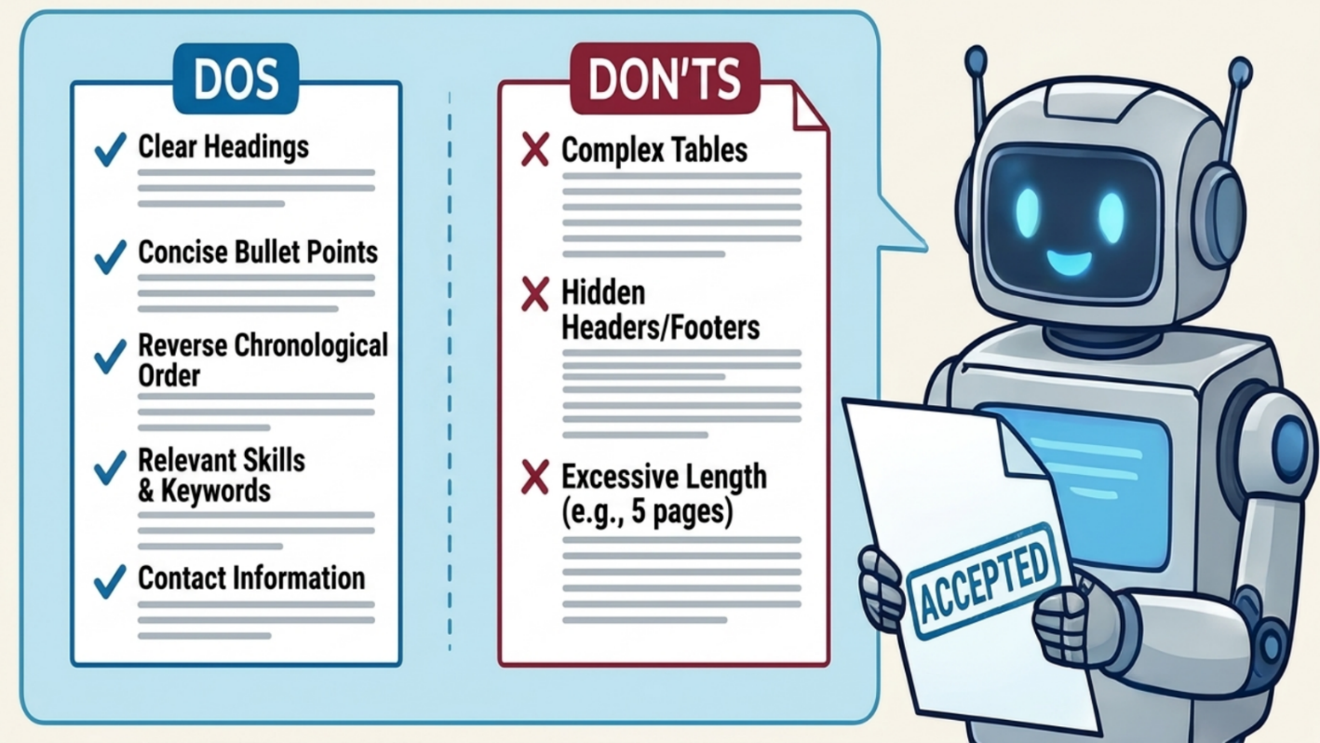
TIP: The optimal length for most resumes is 1 to 2 pages.

Free resume help for individuals with developmental disabilities is coordinated through county boards of developmental disabilities and the Ohio Department of Developmental Disabilities (DODD). The state agency Opportunities for Ohioans with Disabilities (OOD) also provides vocational rehabilitation and dedicated career services.
To get started, consider these key state resources:
- Opportunities for Ohioans with Disabilities (OOD): Connect with OOD to get paired with a vocational rehabilitation counselor who provides specialized resume writing and job interview preparation. You can apply directly online at OODWorks.
https://ood.ohio.gov/
- OhioMeansJobs: Access Ohio's free state job portal, where you can utilize resume-building tools, review sample templates, and use the "SkillsMatch" tool to update your resume keywords to match local, in-demand job postings.
https://ohiomeansjobs.ohio.gov/
- Local County Boards: If you are already receiving services, contact your local County Board of Developmental Disabilities Service and Support Administrator (SSA). They can authorize "Career Planning" or "Individual Employment Support" waivers, which pay for a job developer to help build your resume and find a job in the community.

Facilitator Activities
Keep It Simple
Many employers use Applicant Tracking Systems (ATS) to scan resumes before a hiring manager reviews them. Some resume templates use tables, graphics, columns, or other formatting that can make it difficult for these systems to read your information correctly.
When creating a resume for online applications, follow the Keep It Simple approach. Use plain text, clear section headings, and a simple layout. Avoid using tables, text boxes, graphics, images, or unusual fonts.
A good way to check your resume is to copy and paste it into a simple text editor like Notepad. If your information appears in the correct order and is easy to read, it will likely work well with most ATS systems.
You can always create a more visually appealing version of your resume to bring to interviews or use when networking. For online applications, simple is often the best choice.

Facilitator Worksheet
Whether you're having the job seeker build their own resume or receiving help, the following worksheet can help with setting up a resume with your Job Seeker.

Resume Worksheet

Contact Information
Name: _____________________________________________________________________________________
Phone: _____________________________________________________________________________________
Email: ______________________________________________________________________________________
City and State: _____________________________________________________________________________
LinkedIn (Optional): _______________________________________________________________________

Career Goal
What type of job are you looking for?
____________________________________________________________________________________________
____________________________________________________________________________________________

Skills
List your skills.
Examples:
- Customer service
- Teamwork
- Cleaning
- Cash handling
- Microsoft Office
- Communication
- Problem solving

My Skills:
____________________________________________________________________________________________
____________________________________________________________________________________________
____________________________________________________________________________________________

Work Experience
Employer: _________________________________________________________________________________
Job Title: __________________________________________________________________________________
Dates Worked: ____________________________________________________________________________
What did you do?
- ___________________________________________________________________________________
- ___________________________________________________________________________________
- ___________________________________________________________________________________

Employer: _________________________________________________________________________________
Job Title: __________________________________________________________________________________
Dates Worked: ____________________________________________________________________________
What did you do?
- ___________________________________________________________________________________
- ___________________________________________________________________________________
- ___________________________________________________________________________________

Volunteer Experience (Optional)
Organization: ____________________________________________________________________________________________
What did you do?
____________________________________________________________________________________________
Organization: ____________________________________________________________________________________________
What did you do?
____________________________________________________________________________________________

Education
School: ____________________________________________________________________________________
Degree, Diploma, or Certificate: ___________________________________________________________
Graduation Year (Optional): _______________________________________________________________

Certifications
Examples:
- CPR
- Food Handler Permit
- OSHA
- Certified Nursing Assistant

My Certifications:
____________________________________________________________________________________________
____________________________________________________________________________________________

Awards or Accomplishments (Optional)
____________________________________________________________________________________________
____________________________________________________________________________________________
____________________________________________________________________________________________
____________________________________________________________________________________________

Professional and Personal Branding
While some recent studies suggest that traditional resumes are becoming less important in the hiring process, most employers still use resumes as a key part of evaluating candidates. A strong resume remains an important tool for sharing your skills, experience, and qualifications.
However, today's job search offers additional ways to showcase your talents and stand out from other applicants. Creating an online presence can help employers learn more about your skills, accomplishments, and professional interests.
Why Personal Branding Matters
In a competitive job market, showing what you can do can be just as important as telling employers about your experience. Personal branding tools allow you to highlight your work, build professional connections, and demonstrate your skills in a more interactive way.

Popular Personal Branding and Portfolio Tools
LinkedIn
https://www.linkedin.com/
- Create a professional profile that serves as an online resume.
- Connect with employers, coworkers, and industry professionals.
- Share updates, accomplishments, and work samples.
- Request recommendations from supervisors, coworkers, or mentors.

Canva Websites
https://www.canva.com/website-builder/
- Build a simple portfolio or digital resume without needing web design skills.
- Showcase projects, certifications, presentations, and accomplishments.
- Share your portfolio with employers through a single link.
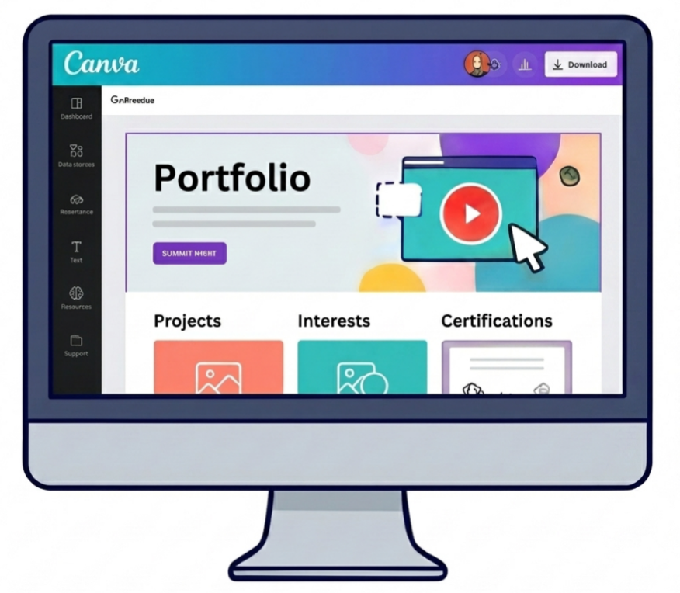
About.me and Carrd
https://about.me/
https://carrd.co/
- Create a simple personal website that highlights who you are and what you do.
- Include links to your resume, social media profiles, portfolio, and contact information.
- Great for creating a professional online presence with minimal effort.

GitHub (Especially for Technology Careers)
https://github.com/signup
- Share coding projects and demonstrate technical skills.
- Collaborate with other developers and contribute to open-source projects.
- Allow employers to see examples of your work and problem-solving abilities.

Job Seeker Tip: If you create an online portfolio or professional profile, include the link on your resume, job applications, and email signature. This gives employers an easy way to learn more about your skills and accomplishments.
Facilitator Tip
Support the job seeker in creating their own LinkedIn profile rather than creating it for them. Encourage them to use their own words to describe their skills, interests, and work experiences. Help them choose a professional profile photo, review privacy settings, and proofread their information, but allow them to make the final decisions. This helps build digital skills and confidence while ensuring the profile accurately reflects who they are.

Activity
Create your LinkedIn Profile at www.linkedin.com
Create a free LinkedIn account and build your profile. Add information about your skills, experience, education, and career goals. LinkedIn can help you connect with employers, explore job opportunities, and grow your professional network.
How to make a good looking profile (LinkedIn Article)
https://www.linkedin.com/help/linkedin/answer/a554351

Turning Technology into Opportunity
Technology has changed the way people find jobs, communicate with employers, and apply for opportunities. For many job seekers, this can feel overwhelming. Between email accounts, online applications, passwords, social media profiles, and job search websites, there can be a lot to manage.
The good news is that you do not need to be a technology expert to successfully search for a job. Just like learning any new skill, confidence comes with practice. By taking a few simple steps, you can build a strong foundation for your digital job search and use technology to your advantage.
Step 1: The Digital Anchor
Create a dedicated email account that will be used only for your job search. Think of this account as your digital anchor. This will be your hub where all job-related communication can be found quickly and easily. When creating your account, use the name you want employers to know you by. A professional email address should be simple, easy to read, and based on your name whenever possible.
Facilitator Tip
With the job seeker's permission, you can review the account together during support meetings to monitor job applications, interview invitations, and employer communications. As the job seeker becomes more independent or secures employment, encourage them to update their password and manage the account on their own. This promotes independence while protecting their privacy and personal information.

Good Examples:
- john.smith@email.com
- john.w.smith@email.com
- jsmith@email.com
Less Professional Examples:
- xgamerguy67x@email.com
- princess123@email.com
- footballfan4life@email.com
Tip: Avoid any sort of Personal Identifying Information in your email address like your birthday or graduation year that employers can easily identify with your age.
Step 2: Strategic Sourcing
Move beyond generic job boards - start by creating a professional online presence. Many employers search for candidates online before scheduling interviews, so it is important that your digital profiles present you in a positive and professional way.
You may already use social media platforms such as Facebook, X, Snapchat, Instagram, or TikTok to connect with friends and family. For job searching, however, consider creating a profile on LinkedIn. As discussed in the previous module, (Module 5.2) LinkedIn is one of the most widely used professional networking platforms and allows you to showcase your work history, skills, education, volunteer experiences, and career interests.
In addition to LinkedIn or other personal branding sites, create a profile on OhioMeansJobs. Completing your profile can help connect you to employers, career resources, training opportunities, and local workforce services throughout Ohio specifically.
https://www.linkedin.com/
https://ohiomeansjobs.ohio.gov/

Build profiles on LinkedIn and OhioMeansJobs to showcase your skills to scouting employers.

Step 3: Portal Navigation
Online job boards and application portals make it possible to apply for dozens of jobs in a single day. While that may sound productive, submitting applications blindly often leads to frustration, burnout, and very few interview opportunities.
Successful job seekers focus on quality over quantity.
Target the role you have identified during Discovery and try to customize your search to your specific themes. Remember, every application is an opportunity. We want you to be excited about the possibilities each application brings.
Step 4: The Hybrid Follow-Up
Websites such as Indeed, Monster, LinkedIn, and OhioMeansJobs are excellent tools for identifying job openings. However, many of these positions are also posted directly on the employer's website. Once you find a job that interests you, visit the company's website to learn more about the organization. Researching an employer can help you decide if the organization is a good fit and prepare you for future interviews.
https://www.indeed.com/
https://www.monster.com/
https://www.linkedin.com/
https://ohiomeansjobs.ohio.gov/
Take a few minutes to explore:
- What products or services does the company provide?
- What is their mission or purpose?
- What values do they promote?
- Why would you like to work there?

After submitting your application online, consider taking an additional step. A professional email, phone call, or LinkedIn message can demonstrate your interest and initiative. While not every employer will respond, a thoughtful follow-up can help employers remember your name and show that you are genuinely interested in the opportunity.
Research the Organization Directly

Visit company websites to ensure the culture fits your needs before you interview.

Activity
Create a professional job-search email account
Create a professional email account using a free email provider such as Gmail or Outlook. Use your name whenever possible and avoid nicknames or usernames that may appear unprofessional.
Write down your email address, password, and account recovery information in a safe and secure location. If you use a password manager, save the information there as well.
Check your email account at least once each day while actively searching for work. Employers often move quickly when scheduling interviews, requesting documents, or following up on applications. Missing an email could mean missing an opportunity.

The Invisible Assistant
Think of artificial intelligence (AI) as an invisible assistant that can help support and organize your job search. Popular AI tools such as ChatGPT, Claude, and Gemini can act as personal job coaches when given clear instructions. They can help you develop a job search strategy, refine application materials, prepare for interviews, track opportunities, and stay organized throughout the process.
https://chatgpt.com/
https://claude.ai/login
https://gemini.google.com/app

Prompting AI
AI is a powerful and evolving tool that can enhance your job search when used effectively. However, the quality of its output depends on the instructions you provide. Clear, specific prompts help AI generate more useful and relevant results, while vague directions can lead to generic or unhelpful responses.
For example, you can use AI to create tailored application materials - including resumes, cover letters, and follow-up emails - by providing a job description and asking it to align your materials with the employer's requirements.
It is important to remember that AI is not always accurate. AI-generated information may be incorrect, incomplete, outdated, or influenced by bias. You are responsible for reviewing and verifying any information against reliable sources. AI should be used as a support tool, not as a substitute for professional judgment or advice in areas such as employment, legal, medical, or financial matters.

Using AI is a skill that improves with practice. There are many AI tools available, and new ones are being developed all the time. The tools included in this guide are just a starting point.
Remember that the goal is not to use the newest tool, it is to achieve the best outcome for the job seeker. Always review AI-generated information for accuracy, keep the job seeker at the center of every decision, and use your professional judgment.
Think of AI like any other tool in your toolbox. You wouldn't use a hammer to drive a screw. Choose the tool that best fits the task, use the tools you are comfortable with, and continue practicing to build your own confidence and skills.

Other Applications of AI
A growing number of AI-powered tools can help job seekers strengthen their applications and prepare for the hiring process. Some platforms use AI avatars to simulate realistic interview scenarios in a safe, low-pressure environment, allowing users to practice responses, improve communication skills, and build confidence before meeting with employers.
Other desktop and web-based platforms analyze your resume alongside a specific job description and provide personalized feedback to help improve your application materials.
The following free and freemium tools offer a variety of features that can support your job search and interview preparation:
- Im>ready: A gamified, offline-friendly mobile app that utilizes interactive virtual avatars and scenarios to help job seekers practice their interviewing skills. It is completely free to download and use on iOS.
https://apps.apple.com/us/app/im-ready/id6446329708
- Google Interview Warmup: A completely free, official Google tool that gives you tailored practice questions for any type of job.
https://grow.google/interview-warmup-archived
- Exponent: Excellent for technical and coding interviews, offering free peer-to-peer and AI-guided mock practice sessions.
https://www.tryexponent.com/practice
- Enhancive: Lets you input a specific job description so you can conduct an out-loud mock interview with AI that adapts to the role.
https://enhancv.com/features/ai-interview-help/

Activity
Using AI to Prepare for Interviews
AI can be a valuable tool for interview preparation, researching job opportunities, and learning strategies for interview success. The prompts below provide a structured approach to practicing common interview questions and developing strong, personalized responses.
Instructions: Copy and paste the following prompts into your preferred AI platform, along with the requested information.

Step 1: Generate Common Interview Questions
Paste the job description and use the following prompt:
"You are a seasoned hiring manager with over 20 years of experience. Based on this job description, what are the 10 most common interview questions you would ask candidates for this position?"
[Paste Job Description]
Review the generated questions and select one that you would like to practice.

Step 2: Understand the Interviewer's Perspective
Once you have selected a question, use the following prompt:
"Please identify the three main reasons an interviewer would ask this question and provide three tips for structuring an effective response."
This step helps you understand what the employer is evaluating and how to organize your answer to address those priorities.
Step 3: Create a Practice Response Using the CARL Method
Next, paste your resume and use the following prompt:
"Based on these tips and my resume, write an interview response using the CARL format (Context, Action, Results, Learning)."
[Paste Resume]
Review the AI-generated response and adapt it so it reflects your own voice, experiences, and speaking style. Practice delivering your answer until it feels natural and can be communicated in approximately two minutes.

Using these prompts provides a structured and low-pressure way to build confidence, strengthen interview skills, and develop muscle memory before participating in a real interview.

The Invisible Architect
The idea of AI as an "invisible architect" means that artificial intelligence quietly shapes the hiring process behind the scenes. Today, AI does much more than screen resumes. Employers use it to help define job requirements, create interview scoring systems, analyze video interviews, administer online assessments, and summarize what candidates say during interviews.

Although recruiters and hiring managers make the final hiring decisions, the information they see has often already been filtered, organized, or evaluated by AI. In many cases, AI helps determine which candidates move forward and how their qualifications are presented.
Because these systems are built using past hiring data and fixed rules, they can sometimes overlook qualified candidates who do not match traditional hiring patterns. As a result, applicants with non-traditional backgrounds, career paths, or communication styles may face challenges even when they have the skills and experience needed for the job.
Accommodation for AI-Driven Assessments
Under the Americans with Disabilities Act (ADA), it is your responsibility to inform a potential employer if you need an accommodation during the application, interview, or employment process. Every employer may have a different procedure, but they should have a clear way for you to request an accommodation if you need one.

Requesting an accommodation should not hurt your chances of getting a job. Accommodation is designed to give qualified individuals an equal opportunity to demonstrate their skills and perform their job duties successfully. Employers are looking for people who can contribute to their organization, and accommodations are often a simple way to remove barriers that may get in the way.
Accommodations can look different for different people. Some examples include:
- Receiving interview questions in writing.
- Having extra time to complete a hiring assessment or test.
- Using assistive technology, such as screen readers or speech-to-text software.
- Having a sign language interpreter during an interview or training.
- Conducting an interview in a quieter location with fewer distractions.
- Receiving written instructions in addition to verbal instructions.
- Adjusting a work schedule for medical appointments or treatment needs.
- Using a handwritten application.
- Using specialized equipment or workplace modifications to complete job tasks.
Remember, accommodations are not special treatment. They are tools that help ensure you have the same opportunity to succeed as any other job seeker. If you are unsure what accommodation might help, start by thinking about what supports have helped you learn, communicate, or perform tasks successfully in the past.

Activity
Learn About a Company's Accommodation Process
Think of three to five companies or organizations where you might want to work. Visit their careers website and look for information about their hiring process and accommodations for applicants with disabilities.
As you explore each website, try to answer the following questions:
- Do they explain how to request an accommodation during the application or interview process?
- Is there a specific person, email address, or phone number to contact for accommodation requests?
- Do they mention accommodations for online assessments, video interviews, or other technology used in hiring?
- Is the information easy to find and understand?
Take notes on what you learn from each employer. Then compare your findings.
Consider these questions:
- Which employers made it easiest to find information about accommodations?
- Which employers provided the clearest instructions for requesting support?
- Were there any employers that did not mention accommodations?
- Would the information you found affect whether you apply for a job there? Why or why not?

The Empowered Candidate
While the modern job search relies heavily on technology, remember that you are still in control. Technology is simply a tool. It should open doors for you, not create barriers.
The digital job market can feel overwhelming at times. New websites, applications, passwords, online profiles, and hiring systems can make the process seem complicated. But behind every online application is the same goal that has always existed: helping employers find talented people who can contribute to their organization.
The skills that make a great employee have not changed. Employers are still looking for people who are dependable, hardworking, eager to learn, and willing to contribute. Technology is simply the way those qualities are discovered and communicated in today's workforce.
Technology as a Bridge

Use digital tools to confidently communicate your strengths and connect with potential employers.
By using the Job Seeker's Guide, completing its activities, and applying the strategies and resources throughout this module, you can combine proven job-search practices with the digital tools that dominate today's job market. The goal is not to master every piece of technology. The goal is to use technology confidently enough to showcase your strengths, connect with employers, and pursue opportunities that match your interests and goals.
Remember: technology does not define your potential. Your skills, experiences, interests, and determination do. Use technology as a tool, trust the process, and continue moving forward one step at a time.
Your next opportunity may be just one click, one conversation, or one application away.

Assistive Technology

YouTube Link: https://youtu.be/4Unyzj06W6M

Module 5 Resources

Worksheets
Facilitator Resume Worksheet – Module 5.1

Videos
Assistive Technology
https://youtu.be/4Unyzj06W6M

Additional Resources
The Public Library Association’s DigitalLearn.org
https://att.digitallearn.org/
Im>ready
https://apps.apple.com/us/app/im-ready/id6446329708
A gamified, offline-friendly mobile app that utilizes interactive virtual avatars and scenarios to help job seekers practice their interviewing skills. It is completely free to download and use on iOS.
Google Interview Warmup
https://grow.google/interview-warmup-archived
A completely free, official Google tool that gives you tailored practice questions for any type of job.
Exponent
https://www.tryexponent.com/practice
Excellent for technical and coding interviews, offering free peer-to-peer and AI-guided mock practice sessions.
Enhancive
https://enhancv.com/features/ai-interview-help/
Lets you input a specific job description so you can conduct an out-loud mock interview with AI that adapts to the role.

Getting There:

Mastering Your Commute
Securing employment is an important milestone that requires proactive preparation, including commuting to the workplace. This guide serves as a practical resource to help job seekers evaluate various travel methods, ranging from personal vehicles and walking to public transit and specialized paratransit services.
By addressing critical topics such as scheduling availability, total commute time, and financial costs, job seekers can develop a concrete plan for reliable attendance.
Transportation planning tends to be an afterthought when supporting individuals with disabilities to plan for employment. This can result in frustration and wasted time. This section encourages the individual to begin considering transportation options earlier in the process.
How Are You Going to Get to Work?
Having a job in the community is an exciting opportunity to earn money, make new friends and to do work that you enjoy. A key part of getting a job is planning how you are going to get there.
There are many ways to get to work. Some people have jobs that are walkable from their homes while others need to travel a few miles. Some individuals drive themselves to work while others may use public transportation or get a ride from a family member.
In this section you will learn about the various types of transportation options available and see a tool you can use to make a transportation plan.

Some good questions to consider as you are planning your trip to work include:
- Is public transportation an option and is it available during the days and times I need to go to work?
- Do I qualify for paratransit and is that available in my area?
- What does it cost to use various forms of transportation?
- Can I get assistance to pay for transportation costs?
- How long will the commute be from where I live to work?
- Would I like to explore getting a driver’s license?

Facilitator Activities
As a facilitator, you can kick off this conversation by posing the following questions:
- Is public transportation an option and is it available during the days and times I need to go to work?
- Do I qualify for paratransit and is that available in my area?
- What does it cost to use various forms of transportation?
- Can I get assistance to pay for transportation costs?
- How long will the commute be from where I live to work?
- Would I like to explore getting a driver’s license?
These answers you get from the individual can guide further resource exploration and connection. For example, helping the individual learn the process for accessing paratransit or making a grid that outlines the cost of various transportation options.

Types of Transportation
When planning for your transportation to work it is helpful to know your options. The types of transportation available to you will depend on the area you live in. For example, larger cities tend to have more public and paratransit options while smaller, more rural areas will have limited options. The section below lists the most common types of transportation options available:
- Paratransit - Types of Transportation
- Taxis - Types of Transportation
- App-Based Rideshare - Types of Transportation
- Public Transportation - Types of Transportation
- Family, Friends and Community - Types of Transportation
- Walking and Biking - Types of Transportation
The purpose of this section is to inform job seekers about the wide array of transportation options to consider when planning for employment. In many cases, individuals will need to be creative and think outside the usual options. The transportation planning tool in Module 6.9 – Making a Transportation Action Plan can be used to begin the discussion, but facilitators can also gather information from the job seeker’s family, OOD counselor or Service and Support Administrator.


Bulletproof Your Commute to Work
This podcast-style explainer guides listeners through the process of creating a reliable transportation plan to support employment success and independence. The discussion explores practical strategies for identifying daily transit options, developing backup transportation methods, and connecting with local mobility managers for additional support and resources.
Listeners will also learn ways to coordinate carpools with coworkers, friends, or family members, locate volunteer ride programs within their communities, and determine whether walking or biking may be safe and realistic transportation choices.
In addition, the audio clip provides information on requesting accommodations for driver license testing and highlights the importance of proactive planning to reduce transportation barriers in the workplace.

YouTube Link: https://youtu.be/4VcWWC6iiCc

Types of Transportation
Paratransit
Many larger cities in Ohio have transportation services specifically for individuals with disabilities. This is often called “Paratransit”. This type of transportation will take you where you want to go within a certain area and within certain times.
Paratransit is an “eligibility-based service”, meaning that your disability needs to impact your ability to take regular public transportation options. If you are interested in this option a meeting will be held to determine if you are eligible.
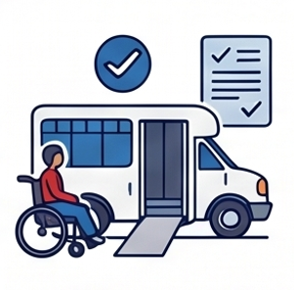
Paratransit can be used to get to work as well as for you to get to other places like doctor’s appointments or to see friends. The cost of a ride tends to be inexpensive, and you can either pay cash or purchase a ticket online.
Not every city in Ohio is big enough to have its own paratransit program. Your area’s mobility manager can help you explore options in your community – learn more here: Planning For Transportation – Mobility Managers.

Types of Transportation
Taxis
Taxis are an example of “private transportation”. For a fee, called a “fare”, a taxi can bring you where you need to go at any time of the day. The benefit of taxi service is that it is flexible, but the drawback is that the cost might be too high to rely on it for frequent trips.
App-Based Rideshare
One of the most popular ways to get from one place to another is by using a rideshare app such as Uber or Lyft. These are transportation services provided by people who use their own vehicles to give rides. Rideshare can be ordered at the time you need a ride, or you can reserve a ride for a specific pick-up time.
Rideshare options may not be available in smaller communities or in rural areas. The cost of a ride depends on how far you are going and if it is a busy time of the day.
Ordering a ride is done through an app on your phone and that is how it is paid for as well. Rideshare has many safety features such as cameras in the cars and the ability to have your family “track” your trips to make sure you get places with no issues.
The 4 Safety Rules
- Verify the car’s make and model.
- Check the license plate number.
- Match the driver’s face to their app photo.
- Share your trip status/tracking with family.
Here are some tips for using rideshare:
- Give plenty of time to get connected to a ride. There may be a lag between when you request a ride and when a driver is available.
- If you know what time you need to get picked up, schedule a ride in advance.
- Always make sure that you are getting into the correct car with the right driver. The make and model of the car, the license plate, and a picture of the driver will be shown on the app once the trip is verified.
- Be sure that your pick-up location is correct.
- Share your trip status with others so they know when you are taking a ride and where you are going.

Types of Transportation
Public Transportation
In many communities there are transportation services that all people can use. These are not only for people with disabilities but for anyone who needs to get places without needing to use a car.
For example, a city might offer bus service where riders can get to work or other destinations for a fee. Buses probably won’t bring you directly to work but you can explore the “bus route” that has a stop close to your destination. Keep in mind that the times of the day a bus runs will depend on the city and route. It is important to plan ahead and be aware of schedules to avoid problems.

Activity
Map Your Public Transit Commute
Objective: Use the Gohio Commute tool to find a reliable public transportation route to your current or potential workplace.
Instructions:
- Access the Tool: Open your web browser on your phone or computer and visit https://gohiocommute.com.
- Enter Your Details: Type in your home address as your starting point and the address of your workplace (or a business you are applying to) as your destination.
- Find the Closest Stop: Review the suggested public transit routes. Because buses typically will not drop you off directly at your workplace's front door, look for the bus route that offers a stop closest to your final destination.
- Verify the Schedule: Check the operating hours for that specific route. Bus schedules depend on the city and the route itself, so you must confirm that the bus runs during the times you need to arrive at work and head home.
- Plan Your Timing: Calculate how long the total trip will take so you can plan ahead and avoid problems being late for your shift.
- Plan the Final Stretch: If your bus stop is a few blocks away from your workplace, you can use map apps on your smartphone to find the best walking or biking route for the remainder of your trip.
Gohio Commute is an excellent resource for people living in the state’s main metropolitan areas. For those living in more rural areas, a simple inventory of existing public transportation options would be a good place to start.

Types of Transportation
Family, Friends and Community

Another option for transportation to work is to see if you have any family members, friends, or neighbors who can give you a ride. In this case, it may be necessary to build a schedule where multiple members of your network help with transportation on various days.
Here are some questions to consider:
- Is there anyone in my family who can drive me to work?
- Can I match my work schedule with friends so we can ride together?
- Do any coworkers live near me that I can carpool with?
- Are there any volunteer transportation services in my community that I can use?


Scenario: Hollie’s Transportation Plan
Hollie works four days a week at a local restaurant. She uses different transportation options to get to her work depending on her schedule. During her weekday shifts she is able use a local volunteer ride program through her church. For her evening and weekend shifts she has several people who help her get to work. Sometimes her father will drive her while other times a co-worker picks Hollie up and they carpool.
To make sure Hollie always has a ride, Hollie and her family have created a schedule. They plan each week and plan for who will be helping her get to work. This plan helps Hollie get to work on time, keep her job and feel confident about her schedule.
Here are some follow up questions based on Hollie’s scenario that you can use to encourage job seekers to think critically about their own transportation plans.
What should Hollie's backup plan be if her co-worker calls in sick or the church volunteer program is unexpectedly closed?
Because Hollie relies on a complex schedule with multiple drivers, how should she handle communicating unexpected schedule changes, like picking up an extra shift or working late?
Hollie successfully found a co-worker to carpool with; how can other job seekers go about asking coworkers if they live nearby and are willing to share a ride?

Types of Transportation
Walking and Biking

Walking or using your bicycle to get to work is a great way to save money and stay active. As you are looking for a good job for you, ask yourself if there are any businesses within walking distance from your home that you might like to try working at.
Here are some questions to consider:
- Are there sidewalks and crosswalks available on my route to work so I can walk safely?
- Do I have a backup plan in case weather keeps me from walking or biking?
- Can I arrange a ride home from work so I don’t have to walk or bike in the dark?
- Do I have everything I need to bike safely, including a reliable bicycle, helmet, and a good bike lock?
- Will the employer have a safe space to store my bike while I am working?
Facilitator Tip:
Assess their location and tailor the options: Help the job seeker understand that their transportation choices will depend heavily on where they live, as larger cities offer public and paratransit options, while smaller or rural areas will have limited services. Consider what is feasible first and build out from there.

Did you know?
Map apps on your phone can help you find the best walking and biking routes to work.


The Active Checklist
 | ☐ Are there safe sidewalks/crosswalks?
 | ☐ Is there safe bike storage at the workplace?
 | ☐ Do I have a weather backup plan?
 | ☐ Do I have a helmet, lock, and a reliable bike?

Getting a Driver’s License
Having a disability does not mean that you are not able to get a driver’s license. In fact, many people with physical, mental health, or developmental disabilities are able to drive themselves to places, including work.
In Ohio, a person is able to get a learners’ permit at the age of 15 years and 6 months old, but you can get a permit at any age. A learners’ permit allows a person to practice driving as long as an adult who has a driver’s license is with them. In Ohio any person under 21 needs to go through formal driver’s education classes and complete 50 hours of “behind the wheel” practice before being eligible to take the driver’s test.
A person with a disability can request accommodations for taking the learners' permit test and the license road test. This may mean having the test read to you or getting extra time. If you would like to request an accommodation, email HHRequestADA@dps.ohio.gov.
It is important to note that a person with a disability needs to pass the same tests and exams to get a license as everybody else. You may also be asked to get a note from a doctor saying it is safe for you to drive.
Getting a driver’s license is a big responsibility and not everyone is comfortable with this level of responsibility. There is no hurry in exploring getting a license. You can begin the process at any age.

The Roadmap to Driving

Obtain a Learners’ Permit. | Email HHRequestADA@dps.ohio.gov for extra time or an exam reader. | Requires 50 behind-the-wheel hours if under 21. | Pass the same exact skills test as all Ohioans.

Scenario
Darius got his learners’ permit at age 18 but wasn’t comfortable taking the road test at that time. When he was 38, he decided he was ready to complete the process. Daruis needed to retake the permit test and was able to practice driving with his family. He was nervous when the day came to take the road test but was able to show all the skills he learned and passed! Today, Darius drives himself to work and enjoys the freedom of seeing friends and being able to take his dog to the park.
The job seekers you are working with may or may not have considered getting their driver’s license and there could be some anxiety about exploring the option. Facilitators should reinforce that there are resources for persons with disabilities who want to get their license, but that there are also plenty of other options for individuals to get to work and other places they want to go.

Planning For Transportation
Planning how you will get to your job may seem overwhelming. Luckily there are some cool resources in Ohio that can help you plan for a safe and reliable trip.
This section is all about helping the job seeker get connected to resources that will support transportation planning as part of the employment process. Facilitators should play an active role in helping the individual not only learn about the resources listed in this section, but also to make sure those supports are integrated into their employment plan. This may be best accomplished by organizing meetings between the job seeker and their SSA, OOD counselor, and the local Mobility Manager.
Mobility Managers and Travel Training
Mobility management is a statewide program that helps people with transportation challenges plan for their transportation needs. A “Mobility Manager” is a local transportation expert that can help you explore travel options that meet your needs. They can also help identify funding resources (how you will pay for the trip) and provide travel training. Travel training can be done one-on-one or in a group and helps a person learn how to schedule rides, understand how to pay, and find the best routes to and from work.
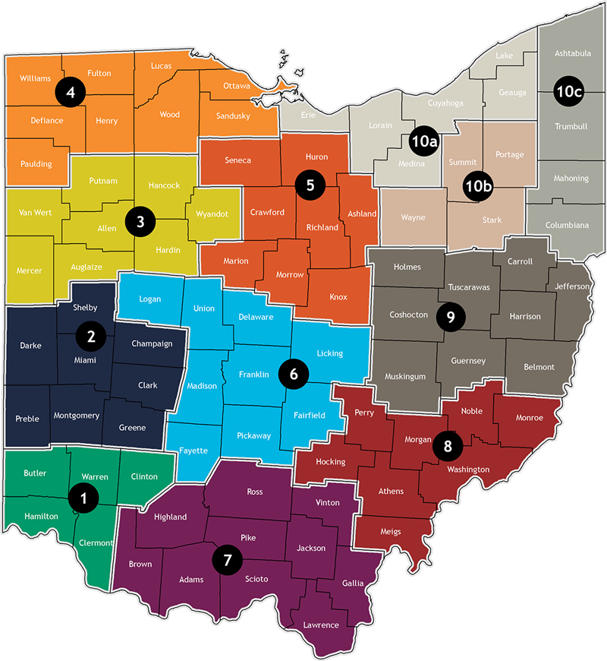

The map above divides Ohio into mobility management regions. Find your region and then explore the Gohio Mobility website. Click here to access the Gohio Mobility Website. This site has helpful resources and includes a list of Mobility Managers around the state. Who is your Mobility Manager?
https://morpc.gohio.com/gohio-mobility/

Did you know?
GoBus provides affordable daily rides to destinations all across Ohio. It is for all people and provides a wonderful option for getting from town to town for special occasions or just a day away.
https://ridegobus.com/
Opportunities for Ohioans with Disabilities
As an individual with a disability, you may qualify for employment support through Opportunities for Ohioans with Disabilities (ODD). ODD helps you set a plan for employment and provides training and support so you can reach your job goals. The plan OOD uses is called the Individual Plan for Employment (IPE). That plan should include ideas on how you will get to your job and resources to help with transportation planning. OOD may also offer "specialized transportation assistance" to help you get to and from job related activities. Make sure to talk to your OOD counselor about your transportation needs.

Facilitator Activities
How will a person get to work? It's a key piece of the employment puzzle. Unfortunately, transportation is often cited as one of the main barriers to people finding community employment. As a teacher or resource facilitator transportation becomes a vital consideration in employment planning for individuals with disabilities.
In Ohio, you have key partners to help people identify transportation options. Mobility Managers are widely available and have a unique perspective on building transportation plans.
What is a Mobility Manager?
https://www.youtube.com/watch?v=rbOcD6NibgI

The Gohio mobility website has helpful resources and includes a list of Mobility Managers around the state. https://morpc.gohio.com/gohio-mobility/
If you are working with transition age youth, it is important to provide them with transportation information that can be incorporated into their IEP. The action plan that is used in this section has examples of key questions to explore with students.
Are the students you are working with being given information on obtaining their learner’s permit and the steps for preparing to take the driving skills test? Keep in mind that individuals with disabilities can request accommodations to take the permit test. Encouraging students to explore the independent driving option raises expectations and opens up more opportunities for employment.

Worksheet
Making a Transportation Action Plan
Objective: Use the chart's series of questions to identify your "Top 3 Commute Options".
Instructions for Using the Chart:
- Start at the Top: Begin with the very first question on the chart: "Is the job close enough to walk or bike safely?".
- Follow the Arrows:
  - If your answer is "Yes", follow the arrow pointing to the right. Write down this transportation method (walking or biking)—it is now one of your potential commute options.
  - If your answer is "No", follow the arrow pointing downward to the next question.
- Work Your Way Down: Continue this process for each question on the list. Whenever your answer is "No," move straight down to the next option. The chart guides you to evaluate:
  - Having a driver's license and access to a car.
  - Relying on family or friends to help drive you.
  - The availability of public transportation in your community.
  - Qualifying for and accessing paratransit.
  - Using OOD/DODD employment supports to pay for rideshares.
- Identify Your Top 3: Every time you answer "Yes", add that method to your list of options. The ultimate goal is to reach the bottom of the flowchart having identified your Top 3 Commute Options.
Once you have identified your top three choices, you can use them to create a solid daily commute plan, reserving the second and third options as reliable backup plans for emergencies.
The transportation action plan is a great opportunity to be creative and to involve the job seeker’s support network in the planning process. The plan can be completed as part of a group meeting or be adapted to be completed as an online lesson. Like all similar tools, the transportation action plan is a “living document”, meaning that it is only as effective as the information it contains and the way it is used. It won’t be helpful if it is completed and forgotten.
This tool will likely reveal areas for further exploration for the job seeker. For example, if their community has paratransit, what is the process for qualifying? If they have family and friends that can help with giving rides to work, what is the best way to help organize as schedule? Or of the qualify to take rideshare to work, what are the limitations?

How will I get to work?

Charting Your Transportation Action Plan
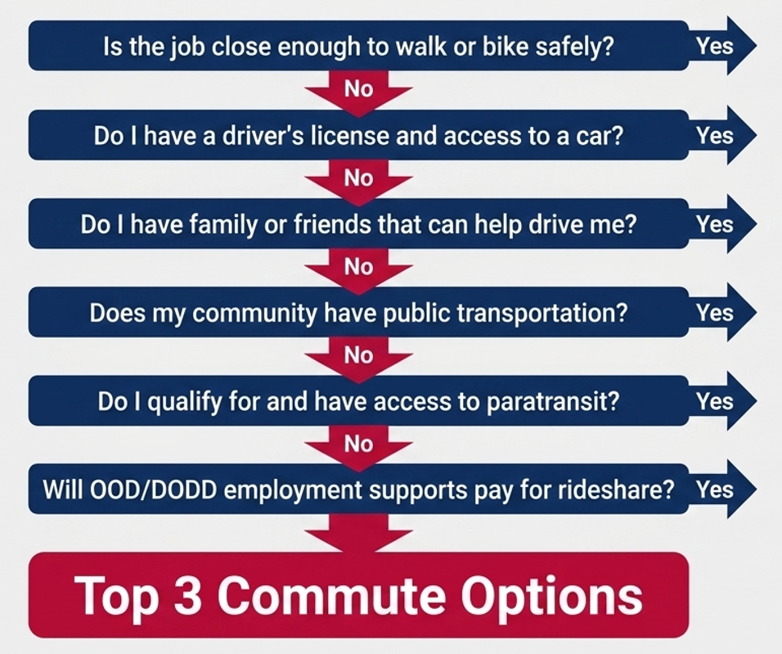

Based on the information above, list the options available for you to get to work:

Module 6 Resources

Videos
What is a Mobility Manager?
https://www.youtube.com/watch?v=rbOcD6NibgI

Worksheets
How will I get to work? Worksheet – Module 6.9
Map Your Public Transit Commute – Activity – Module 6.4

Audio
Bulletproof Your Commute to Work
https://youtu.be/4VcWWC6iiCc
This podcast-style explainer guides listeners through the process of creating a reliable transportation plan to support employment success and independence.

Additional Resources
Gohio Mobility Website
https://morpc.gohio.com/gohio-mobility/
Ride GoBus Website
https://ridegobus.com/

Youth Transition:

Everyone Can Work!
Once you leave high school you will have the opportunity to get a job in the community. Having a job is a great way to show the world what you are good at, to make new friends, and to earn a paycheck. But most of all, having a job can be really fun!
People with all types of disabilities are working in all types of jobs. Having a disability does not mean you can’t work. However, work looks different for everyone. Some people may work part-time (less than 32 hours a week) and others will work more. Some people may have a job coach helping them learn new tasks while others may work independently. There is no wrong way.
It is also important that your job matches what you are good at and comfortable with. A person who is good with people should consider a job in customer service. A person who is good with their hands might find success fixing or assembling things. It is a good idea to explore different types of jobs. There are many places you can work that you may have never thought of.
Perhaps the most important thing a facilitator can do is to help students understand that everyone can have a real job in the community if they want one. To help them see themselves as people who can work despite having a disability. All too often students get mixed messages about employment and are guided towards more restrictive post-school options. This module of the job seekers guide aims to reach transition-age students with positive information about the benefits of competitive employment.

Job Skills Program Helps Faith Succeed at Local Restaurant
Faith learned job skills from the Licking County Project SEARCH program, which taught her what she needs to know on the job as a table busser for the Nutcracker Family Restaurant. Next, Faith is looking forward to getting her driver’s license.

YouTube Link: https://www.youtube.com/watch?v=i9ggfP9Dsoo
A key concept found throughout this module is taking a strengths-based approach to helping a student explore careers and find a good job match. In our efforts to be “realistic” we need to be careful not to make quick judgements that impact student opportunities. Facilitators can use this video to have a discussion about why Faith is successful at the restaurant and to begin helping students explore places they would like to try working.

More Than a Paycheck: Why Having a Job Matters
There are many reasons why people work. These reasons are different for everyone. Some people may like to work because it gives them a paycheck while others may like interacting with customers. Here are some key reasons why having a job in the community is an important part of being an adult:
  Financial Freedom | - Money. Money is, of course, important. Having a job in the community means that you will receive a paycheck for the work you do. The more hours you work, the more money you will make. You can use this money to pay your bills (such as cell phone or groceries), to buy something for yourself, or to save it for when you need it later.
- Doing something you enjoy. Believe it or not, having a job can be fun, especially if you are working at a place you are comfortable with and doing tasks you enjoy. The great thing about having a job is that you can learn many skills and find new things that you never knew you liked to do. |  |   Follow Your Passion
- Making new friends. Many people make new friends at the places they work. Your work friends can help you solve problems and being around people you enjoy helps you feel like you are part of the team.
  Watch How You Grow | - Build self-confidence. Doing something new can be scary. This includes getting your first job. You might be worried that you won’t be able to learn new things or get along with your co-workers. Many people feel this way, but once they begin the job, they see that they are really good at it. Having a job helps us succeed at new things and trying new things is how we grow.
- It’s what adults do. Once you leave high school you are free to make your own choices, but you will also have the responsibilities of being an adult. What are some of the things that adults do? Having a job is certainly on that list. Employment helps us structure our days and shows the world that you are a person with skills and talents. |  |   Adult Responsibilities

Students with disabilities may be told many things about the importance of having a job, and unfortunately, not all of these messages are positive. The secret is to help students connect employment to their own life goals. These may include being able to live in their own apartment, travelling, making a dream purchase or having a job they are proud of.
This section highlights the many reasons why having a job may be important to someone, but the list shared is not exhaustive. As a facilitator you can discuss other reasons why work may be important such as building self-advocacy skills, the pride in contributing to a team (both reasons highlighted in the “Jessica” video) and the possibility of making parents and loved ones proud.
Activity
Create a slide show that describes why having a job is important to you. Find 3-5 images on the internet that show how your life will be different once you have a job and put them into the slide show. The images could be of a place where you would like to work, something you would like to do with your money, or the way you will feel being part of a team. You can share the slideshow at your next IEP team meeting.
When facilitating the activity, try to steer students away from simply listing monetary reasons. You can use prompting questions like:
- What types of jobs do your family do?
- What do you think having a job would allow you to do that you couldn’t if you didn’t have a way to make money?
- Is there any place in the community that you think it would be fun to work at?
- Can you give an example of working as part of a team while doing a school or community activity? How did that make you feel.
Make sure the student gets the opportunity to share their thoughts with their IEP team and be intentional about incorporating this information into planning documents.

Jessica “Steps Out of Shell” with Summer Job
In Belmont County, Jessica worked at the Sleep Inn & Suites as part of a summer employment program aimed at teaching high school students new job skills. Her boss and support team say the job has helped Jessica advocate for herself and communicate more with others. Watch her story.

YouTube Link: https://www.youtube.com/watch?v=MwVdjYx6VLM

Finding the Right Fit for Yourself
Creating your SPIN
What areas do you need help with?
Everyone has things that they are good at and no skill is insignificant. When we think about our “strengths” we can break things down into two parts, 1) the skills we have, and 2) our positive traits. To find the right job match and be successful in employment we need to have a combination of both.
A skill is the ability to do something well and usually comes from natural ability or practice. There are many useful skills that employers are looking for. They might include being able to use technology, having experience using certain tools or machines, or being able to create fun activities for other people. You probably have many more skills than you know. If you are having trouble thinking of the skills you have, ask your family, teacher, or friends what they see as your greatest skills.
A trait is a quality that we have that makes us who we are. For example, a person might be friendly, observant, hardworking, or curious. Employers seek employees with positive traits because that means the person is more likely to do a good job. What do you think are your best traits? What do others say they appreciate about you?
Just like everyone has skills, everyone has areas they need help with. It is completely normal not to be good at everything. As an individual with disabilities, it is important that you understand the things you need help with. One way to make sure you find a good job match is to find work that maximizes your strengths and minimizes your need areas.
Scenario
Diego always wanted to work at a sports arena. He loves the local teams and enjoys attending games with his family. Diego got the opportunity to tour the local arena and learn about all the different types of jobs that are needed. After the tour he thought that selling tickets and working security would not be a good fit for his skills. However, he knew the arena seating chart well and thought he could help people find their seats on gamedays. He also liked the idea of bringing supplies to the food vendors when needed. Thinking of job tasks that matched his skills made him excited to interview for a position.
Transition Youth

YouTube Link: https://youtu.be/lt4A4tybf9Y

Worksheet

I’m Determined
Instructions: Complete the I’m Determined One-Pager. Answer each of the four parts. Your answers will help you create your SPIN,
or your:
Strengths
Preferences
Interests, and
Needs.
Give it to your teacher, OOD counselor or employer so they can understand you better and help you with a successful job search.

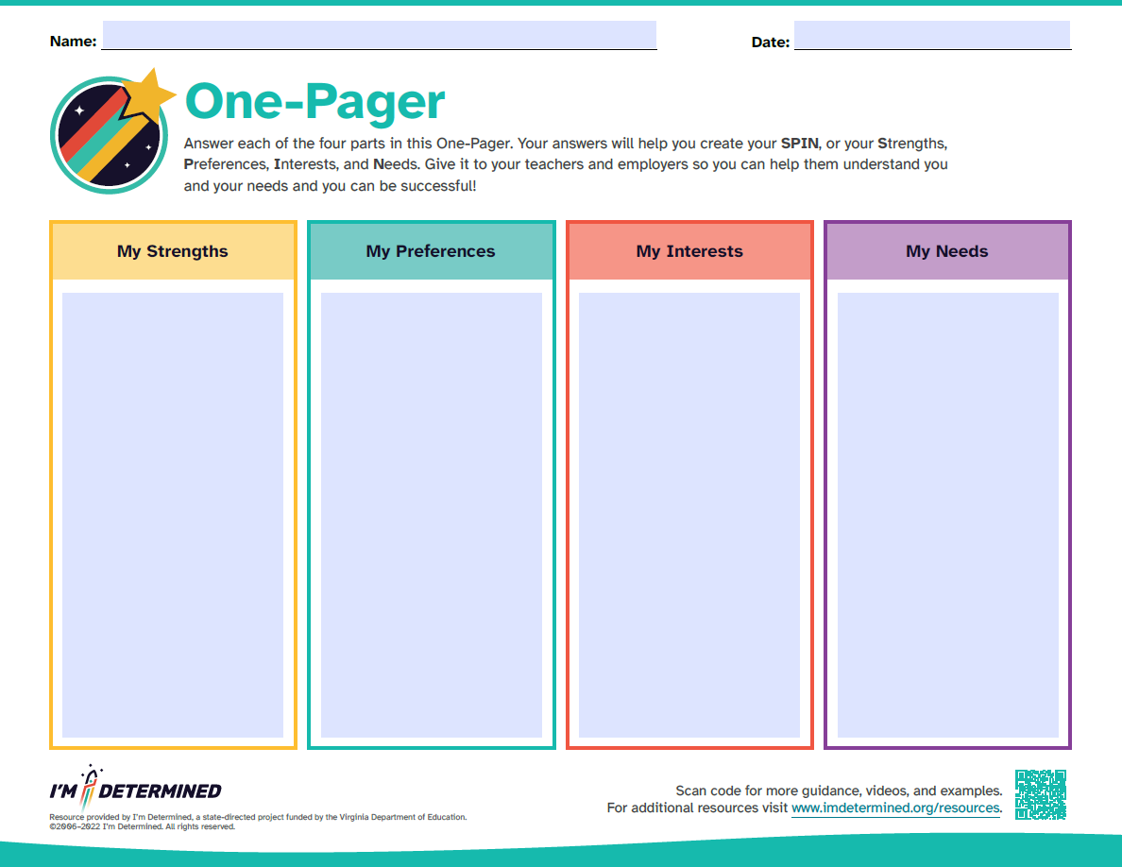

How Do I Find a Good Job Match?
What does it mean to find a good job match? It means getting a job that matches your skills, strengths, and interests while staying away from tasks or environments that don’t work well for you. It means finding where you will shine.
The first step is to make a list of the things you do well and the types of jobs you think you would be good at. Ask yourself some key questions:
- Would I like to work inside or outside (or a combination of both)?
- Would I like a busy workplace with a lot of excitement or a quieter workplace?
- Do I do my best at work in the morning, afternoon, or evening?
- Do I like interacting with customers or do I want a job where I don’t have to interact with customers?
- Are there any businesses that are close to me that I have always wanted to work at?
- Do I like the idea of helping people or making things?
- Do I have any special skills that I want to use in my job (such as being able to use technology or organizing things)?
The second step is to explore the types of jobs that match your work preferences. Keep in mind that there are thousands of different types of jobs and places to work. We sometimes make our job search too narrow by only choosing options that we are familiar with.
For example, you may want to work at a certain store because that is where your family shops, but there are many retailers to explore that might be a better fit.

Get Hands-On Work Experience

Use job shadows, tours, and internships to see if a career is a good fit.
Lastly, once you find 3-5 types of jobs you are interested in, ask your teacher, pre-ETS provider or OOD counselor to help you get a tour or work experience. We never know if a job is a good fit unless we are able to spend time there doing the work and meeting the people.

Did you know?
Did you know that your first job likely won’t be the only job you have in your life? It is common for people to have many jobs as adults. People change jobs for various reasons. You may find that you want to try something new or you may want a job at a different location.
There is nothing wrong with wanting to stay in a job for a long time. But there is also nothing wrong with exploring new jobs along the way.

Facilitator Activities

Why is finding a good job match so important for a student with a disability? The answer is simple – we do better in jobs we like and that match our skills. While it is important to give students the opportunity to explore many types of jobs, the end result should be career goals that are aligned with strengths and interests. Putting a person into a job that isn’t a good match can result in a failed placement and an emerging narrative that a student “can’t work” or is “not ready yet”.
The Charting the LifeCourse trajectory for employment planning is a student-centered tool to help hone in on that good job match. Couple this with information gathered on the Positive Personal Profile (see Section 3) to begin creating a meaningful path for skill-building and work experiences.
Charting the LifeCourse is a nationally recognized person-centered planning framework that helps individuals with disabilities and their families organize ideas, address problems and set a vision for a good life across the lifespan. CtLC offers a wide array of intuitive, visual tools that are perfect for helping students express their goals and identify supports. All of the Charting the LifeCourse tools are available free of charge at:
https://www.lifecoursetools.com/
Charting the LifeCourse – Karyssa
https://www.youtube.com/watch?v=5iuE1soM8nk
Overview of Charting the LifeCourse
https://www.youtube.com/watch?v=nyCChsT24-4

The Charting the LifeCourse Portfolio for Exploring Employment combines many of the common CtLC planning tools into one planning and visioning document. It is broken into sections, making it easy to facilitate with students over a period of time. Use this portfolio to help identify career goals, set IEP goals and plan for work experiences and workplace supports.
Find the Charting the LifeCourse employment planning tools here:
https://www.lifecoursetools.com/lifecourse-library/exploring-the-life-domains/daily-life-and-employment/

Worksheet
Charting the LifeCourse Trajectory for Employment Planning
Instructions: Have a family member, teacher, or Pre-ETS provider help you complete the Charting the LifeCourse Trajectory for Employment Planning. That tool helps you create a vision for what types of jobs you think would fit your strengths and interests the best. Share your trajectory during your next IEP team meeting.

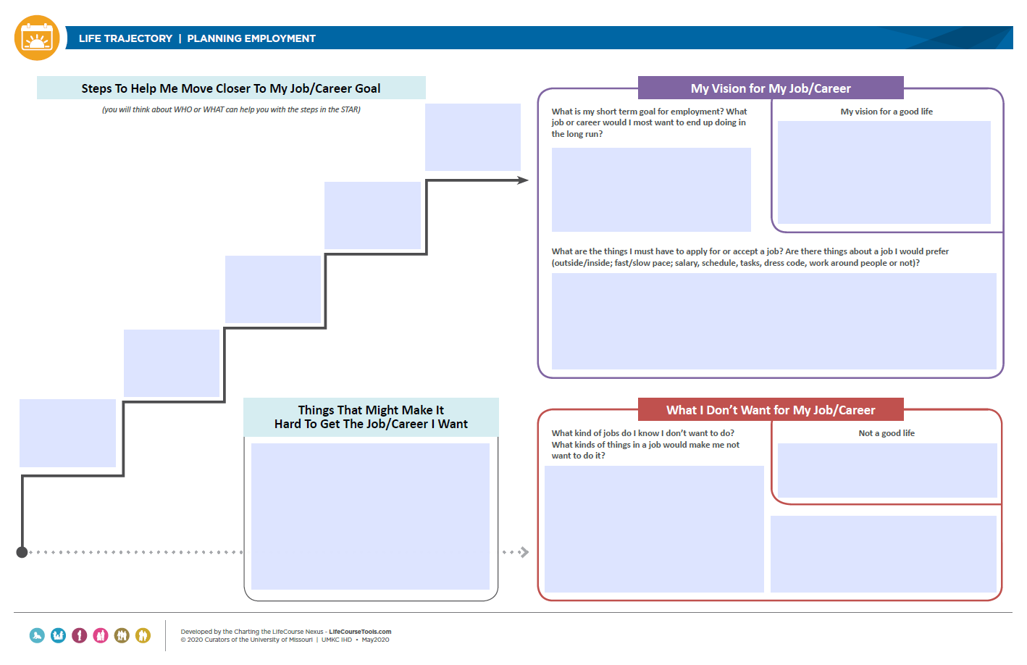

Continue Your Education
How Does School Help Me Prepare for a Job?
In Ohio, the focus of your high school program moves to helping you prepare for life in the community. This is referred to as “transition”. The last years of your high school experience are spent building skills and exploring options in 3 areas:
- Community employment,
- Education or training after high school, and
- Independent living.
Goals related to these areas are included in your Individualized Education Program.
Community Employment means helping you explore careers and building skills needed to be successful in the workplace.
Education or training after high school refers to exploring the possibility of continuing your education at a 2 or 4 year college or obtaining the training needed to do a certain job. Examples of this are CPR certification or food safety courses to work in a restaurant or food service.
Independent living skills are those you need to navigate the adult world on your own. They include being able to budget your money, cook meals for yourself, do your own laundry, and finding transportation. Learn more about transportation here: Mastering Your Commute – Module 6.
IEP stands for Individualized Education Program, and it is the plan that determines what classes, experiences and supports you will receive to be able to reach your post-school goals. It is important to know that the IEP is all about you, and you should have a say in what your plan is. Don’t be afraid to speak up during your IEP meetings if there are things you don’t understand about your plan.

Lead Your IEP Meeting

Speak up in your IEP meetings to set goals for employment.
Your IEP should contain goals related to helping you prepare for employment. This might mean classes that help you build needed work skills, opportunities to practice working both in school and in the community, and getting you connected with programs that can help you such as OOD. During your last year of high school, you should have opportunities to try many different types of jobs and have a good idea of the type of work you want to try first after graduation.
One reason students and families may seem disconnected to the secondary transition planning process is that the IEP is intimidating to them. Often, students feel the IEP involves other people planning for their life, and don’t feel a sense of ownership. This section is designed to help students view the IEP as their plan, and to begin giving them strategies for them to meaningfully contribute.

Activity
It is important that you understand how your IEP is helping you prepare for employment and life after high school. Ask your IEP team lead for the answers to the following questions:
- How is my IEP helping me prepare for community employment?
- How are my strengths and interests reflected in the IEP?
- How will my IEP help me explore jobs and get work experiences?
- How is my IEP helping me explore education and training after high school?
- What employment supports can I consider using after high school?
- What can I do to be an active participant in my IEP process?
Discuss the answers with your family and IEP team lead to see if there are any changes that need to be made to your IEP goals.

Facilitator Activities
A key role of facilitators is to help students better understand what their IEP goals are and how they help them explore careers and build work skills. One creative way to conduct the activity described above is to involve the family. Chances are they have just as many questions about the IEP as the students. See the “backwards planning” resource below from OCALI. It represents an effective way to build more meaningful IEP goals and transition activities by first setting a vision and identifying the gaps that need to be addressed between the vision and implementation.
Backwards Planning
Planning for a future adult life is critical. Using Backwards Planning as the foundation for that process can enhance the success of the plan. In both Backwards Thinking and Backwards Planning, you begin with the vision or goals for the future adult life as well as the skills and knowledge that will need to be in place to be able to achieve those goals and work through "The Gap'.
OCALI Backwards Planning Resources:
https://ocali.org/Using-Backwards-Planning-in-the-Transition-Planning-Process

Preparing For Employment
What programs can help me prepare for a job?
Opportunities for Ohioans with Disabilities (OOD)
Opportunities for Ohioans with Disabilities, or OOD is a program that is available statewide. As a student with a disability, you may qualify for their services if your disability means you will need extra help finding employment. In fact, you may have already met an OOD counselor in your school.
OOD staff can attend your IEP meetings to help brainstorm possible employment opportunities and to help connect you to programs. The main program they operate in high schools is Pre-ETS (see next page for more information.) They also offer a Summer Youth Work Experience Program.
OOD is an important part of your school transition team. If you have not been connected with one of their staff, please ask your Special Education teacher to add them to your meetings.
A key concept to reinforce is that people with disabilities are not required to use a service providers or programs to get a job. Individuals are always free to follow the same employment process (application, interview, etc.) as anyone would. However, getting support with the employment process is available to those who may need it.

Building Confidence: Discover Summer Work Experiences for Students with Disabilities
In the summer of 2025, Summer Youth Work Experience program unfolded across Ohio for students with disabilities aged 14-21. The program led by Opportunities for Ohioans with Disabilities (OOD) provided valuable on-the-job training and insights into the world of work, setting the stage for brighter futures.
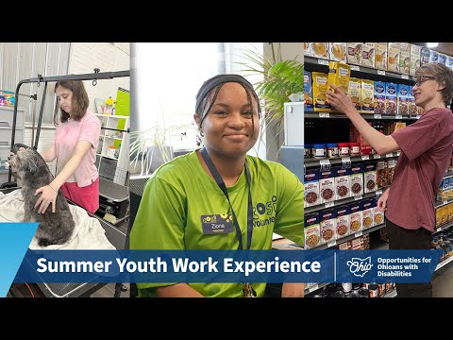
YouTube Link: https://www.youtube.com/watch?v=kuin883eJLA
“Working means happiness to me.”
Use this video to help students explore OOD summer work options. It will be important for facilitators to understand the programs in their own region to avoid confusion with those shown in the video.

Pre-ETS
Opportunities for Ohioans with Disabilities offers a program for high school students with disabilities to help them explore careers and build skills to be successful in employment. It is called Pre-Employment Transition Services or Pre-ETS and it is a great way to begin your employment journey.
Pre-ETS can help you in five key ways:
- Pre-ETS can help you explore various careers and work with you to set job goals.
- Pre-ETS can provide opportunities to practice different jobs to see which ones you may like to explore further.
- The program provides you with information on the education or training you will need after high school to build skills for certain jobs.
- Pre-ETS can help you build the needed “people skills” to successful on the job.
- Pre-ETS helps you practice speaking up for the things you need.
Pre-ETS activities can be provided by a person from outside of the school or by a school staff member. The program is free, but you have to apply to participate. Ask your Special Education teacher if you are currently in the program and how to apply if you are not.



Employment Providers
As an adult you may qualify to receive assistance finding employment and learning new skills while on the job. These services will be given by an agency in your community that specializes in supporting people with disabilities. These “providers” may also have worked with you while in high school.
Speaking of high school, you can request that a local disability employment provider attend your IEP meeting to help plan what employment will look like after high school. Your Special Education teacher or OOD counselor can give you the names of these resources.
It is important to know that you have a choice in what provider you work with. Your family can help you make a decision as to which program is best for you.
The concept of a “provider” or services provided by outside agencies that are done in partnership with the school can be confusing for students and their families. Facilitators play a key role in helping students and families understand the crucial function these partners can play in the employment process. To do this effectively, students will need accessible information about program options and the opportunity to build relationships with their OOD and service provider staff.

Facilitator Activities
Key questions to address with students include:
- Do you currently have a Service and Support Administrator?
- Do you currently have an OOD counselor?
- Has either one ever attended your IEP meeting?
- Are you currently enrolled in Pre-Employment Transition Services?
- Are you interested in a summer work experience?
- What other work experiences would you like to explore while in high school? (What jobs would you like to try?)
- Has anyone talked to you about agencies in your community that would help you get a job?

What is a “Work Experience”?
How do you know if a job you are interested in is a good fit for you? You need to have a “work experience”. A “work experience” is an opportunity for a student to explore careers or try a job they are interested in. These are often done at a business in the community so you can experience the environment and job tasks for yourself.
Categories of “work experiences” are listed below:
 | Career Awareness: Career awareness activities give you the opportunity to gain an understanding of the world of work and to begin exploring jobs you might be interested in. This includes watching presentations from employers, conducting informational interviews with specific employers, and attending career fairs.
 | Career Exploration: Once you get a good idea of the types of jobs you are interested in now you can learn more about the businesses in your community that do similar work. These work experience activities give you the opportunity to get hands on experience doing different jobs. Career exploration can include observing how a job is done through a job shadow, taking a tour of a business, and participating in service-learning projects that help the community.
 | Career Preparation: Now that you have explored different types of jobs you can set a career goal. Having a career goal means you have one or two clear job types that you would like to be employed at. Career preparation activities help you gain the skills and technical knowledge needed to do your preferred job. This is done through summer work experience programs, internships and apprenticeships.

Scenario
Sage is interested in working with animals and wants to explore different jobs she can do. She contacts a local dog spa and asks for an informational interview. During that interview Sage learns about all the different tasks that are done by the staff. She then asks if she can come in and job shadow for a day. During her day at the spa Sage got a good idea about how noisy dogs can be, but Sage still wanted to give it a try. Finally, Sage offered to volunteer so she could get hands-on experience with supervising the dog play area and cleaning the grooming stations. Today, Sage is a Grooming Assistant and loves being around dogs at work.

Facilitator Activities
Research suggests that individuals who have paid employment or meaningful work experiences in high school have better employment outcomes as adults. This holds true for students with or without disabilities. The concept is straightforward – people need the opportunity to explore and practice jobs they are interested in. Sometimes a work experience will reveal that a certain job is not a good match, and that is a perfectly acceptable outcome.
Students with disabilities, especially those with more complex support needs, often do not get opportunities for individualized, community-based work experiences. The goal of this section is to have students prepare for the jobs they are interested in by planning for various types of work experiences. The facilitator role is to help the student access opportunities that not only allow for exposure to jobs, but provide authentic opportunities to practice work tasks in real employment settings.
Helpful tip: Make sure you document student skill attainment during work experiences and include those on the Positive Personal Profile or another type of portfolio. This will be useful information for employment plans and job interviews.

What Can I Do to Build My Skills?
Employers are looking for employees who have the skills or can learn the skills needed to do the jobs they need done. Your high school years are perfect for building your own skill set so you can impress employers. Here are some of the main skills employers are looking for:
- A person who is friendly and good with customers.
- A person who works well as part of a team.
- A person who is well groomed and comes to work on time.
- A person who is responsible and gets tasks done.
- A person who communicates well with others.
- A person who is eager to learn new things.
- A person who is willing to ask for help when needed.
Here are some great ways to begin building these skills:
Helping out around the house: Do you have chores you are responsible for at home? Chores are a great way to build skills such as cleaning, organizing, planning and time management. If you have had the same chores for many years, ask your family if there are other ways you can help.
Be involved in the community: There are many ways to build work skills while also being a helpful member of the community. You could help gather goods for a food drive or offer to mow or shovel for a neighbor. Schools often have “service learning” projects where students plan a project that helps others. The best thing is that employers like to see people take initiative so make sure you list your activities on your resume or portfolio.
Try new things: How do you know if you are good at something unless you try it? It is much better to try something new and have it not go well than to never try anything new at all. And any new job you get will require you to learn new things, so why not practice now? This could mean trying being part of a theatre production or practicing making a food that is new to you.
Learn a new skill: Employers appreciate employees who are willing to learn new tasks. What is the last “new” thing you learned how to do? Challenge yourself to keep learning to do new things. For example, do you know how to use the washer and dryer? Is there a computer program you would like to be better at? Or maybe it’s learning how to start a conversation with someone.
Practice the skills needed for the job you want: When you think about the type of job you want, can you identify the tasks and skills needed to do the job successfully? A person who works with the maintenance team at a health club will need to be able to clean surfaces, sanitize equipment, stock towels, empty trash and vacuum floors. These are all skills you can practice at home. When it’s time for your interview, you can tell the health club manager that you are ready to do what needs to be done.

Hard Skills vs. Soft Skills
This video includes information on:
- Hard skills, which include physical skills that are important to your job
- Soft skills, which are people skills like communication, teamwork, and adaptability
- The importance of both types of skills
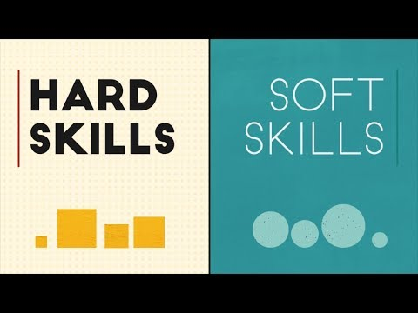
YouTube Link: https://www.youtube.com/watch?v=0FFLFcB9xfQ
Facilitator Activities
The key to successful employment preparation for students with disabilities is skill building. This includes both hard skills and soft skills. Why? Because employers are looking for reliable employees that have the skills to either do needed tasks or to learn how to do needed tasks (with or without support). The secondary transition years are the perfect time to help students gain transferable skills that will appeal to employers.
This section not only outlines key ways that students can build skills but also offers a tool that will help them communicate goals and skills in a visual way. If you are a Pre-ETS provider or secondary transition lead, your goal should be to have every student create their own “vision statement”.
Another useful activity will be to help students better understand the broad scope of skills needed for the jobs they would like to explore. For example, what specific skills and tasks are needed for a person working a restaurant? Obtaining a food safety certificate? Building skills and experiences should be intentional to the job a student is exploring.
Helpful tip: Students with certain types of disabilities may struggle with social interactions. This is a skill set that should be addressed early through IEP goals and activities.

Activity
Build a Vision Statement
Review the example vision statement below so you know what one looks like. Then download the “Vision Statement Template” and create your own. Insert a picture of yourself and tell the world your strengths, skills and vision for your future. This can also be used as a resume when you interview for jobs.
If you are using Microsoft Word, use the following instructions to insert a photo into your vision statement:
- Right click the rectangle at the top of the page
- In the small popup box, click “Fill”
- In the menu that pops up, click “Picture” towards the bottom of the box
- Search for the place on your computer where you saved your picture, landscape style photos work best here
- You may need to reshape your photo a little bit! Click and drag the handles at the top corners of the image to do so.

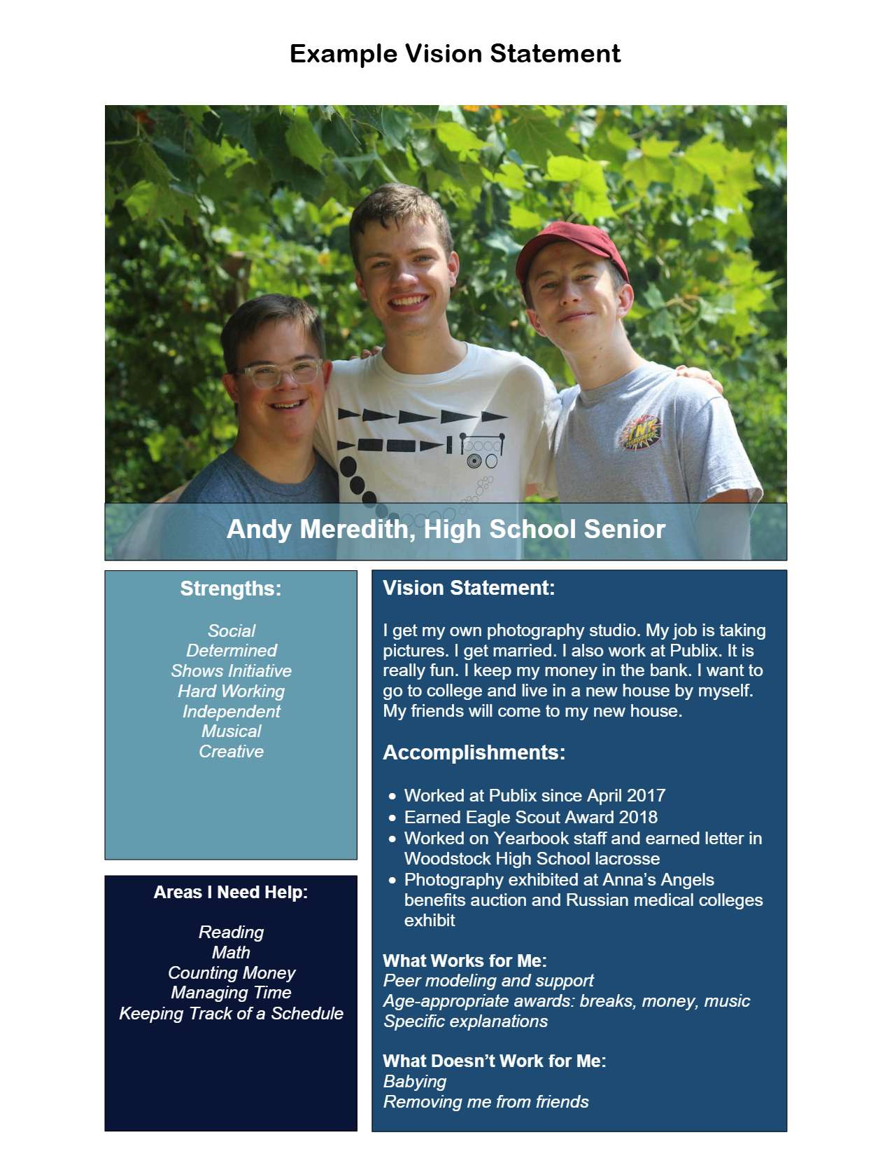

Your Name Goes Here,
Current School or Work Role
Vision Statement:
Your vision statement goes here.
Accomplishments:
Your accomplishments go here.
What Works For Me:
Your likes and preferences.
What Doesn’t Work For Me:
Things others do that you don’t like.

Areas I Need Help:
What
Support
Do
You
Need?
Strengths:
Your
Strengths
Go
Here!

Education and Training After School
There are many options for students with disabilities to continue their education after high school. This is known as “post-secondary education” or PSE. Some job fields may require some type of degree or certification to be able to do the job.
When students hear the word “college” they often think of big places like The Ohio State University or the University of Cincinnati. But there are many types of colleges and programs that can fit your needs. They range from 4-year colleges and universities to 2-year community and technical colleges. Ohio also has over 50 Technical Centers where adults can get career training from programs lasting 3-18 months.
Many students and families dismiss the idea of post-secondary education because they think it means rigorous college courses. Reinforce that PSE comes in many different forms and is an excellent way to build work skills and explore areas of personal interest.
As a student with a disability, you can receive accommodations while in college to help you complete the required coursework. These may include extra time to take a test or having a quite space to take a test. Keep in mind that IEPs do not apply to college, so don’t expect the same level of support. If you are interested in attending a college program, be sure to visit with the college’s student disability services office before you enroll to check to see what accommodations are available to you.
Receiving training after high school does not require that you go to college. There are common certifications that you can get that will help you get certain jobs. For example, if you are interested in working in an office then you can take a course on using office software such as Word and Excel. These courses might be available at your local community or technical college or through community education programs.

Scenario
Maddie always wants to work in the medical field. She liked the idea of using her skills to help people. During high school she explored healthcare careers and had work experiences in a nursing home and a hospital.

She realized that if she wanted to start building a career she would have to complete a Certified Nursing Assistant (CNA) program after graduation. Maddie found a program that had online classes and in-person practice sessions. Today she is a CNA at a small hospital in her hometown and she feels great about playing her role to provide quality medical care.
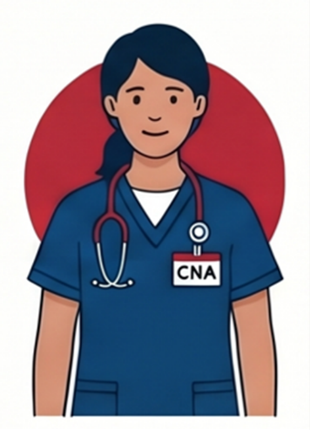

Did you know?
There are currently 9 programs in Ohio that offer college experiences for students with developmental and intellectual disabilities. These programs are help on college campuses and often lead to skills building and certifications needed to be employed.
Visit the Think College Website’s College Search Tool for more information.
https://thinkcollege.net/college-search?fulltext=&state%5bOH%5d=OH
This section highlights the important link between employment and acquiring needed skills and certifications through post-high school education and training. The role of the facilitator is to make sure that students and families are aware that there are opportunities for individuals with disabilities to attend college or to earn less rigorous certificates that will enhance employability. Coupled with this concept should be information on disability student service programs on campuses, testing accommodations (especially for trade exams), and assistive technology that can support learning and organization.

Understanding SSD Benefits
Some individuals with disabilities have applied for and receive funds from the federal government to help with the cost of living in the community. The two main types of programs are Supplemental Security Income (SSI) or Social Security Disability Insurance (SSDI). They are both administered by the Social Security Administration but are very different. This job seekers guide has a module where you can learn more about these programs.
For transition age students, it is important to know that you can still work even if you receive SSI or SSDI. In fact, a person usually earns more money working in the community than they will just relying on the Social Security benefits.
There are a lot of myths and misunderstandings about Social Security programs. Luckily, there are experts called “benefits counselors” who can help you and your family better understand how employment will impact your benefits. Please see the map below for the benefits counseling agency in your area.
Take a look at Benefits Planning – Module 3 to find out more about benefits planning myths, recommendations, and services.
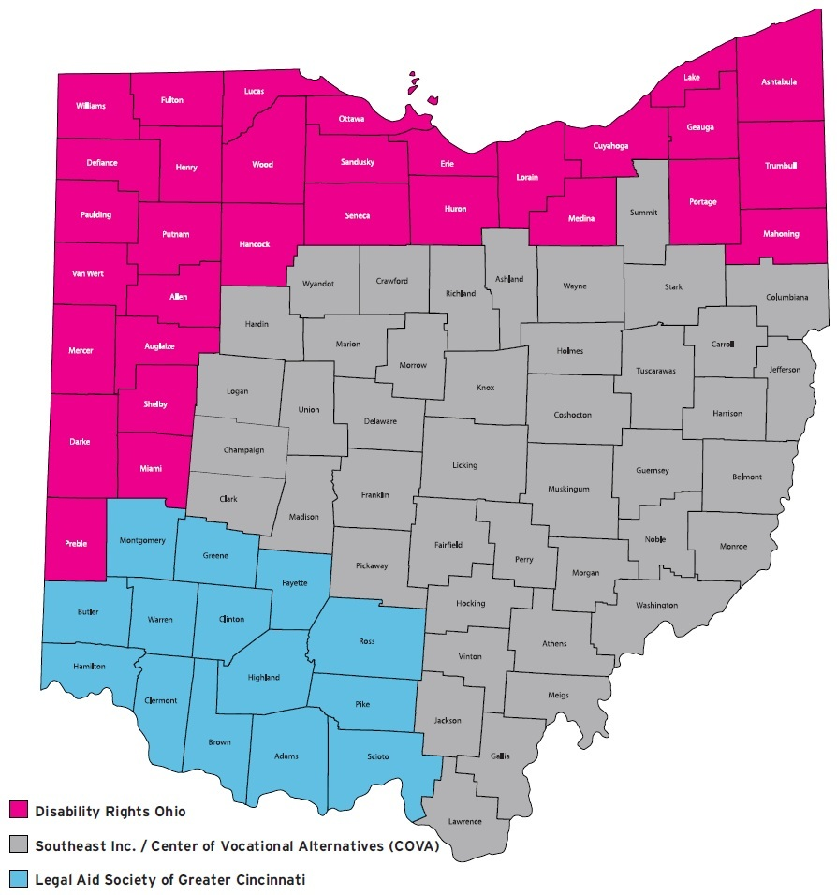

Legal Aid Society of Greater Cincinnati  215 E. 9th St., Suite 200  Cincinnati, OH 45202  513-241-9400 or  800-582-2682  Fax 513-241-0047  lascinti.org | Southeast Inc / COVA  3770 N. High Street  Columbus, OH 43214  (614) 294-7117 — voice  (614) 294-7443 — fax  www.cova.org | Disability Rights Ohio  200 Civic Center Drive, Suite 300 Columbus, OH 43215  614-466-7264 or  800-282-9181  disabilityrightsohio.org

Did you know?
When SSI recipients turn 18 they will go through a “redetermination” process. This process decides if a person meets the adult criteria to continue to receive benefits. Families and students should be aware that receiving SSI as a youth does not mean you will receive it as an adult.

Students under the age of 22 who regularly attend school (high school or post-secondary education) can have a job and deduct a portion of their earnings from their countable income. This is called the Student Earned Income Exclusion (SEIE) and allows students to gain work experience without losing their SSI payments.
For more information, visit the SSA website’s What is the Student Earned Income Exclusion? Informational page. https://www.ssa.gov/ssi/spotlights/spot-student-earned-income.htm

Worksheet
Create Your Action Plan
Instructions for Creating your Action Plan:
This worksheet is designed to help you think about your future career goals and create a plan for reaching them. As you work through each section, use what you have learned in this module about employment, self-advocacy, and planning for life after high school.
There are no right or wrong answers. Your interests, strengths, and goals may change over time, and that is okay. This worksheet is meant to be a living document that you can revisit and update as you learn more about yourself and different career opportunities.
The key intended outcome of this module is that students walk away with an employment action plan that informs in-school transition services, summer programming, and post-school employment supports. The action plan should be seen as a “living document”, meaning that it should be revisited and revised frequently based on the changing goals of the student.
Students should be given the opportunity to share their completed plan not only with family and the IEP team, but also through shareable formats like a visual portfolio. As a facilitator, a good goal to envision is supporting the students towards securing their first paid job before they leave high school. This also includes having the student and their family connected to adult services that support employment. This is often referred to as “seamless transition.”

Create Your Action Plan
Complete each section as thoroughly as possible:
List all the types of jobs you are interested in here.

List all your strengths, skills and positive traits here.

List the skills you will need to do the job you are interested in here.

List the things you might need help with while on the job here.

Action Step: Ask your IEP team how your program is helping you prepare for employment.

Action Step: Pick 3 job possibilities that you would most like to explore.
1.
2.
3.
Action Step: Create a vision statement and share it with your family and IEP team.
Action Step: Enroll in Pre-ETS and invite ODD to your IEP meeting.
Action Step: Request a work experience at one of your preferred job types.

What did you learn during the work experience? Is the job a good fit for you?
Action Step: Explore the training or education after high school that you will need to qualify for your preferred job. List needed certification here:
1.
2.
3.
Action Step: If you are receiving SSI, begin the redetermination process at age 18.
Final Action Step: Before graduating begin working your first real job. Congratulations!

Module 7 Resources

Worksheets
I’m Determined – One-Pager – Module 7.2
Charting the LifeCourse Trajectory for Employment Planning – One Pager – Module 7.3
Build a Vision Statement – Activity – Module 7.7
Create Your Action Plan – Worksheet – Module 7.10

Videos
Job Skills Program Helps Faith Succeed at Local Restaurant
https://www.youtube.com/watch?v=i9ggfP9Dsoo
Faith learned job skills from the Licking County Project SEARCH program, which taught her what she needs to know on the job as a table busser for the Nutcracker Family Restaurant. Next, Faith is looking forward to getting her driver’s license.
Jessica “Steps Out of Shell” with Summer Job
https://www.youtube.com/watch?v=MwVdjYx6VLM
In Belmont County, Jessica worked at the Sleep Inn & Suites as part of a summer employment program aimed at teaching high school students new job skills. Her boss and support team say the job has helped Jessica advocate for herself and communicate more with others. Watch her story.
Building Confidence: Discover Summer Work Experiences for Students with Disabilities
https://www.youtube.com/watch?v=kuin883eJLA&t=7s
In the summer of 2025, Summer Youth Work Experience program unfolded across Ohio for students with disabilities aged 14-21. The program led by Opportunities for Ohioans with Disabilities (OOD) provided valuable on-the-job training and insights into the world of work, setting the stage for brighter futures.
Charting the LifeCourse – Karyssa
https://www.youtube.com/watch?v=5iuE1soM8nk
Overview of Charting the LifeCourse
https://www.youtube.com/watch?v=nyCChsT24-4

Additional Resources
Think College by UMASS College Search Tool
https://thinkcollege.net/college-search?fulltext=&state%5bOH%5d=OH
What is the Student Earned Income Exclusion? SSA Website
https://www.ssa.gov/ssi/spotlights/spot-student-earned-income.htm
Free Charting the LifeCourse tools
https://www.lifecoursetools.com/
OCALI Backwards Planning Resources:
https://ocali.org/Using-Backwards-Planning-in-the-Transition-Planning-Process

